Appendix E Data Dictionary

ACCOUNTS MODULE
JAVA



ABM Knowledgeware Ltd.
ABM House, Plot No. 268,
Linking Road, Bandra(West), Mumbai- 400 050
Website: www.abmindia.com
Email: mainet.support@abmindia.com
Document Name : |  | Appendix E Data Dictionary for Account Module –JAVA
Project Name : |  | ABM MAINet®
Owner of the document : |  | EGOV – Solutions
Copy Number :  (If hard copy is prepared & distributed) |  | 0
 | Document Revision History

Sr. No | Version | Modified By | Date | Changes incorporated in brief | Reviewed By | Reviewed Date | Approved By | Approved Date
 | 1.0.1 | Dharmendra Chouhan | 14-12-2016 |  | Nilima Kshirsagar | 16-12-2016
 | 1.0.1 | Dharmendra Chouhan | 30-12-2016
 | 1.0.1 | Dharmendra Chouhan | 4-1-2017 | tb_service_receipt_mas  tb_srcpt_modes_det  tb_srcpt_fees_det  rename column with userid to createdby ,  lmodate to createddate  and wt_ replace column name with rm_,rd_,rf_
 | 1.0.1 | Dharmendra Chouhan | 9-1-2017 | With reference to review meeting dated 04-01-2017 changes
 | 1.0.1 | Dharmendra Chouhan | 10-1-2017 | With reference to review meeting dated 10-01-2017 changes  drop table  TB_AC_BANK_DEPOSITSLIP_DET  TB_AC_CONTRADET  TB_AC_CONTR_CASHDEP_DET  alter table  TB_RECEIPT_MAS  TB_RECEIPT_DET  TB_RECEIPT_MODE
 | 1.0.1 | Dharmendra Chouhan | 12-1-2017 | create new table -TB_AC_BUDGETCODE_MAS for account budget code creation  Changes done on account template table add crated new details table  TB_AC_VOUCHERTEMPLATE_MAS  TB_AC_VOUCHERTEMPLATE_DET
 | 1.0.1 | Dharmendra Chouhan | 13-1-2017 | Account Budget code added column and remove fund_id, function_id,  FUND_ID, FUNCTION_ID, FIELD_ID, PAC_HEAD_ID, SAC_HEAD_ID
 | 1.0.1 | Dharmendra Chouhan | 19-1-2017 | Drop table TB_AC_TAX_HEADMAPPING  TB_CUSTBANKS  TB_CUSTBANKS_HIST  TB_CUSTBANKS_MAS  TB_CUSTBANKS_MAS_HIST  TB_BANKACCOUNT_BAL  TB_BANKACCOUNT  TB_BANKACCOUNT_HIST  TB_BANKMASTER_HIST  TB_BANKMASTER  TB_AC_CHEQUEBOOKLEAF_MAS_HIST  TB_AC_SECONDARYHEAD_MST_HIST  TB_BANKACCOUNT_FUNDMAP  ACCOUNT_FUND  Added new column --TB_TAX_MAS  fund_id  function_id  pac_head_id  sac_head_id  pac_head_id_lib  sac_head_id_lib  Rename bank master and bank account colunn  TB_VENDORMASTER  TB_PG_BANK  TB_RECEIPT_MODE  TB_AC_BANK_DEPOSITSLIP_MASTER  TB_AC_CHEQUEBOOKLEAF_MAS  TB_AC_SECONDARYHEAD_MASTER
 | 1.0.1 | Dharmendra Chouhan | 23-1-2017 | alter table TB_AC_BUDGETCODE_MAS modify budget_code NVARCHAR2(500);
 | 1.0.1 | Dharmendra Chouhan | 24-1-2017 | Added new column for Reconciliation  alter table TB_RECEIPT_MODE add discrepancy_flag char(1) default 'N';  alter table TB_RECEIPT_MODE add discrepancydetails NVARCHAR2(500);  bm_billdate drop column from TB_AC_BILL_MAS  Create new table for payment voucher  TB_AC_PAYMENT_MAS  TB_AC_PAYMENT_DET
 | 1.0.1 | Dharmendra Chouhan | 25-1-2017 | Alter cheque book details table for  1.Payments Cheque Issauance Entry  2. Stop Payment Order  3.Cancellation / Re-Issue Of Cheques  Alter payment master table for  4. Bank Reconciliation  -----------  5. Cheque Dishonour Entry
 | 1.0.1 | Dharmendra Chouhan | 31-1-2017 | alter table TB_AC_PRIMARYHEAD_MASTER add cpd_id_bank_type for BAT prefix  alter table TB_AC_BUDGETALLOCATION_HIST add cpd_bugsubtype_id
 | 1.0.1 | Dharmendra Chouhan | 2-2-2017 | alter table TB_AC_PROJECTEDPROVISIONADJ add budget_identify_flag
 | 1.0.1 | Dharmendra Chouhan | 4-2-2017 | --  TB_RECEIPT_MODE added new column budgetcode_id

TABLE OF CONTENTS
1. Introduction 9
1.1. Executive Summary 9
1.2. Scope & Design Context 10
1.3. Design Vision & Objectives 10
1.4. Definitions/Acronyms/Abbreviations 10
1.5. References 10
1.6. Assumptions 10
1.7. Constraints 10
2. Application Modules 11
2.1. INTEGRATION WITH OTHER MODULES 11
2.1.1. Water 11
2.2. DEAS 12
2.2.1. Master 12
2.2.1.1. Configuration Master for Deas Code Master 12
2.2.1.2. Funcation Master 16
2.2.1.3. Fund Master 18
2.2.1.4. Field Master 21
2.2.1.5. Account Head – Primary Account Code Master 24
2.2.1.6. Account Head –Secondary Account Code Master 27
2.2.1.7. Account Budget Code 31
2.2.1.8. Cheque Book Leaf Master 34
2.2.1.9. Bank Master, Bank Ulb Mapping and Bank account entry 39
2.2.1.10. Vendor Master 45
2.2.1.11. Statutory Deductions Mapping Entry 49
2.2.1.12. Budget Head Opening Balance 51
2.2.1.13. Bank Master Entry For TDS 57
2.2.1.14. Deposits and Advanced Heads Mapping Entry 59
2.2.1.15. Voucher Template Entry 63
2.2.1.16. Financial year Entry 68
2.2.1.17. Tax Master (Accounts head linkage) 72
2.2.1.18. Standard Account Heads Mapping 76
2.2.1. Transation 77
2.2.1.1. Original Budget for Revenues 77
2.2.1.2. Original Budget for Expenditure 82
2.2.1.3. Budget Allocation 86
2.2.1.4. Re-Appropriation of Budget 92
2.2.1.5. Additional / Supplemental Budget 102
2.2.1.6. Budgetory Revision 108
Validation on Budgetory Revision Form 112
2.2.1.7. Estimation Preparation 113
Validation on Estimation Preparation Form 117
2.2.1.8. Accounts Receipt and Receipt Reversal 118
Account Receipt Reversal 130
2.2.1.9. Contra Entry form 130
2.2.1.10. Voucher Entry 141
2.2.1.11. Tender Entry 146
2.2.1.12. Liability Book Entry 151
2.2.1.13. Pay In Slip – Cash / Cheque / Dd Deposit 155
2.2.1.14. Voucher entry posting 161
2.2.1.15. Bills / Invoices / Payment Orders 166
2.2.1.16. Deposit Master 175
2.2.1.17. Payments Entry 179
2.2.1.18. Direct Payment Entry 184
2.2.1.19. Payments Cheque Issauance Entry 189
2.2.1.20. Stop Payment Order 189
2.2.1.21. Cancellation / Re-Issue Of Cheques 189
2.2.1.22. Bank Reconciliation 190
2.2.1.23. Cheque Dishonour Entry 190

Introduction
Financial Accounting system handles day-to-day transactions of the Accounts Department. This module follows the single entry accounting system as well as double entry accounting system depending on the parameter set in the Software. Since most of the Municipal corporations and councils are currently Following the single Entry Accounting System and now they are converting the system to double Entry, our software allows them to use their old Single entry Account code and still they can follow the Double Entry accounting principles.
Receipts and Payments transactions are carried out in Collection Center. All the ABM MAINet® modules are integrated with the ABM MAINet® Accounts Module.
Accounts Department
- Chief Accounts Officer
- Account Officer
- Accountant
- Cashier
- Sr. Clerk
- Clerk

Executive Summary
Accounts module is the prime module of ABM MAINet® application software, which facilitates the process of:
- Collections
- Deposit Slips
- Payments
- Deposits and Refunds
- Grants
- Investments
- Loans
- Advance Payments
- Revenue Stamps
Following are the major highlights of the system:
- Generating Detailed and summarized Cash Books
- Collection through the receipt entry form
- Creation of tenders and liabilities.
- Management of deposits and their refunds
- Creation of Payment vouchers for payment to vendors
- Loan Management
- Grant management
- MIS Reports for Income and Expenditure.

Scope & Design Context
All Receipts and Payments transactions carried out in Head Office and Ward Offices are maintained in the system. Transactions related to Employees are not tracked in the system. Cash Book Consolidation for all wards and HO is also considered in the system.

Design Vision & Objectives
We had a vision to develop all System having the best possible parameterization, which could ultimately lead to our Objective of easy replication of System, at other Municipal Corporations.
Hence the major parameter table used in Accounts System is Common Parameter Table, which stores Prefixes (3 character code) to identify type of parameter and detail records store actual values of Parameters. Also, sometimes even value field of Detail table is used for further identifying parameters against a specific prefix. This data should not be allowed to change by the Application Users.

Definitions/Acronyms/Abbreviations
Sr. No | Abbreviation | Description
 | CFC | Citizen Facilitation Center
 | DD | Demand Draft
 | PO | Pay Order
 | CE | City Engineer
 | TDS | Tax Deducted at Source
 | WCT | Works Contract Tax
 | HO | Head Office

References
The National Municipal Accounts Manual.

Assumptions
All Reports generated by the system will be in English or Regional.

Constraints
Employee related transactions/activities couldn’t be taken into consideration for Accounts system development because the source information required is unavailable.

Application Modules

INTEGRATION WITH OTHER MODULES

Water

DEAS

Master

Configuration Master for Deas Code Master

Operations-→  Tables | Select | Insert | Edit | Delete
TB_AC_CODINGSTRUCTURE_MAS | Y | Y | Y | N
TB_AC_CODINGSTRUCTURE_DET | Y | Y | Y | N
TB_ORGANISATION | Y | N | N | N
TB_COMPARAM_MAS | Y | N | N | N
TB_COMPARAM_DET | Y | N | N | N
EMPLOYEE | Y | N | N | N

Prefixes used:
Prefix | Description | Remarks/use
CMD | Account Component Name | - New prefix for Component description and accounts code configuration master  Other value is ‘Y’ for Mandatory component for accounts code,  ’N’ Component is not mandatory (This flag update by java -  Configuration Master for DEAS Code Master Form if component is applicable).

TB_AC_CODINGSTRUCTURE_MAS

Purpose: - This table stores all the master record of account Coding Structure involved in the accounting system.

Name | Type | Nullable | Default | Comments
CODCOF_ID | NUMBER(12) |  |  | Primary Key
COM_APPFLAG | CHAR(1) | Y |  | Fund Applicable flag (Applicable->‘Y’,Not Applicable-> ‘N’)
COM_CPD_ID | NUMBER(12) | Y |  | Value from CMD prefix
COM_CHAGFLAG | CHAR(1) | Y |  | Allow to change component description (Allow->’Y’,Not Allow ‘N’)
COM_DESC | NVARCHAR2(200) | Y |  | New Component description
DEFINE_ONFLAG | CHAR(1) | Y |  | define component on State level flag - for State Y
COD_NO_LEVEL | NUMBER(2) | Y |  | No of level required
ORGID | NUMBER(4) |  |  | orgnisation id
USER_ID | NUMBER(7) |  |  | User_id
LANG_ID | NUMBER(4) |  |  | Langid
LMODDATE | DATE |  |  | Created Date
UPDATED_BY | NUMBER(7) | Y |  | updated by
UPDATED_DATE | DATE | Y |  | updated date & time
LG_IP_MAC | VARCHAR2(100) | Y |  | client machine?s login name | ip address | physical address
LG_IP_MAC_UPD | VARCHAR2(100) | Y |  | updated client machine?s login name | ip address | physical address

Index (es):-

Index Name | Table Name | Field Name | Index Type
PK_AC_CODCOF_ID | TB_AC_CODINGSTRUCTURE_MAS | CODCOF_ID

Other Information:-

Key | Name | Field Name | Reference Table | Reference Field
Primary | PK_AC_CODCOF_ID | CODCOF_ID
Foreign | FK_AC_COM_CPD_ID | COM_CPD_ID | TB_COMPARAM_DET | CPD_ID

TB_AC_CODINGSTRUCTURE_DET

Purpose: - This table stores all the details records of account Coding Structure involved in the accounting system

Name | Type | Nullable | Default | Comments
CODCOFDET_ID | NUMBER(12) |  |  | Primary Key
CODCOF_ID | NUMBER(12) | Y |  | FK tb_ac_codingStructure_mas
COD_LEVEL | NUMBER(2) | Y |  | Componet LEVEL 1,2,3,4
COD_DESCRIPTION | NVARCHAR2(500) | Y |  | Componet description
COD_DIGITS | NUMBER(2) | Y |  | No. Of digits level level wise
ORGID | NUMBER(4) |  |  | orgnisation id
USER_ID | NUMBER(7) |  |  | User_id
LANG_ID | NUMBER(4) |  |  | Langid
LMODDATE | DATE |  |  | Created Date
UPDATED_BY | NUMBER(7) | Y |  | updated by
UPDATED_DATE | DATE | Y |  | updated date & time
LG_IP_MAC | VARCHAR2(100) | Y |  | client machine?s login name | ip address | physical address
LG_IP_MAC_UPD | VARCHAR2(100) | Y |  | updated client machine?s login name | ip address | physical address

Index (es):-

Index Name | Table Name | Field Name | Index Type
PK_AC_CODCOFDET_ID | TB_AC_CODINGSTRUCTURE_DET | CODCOFDET_ID

Other Information:-

Key | Name | Field Name | Reference Table | Reference Field
Primary | PK_AC_CODCOFDET_ID | CODCOFDET_ID
Foreign | FK_AC_CODCOF_ID | CODCOF_ID | TB_AC_CODINGSTRUCTURE_MAS | CODCOF_ID

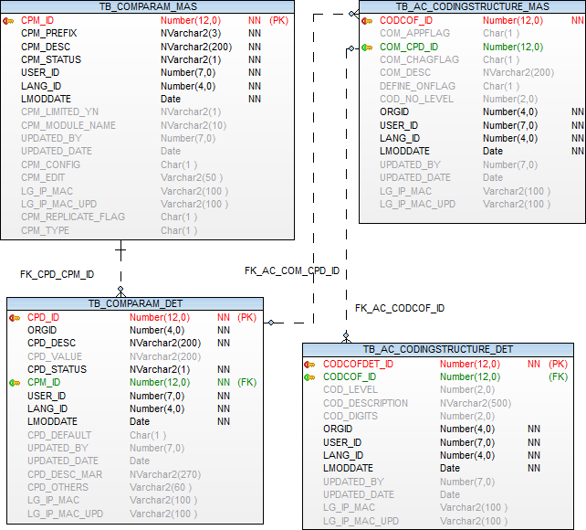

Funcation Master

Operations-→  Tables | Select | Insert | Edit | Delete
TB_AC_FUNCTION_MASTER | Y | Y | Y | N
TB_ORGANISATION | Y | N | N | N
TB_COMPARAM_MAS | Y | N | N | N
TB_COMPARAM_DET | Y | N | N | N
EMPLOYEE | Y | N | N | N
TB_AC_CODINGSTRUCTURE_MAS | Y | N | N | N
TB_AC_CODINGSTRUCTURE_DET | Y | N | N | N

TB_AC_FUNCTION_MASTER

Purpose: - Table is used to store Function Information in Hierarchical format (self join between FUNCTION_ID and FUNCTION_PARENT_ID),
Function code define on state level.

Name | Type | Nullable | Default | Comments
FUNCTION_ID | NUMBER(12) |  |  | Primary Key
CODCOFDET_ID | NUMBER(12) | Y |  | PK TB_AC_CODINGSTRUCTURE_DET
FUNCTION_CODE | VARCHAR2(10) | Y |  | FUNCTION Code
FUNCTION_DESC | NVARCHAR2(500) | Y |  | FUNCTION Description
FUNCTION_PARENT_ID | NUMBER(12) | Y |  | PARENT_ID from FUNCTION_id
FUNCTION_COMPCODE | VARCHAR2(20) | Y |  | FUNCTION Composite Code
ORGID | NUMBER(4) |  |  | Organization id
USER_ID | NUMBER(7) |  |  | User id
LANG_ID | NUMBER(4) |  |  | Language id
LMODDATE | DATE |  |  | Entry Date
UPDATED_BY | NUMBER(7) | Y |  | Updated by
UPDATED_DATE | DATE | Y |  | Updated Date
LG_IP_MAC | VARCHAR2(100) | Y |  | Client Machine¿s Login Name | IP Address | Physical Address
LG_IP_MAC_UPD | VARCHAR2(100) | Y |  | Updated Client Machine¿s Login Name | IP Address | Physical Address
FUNCTION_STATUS_CPD_ID | NUMBER(12) | Y |  | Status, active, inactive, Prefix ACN

Index (es):-

Index Name | Table Name | Field Name | Index Type
PK_AC_FUNCTION_ID | TB_AC_FUNCTION_MASTER | FUNCTION_ID | UNIQUE

Other Information:-

Key | Name | Field Name | Reference Table | Reference Field
Primary | PK_AC_FUNCTION_ID | FUNCTION_ID
Foreign | FK_AC_FUNCTION_MASTCODFDET_ID | CODCOFDET_ID | TB_AC_CODINGSTRUCTURE_DET | CODCOFDET_ID
Foreign | FK_FUNCTION_STATUS_CPD_ID | FUNCTION_STATUS_CPD_ID | TB_COMPARAM_DET | CPD_ID

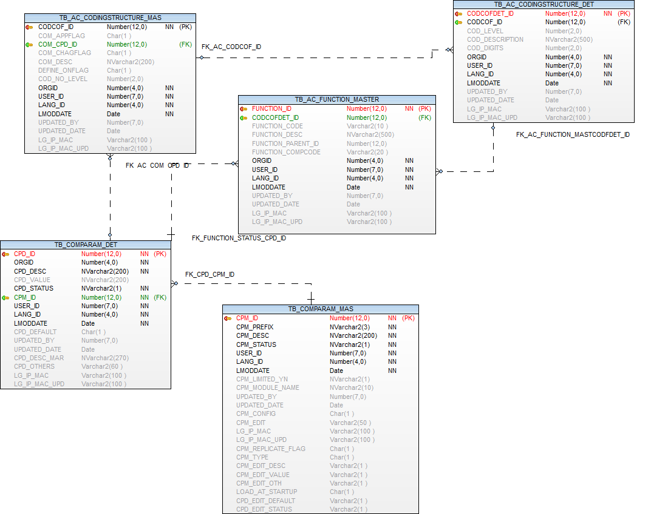

Fund Master

Operations-→  Tables | Select | Insert | Edit | Delete
TB_AC_FUND_MASTER | Y | Y | Y | N
TB_ORGANISATION | Y | N | N | N
TB_COMPARAM_MAS | Y | N | N | N
TB_COMPARAM_DET | Y | N | N | N
EMPLOYEE | Y | N | N | N
TB_AC_CODINGSTRUCTURE_MAS | Y | N | N | N
TB_AC_CODINGSTRUCTURE_DET | Y | N | N | N

TB_AC_FUND_MASTER

Purpose: - Table is used to store Fund Information in Hierarchical format (self join between FUND_ID and FUND_PARENT_ID),
Fund code define on state level.
Name | Type | Nullable | Default | Comments
FUND_ID | NUMBER(12) |  |  | Primary Key
CODCOFDET_ID | NUMBER(12) | Y |  | PK TB_AC_CODINGSTRUCTURE_DET
FUND_CODE | VARCHAR2(10) | Y |  | Fund Code
FUND_DESC | NVARCHAR2(500) | Y |  | Fund Description
FUND_COMPOSITECODE | VARCHAR2(20) | Y
FUND_PARENT_ID | NUMBER(12) | Y |  | PARENT_ID from FUND_ID
ORGID | NUMBER(4) |  |  | Organization id
USER_ID | NUMBER(7) |  |  | User id
LANG_ID | NUMBER(4) |  |  | Language id
LMODDATE | DATE |  |  | Entry Date
UPDATED_BY | NUMBER(7) | Y |  | Updated by
UPDATED_DATE | DATE | Y |  | Updated Date
LG_IP_MAC | VARCHAR2(100) | Y |  | Client Machine¿s Login Name | IP Address | Physical Address
LG_IP_MAC_UPD | VARCHAR2(100) | Y |  | Updated Client Machine¿s Login Name | IP Address | Physical Address
FUND_STATUS_CPD_ID | NUMBER(12) | Y |  | Status, active, inactive, Prefix ACN

Index (es):-

Index Name | Table Name | Field Name | Index Type
PK_AC_FUND_ID | TB_AC_FUND_MASTER | FUND_ID | UNIQUE

Other Information:-

Key | Name | Field Name | Reference Table | Reference Field
Primary | PK_AC_FUND_ID | FUND_ID
Foreign | FK_AC_FUND_MASTERCODCOFDET_ID | CODCOFDET_ID | CODCOFDET_ID | TB_AC_CODINGSTRUCTURE_DET
Foreign | FK_FUND_STATUS_CPD_ID | FUND_STATUS_CPD_ID | CPD_ID | TB_COMPARAM_DET

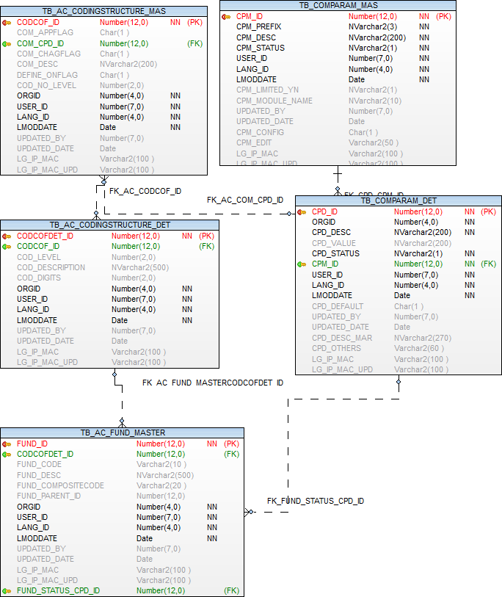

Field Master

Operations-→  Tables | Select | Insert | Edit | Delete
TB_AC_FIELD_MASTER | Y | Y | Y | N
TB_ORGANISATION | Y | N | N | N
TB_COMPARAM_MAS | Y | N | N | N
TB_COMPARAM_DET | Y | N | N | N
EMPLOYEE | Y | N | N | N
TB_AC_CODINGSTRUCTURE_MAS | Y | N | N | N
TB_AC_CODINGSTRUCTURE_DET | Y | N | N | N

TB_AC_FIELD_MASTER

Purpose: - Table is used to store Field Information in Hierarchical format (self join between FIELD_ID and FIELD_PARENT_ID)

Name | Type | Nullable | Default | Comments
FIELD_ID | NUMBER(12) |  |  | Primary Key
CODCOFDET_ID | NUMBER(12) | Y |  | PK TB_AC_CODINGSTRUCTURE_DET
FIELD_CODE | VARCHAR2(10) | Y |  | FIELD Code
FIELD_DESC | NVARCHAR2(500) | Y |  | FIELD Description
FIELD_PARENT_ID | NUMBER(12) | Y |  | PARENT_ID from FIELD_id
FIELD_COMPCODE | VARCHAR2(20) | Y |  | Field Composite Code
ORGID | NUMBER(4) |  |  | Organization id
USER_ID | NUMBER(7) |  |  | User id
LANG_ID | NUMBER(4) |  |  | Language id
LMODDATE | DATE |  |  | Entry Date
UPDATED_BY | NUMBER(7) | Y |  | Updated by
UPDATED_DATE | DATE | Y |  | Updated Date
LG_IP_MAC | VARCHAR2(100) | Y |  | Client Machine¿s Login Name | IP Address | Physical Address
LG_IP_MAC_UPD | VARCHAR2(100) | Y |  | Updated Client Machine¿s Login Name | IP Address | Physical Address
SUP_FIELD_PARENT_ID | NUMBER(12) | Y
FIELD_STATUS_CPD_ID | NUMBER(12) | Y |  | Status, active, inactive, Prefix ACN

Index (es):-

Index Name | Table Name | Field Name | Index Type
PK_AC_FIELD_ID | TB_AC_FIELD_MASTER | FIELD_ID | UNIQUE

Other Information:-

Key | Name | Field Name | Reference Table | Reference Field
Primary | PK_AC_FIELD_ID | FIELD_ID
Foreign | FK_AC_FIELD_MASTCODFDET_ID | CODCOFDET_ID | CODCOFDET_ID | TB_AC_CODINGSTRUCTURE_DET
Foreign | FK_FIELD_STATUS_CPD_ID | FIELD_STATUS_CPD_ID | CPD_ID | TB_COMPARAM_DET

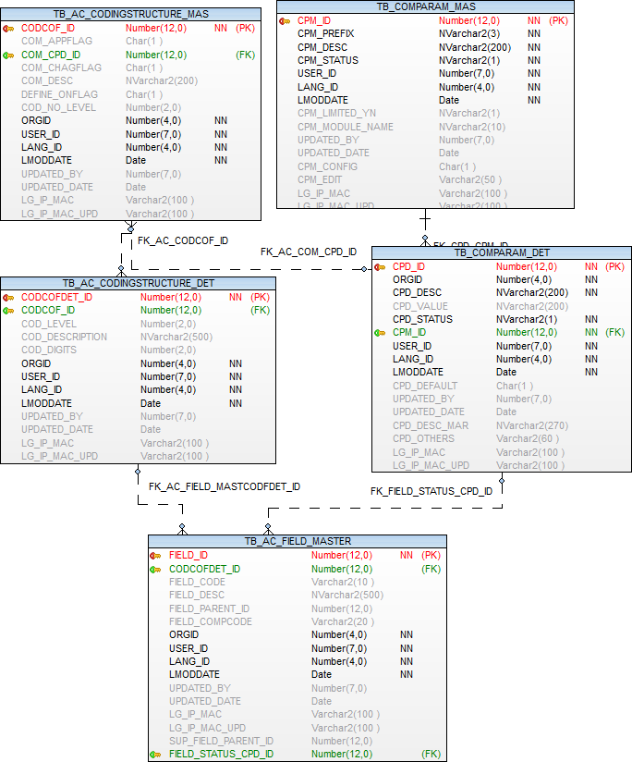

Account Head – Primary Account Code Master

Operations-→  Tables | Select | Insert | Edit | Delete
TB_AC_PRIMARYHEAD_MASTER | Y | Y | Y | N
TB_ORGANISATION | Y | N | N | N
TB_COMPARAM_MAS | Y | N | N | N
TB_COMPARAM_DET | Y | N | N | N
EMPLOYEE | Y | N | N | N
TB_AC_CODINGSTRUCTURE_MAS | Y | N | N | N
TB_AC_CODINGSTRUCTURE_DET | Y | N | N | N

Prefixes used:
Prefix | Description | Remarks/use
COA | Account Head Types
  Description | Value | Other Value
  Income | I | 1
  Expense | E | 2
  Liability | L | 3
  Asset | A | 4

TB_AC_PRIMARYHEAD_MASTER

Purpose: - Table is used to store Primary Head code(Object code) Information in Hierarchical format (self join between PAC_HEAD_ID and PAC_HEAD_PARENT_ID),
Primary head codes define on state level.

Name | Type | Nullable | Default | Comments
PAC_HEAD_ID | NUMBER(12) |  |  | Primary Key
CODCOFDET_ID | NUMBER(12) | Y |  | PK TB_AC_CODINGSTRUCTURE_DET
PAC_HEAD_CODE | VARCHAR2(10) | Y |  | PRIMARY ACCOUNT Code
PAC_HEAD_DESC | NVARCHAR2(500) | Y |  | PRIMARY ACCOUNT Description
PAC_HEAD_PARENT_ID | NUMBER(12) | Y |  | PARENT_ID from pac_head_id
PAC_HEAD_COMPO_CODE | VARCHAR2(20) | Y |  | Composite Code
ORGID | NUMBER(4) |  |  | Organization id
USER_ID | NUMBER(7) |  |  | User id
LANG_ID | NUMBER(4) |  |  | Language id
LMODDATE | DATE |  |  | Entry Date
UPDATED_BY | NUMBER(7) | Y |  | Updated by
UPDATED_DATE | DATE | Y |  | Updated Date
LG_IP_MAC | VARCHAR2(100) | Y |  | Client Machine¿s Login Name | IP Address | Physical Address
LG_IP_MAC_UPD | VARCHAR2(100) | Y |  | Updated Client Machine¿s Login Name | IP Address | Physical Address
CPD_ID_ACHEADTYPES | NUMBER(12) | Y |  | fk ref. tb_comparam_det Prefix – COA
PAC_STATUS_CPD_ID | NUMBER(12) | Y |  | Status, active, inactive, Prefix can
CPD_ID_ACCOUNT_TYPE | NUMBER(12) | Y |  | Prefix SAM
CPD_ID_PAYMODE | NUMBER(12) | Y |  | Prefix PAY
SECONDARYHEAD_SUBLEDGER_FLAG | CHAR(1) | Y |  | Group behaves like a sub- ledger
CPD_ID_BANK_TYPE | NUMBER(12) |  |  | Prefix BAT

Index (es):-

Index Name | Table Name | Field Name | Index Type
PK_AC_PAC_HEAD | TB_AC_PRIMARYHEAD_MASTER | PAC_HEAD_ID | UNIQUE

Other Information:-

Key | Name | Field Name | Reference Table | Reference Field
Primary | PK_AC_PAC_HEAD | PAC_HEAD_ID
Foreign | FK_AC_PRIMARYHEADCODFDET_ID | CODCOFDET_ID | CODCOFDET_ID | TB_AC_CODINGSTRUCTURE_DET
Foreign | FK_AC_PRIMHPAC_STATUS_CPD_ID | FIELD_STATUS_CPD_ID | CPD_ID | TB_COMPARAM_DET

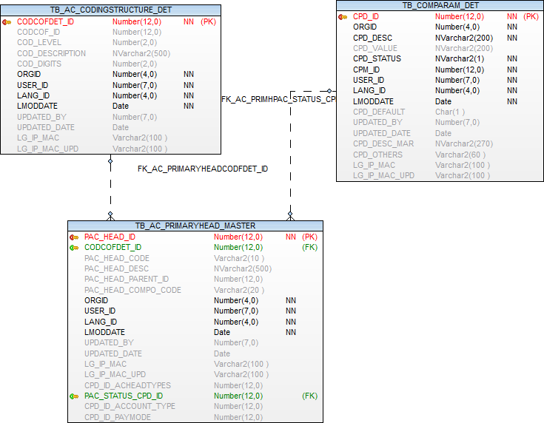

Account Head –Secondary Account Code Master

Operations-→  Tables | Select | Insert | Edit | Delete
TB_AC_SECONDARYHEAD_MASTER | Y | Y | Y | N
TB_ORGANISATION | Y | N | N | N
TB_COMPARAM_MAS | Y | N | N | N
TB_COMPARAM_DET | Y | N | N | N
EMPLOYEE | Y | N | N | N
TB_AC_CODINGSTRUCTURE_MAS | Y | N | N | N
TB_AC_CODINGSTRUCTURE_DET | Y | N | N | N
TB_VENDORMASTER | Y | N | N | N
TB_BANK_ACCOUNT | Y | N | N | N

Prefixes used:
Prefix | Description | Remarks/use
FTY | DEAS - Function Type | Vendor  Bank  Others

TB_AC_SECONDARYHEAD_MASTER

Purpose: - This table stores all the master record of account heads involved in the accounting system.

Name | Type | Nullable | Default | Comments
SAC_HEAD_ID | NUMBER(12) |  |  | Primary Key
CODCOFDET_ID | NUMBER(12) | Y |  | FK TB_AC_CODINGSTRUCTURE_DET
PAC_HEAD_ID | NUMBER(12) | Y |  | FK TB_AC_PRIMARYHEAD_MASTER
SAC_LEDDGER_TYPE_CPD_ID | NUMBER(12) | Y |  | CPD_id Ledger type Bank/Vendor/other Prefix- FTY
SAC_SUB_LEDDGER_TYPE_CPD_ID | NUMBER(12) | Y |  | CPD_id Ledger type - SubLedger type for other
VM_VENDORID | NUMBER(12) | Y |  | FK TB_AC_VENDORMASTER
BA_ACCOUNTID | NUMBER(12) | Y |  | FK TB_BANK_ACCOUNT
SAC_HEAD_CODE | VARCHAR2(10) | Y |  | SECONDARY ACCOUNT Code
SAC_HEAD_DESC | NVARCHAR2(500) | Y |  | SECONDARY ACCOUNT Description
ORGID | NUMBER(4) |  |  | Organization id
USER_ID | NUMBER(7) |  |  | User id
LANG_ID | NUMBER(4) |  |  | Language id
LMODDATE | DATE |  |  | Entry Date
UPDATED_BY | NUMBER(7) | Y |  | Updated by
UPDATED_DATE | DATE | Y |  | Updated Date
LG_IP_MAC | VARCHAR2(100) | Y |  | Client Machine?s Login Name | IP Address | Physical Address
LG_IP_MAC_UPD | VARCHAR2(100) | Y |  | Updated Client Machine?s Login Name | IP Address | Physical Address
FI04_N1 | NUMBER(15) | Y |  | Additional number FI04_N1 to be used in future
FI04_V1 | NVARCHAR2(100) | Y |  | Additional nvarchar2 FI04_V1 to be used in future
FI04_D1 | DATE | Y |  | Additional Date FI04_D1 to be used in future
FI04_LO1 | CHAR(1) | Y |  | Additional Logical field FI04_LO1 to be used in future
STATUS_CPD_ID | NUMBER(12) | Y |  | status cpd_id Prefix "ACN"
OLD_ALIAS_LEDGER_CODE | NVARCHAR2(50) | Y |  | User to enter old alias ledger code

Index (es):-

Index Name | Table Name | Field Name | Index Type
PK_AC_SAC_HEAD_ID | TB_AC_SECONDARYHEAD_MASTER | SAC_HEAD_ID | UNIQUE

Other Information:-

Key | Name | Field Name | Reference Table | Reference Field
Primary | PK_AC_SAC_HEAD_ID | SAC_HEAD_ID
Foreign | FK_AC_BANKACCOUNT_ID | BA_ACCOUNTID | TB_BANK_ACCOUNT | BA_ACCOUNTID
Foreign | FK_AC_PAC_HEAD_ID_SE | PAC_HEAD_ID | TB_AC_PRIMARYHEAD_MASTER | PAC_HEAD_ID
Foreign | FK_AC_SECONDARYHEADMASTER_ID | CODCOFDET_ID | TB_AC_CODINGSTRUCTURE_DET | CODCOFDET_ID
Foreign | FK_AC_VENDORID | VM_VENDORID | TB_VENDORMASTER | VM_VENDORID

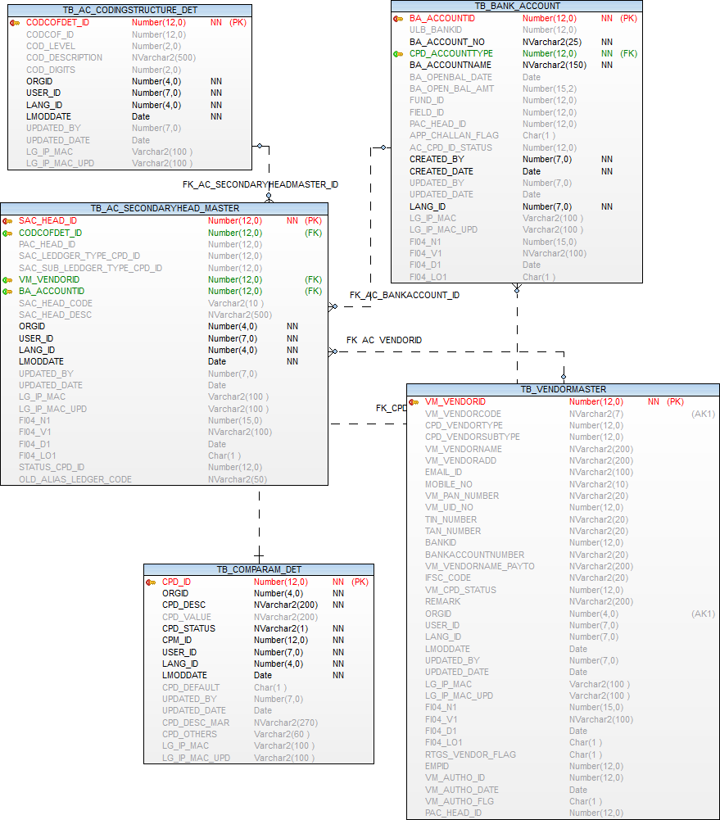

Account Budget Code

Operations-→  Tables | Select | Insert | Edit | Delete
TB_AC_BUDGETCODE_MAS | Y | Y | Y | N
TB_AC_FUNCTION_MASTER | Y | N | N | N
TB_AC_FUND_MASTER | Y | N | N | N
TB_AC_PRIMARYHEAD_MASTER | Y | N | N | N
TB_AC_SECONDARYHEAD_MASTER | Y | N | N | N
TB_ORGANISATION | Y | N | N | N
EMPLOYEE | Y | N | N | N
TB_DEPARTMENT | Y | N | N | N
TB_COMPARAM_MAS | Y | N | N | N
TB_COMPARAM_DET | Y | N | N | N

Prefixes used:
Prefix | Description | Remarks/use
REX | Budget Type | Receipt  Expenditure
FTP | Fund Type | Revenue  Capital

TB_AC_BUDGETCODE_MAS

Purpose: - Table is used to store budget code

Name | Type | Nullable | Default | Comments
BUDGETCODE_ID | NUMBER(12) |  |  | Primary Key
CPD_ID_BUDGET_TYPE | NUMBER(12) | Y |  | PREFIX 'REX'
CPD_ID_BUDGET_SUBTYPE | NUMBER(12) | Y |  | PREFIX 'FTP'
FUND_ID | NUMBER(12) | Y |  | Fund Master Reference key --TB_AC_FUND_MASTER
FIELD_ID | NUMBER(12) | Y |  | Field Master Reference key --TB_AC_FIELD_MASTER
FUNCTION_ID | NUMBER(12) | Y |  | Function Master Reference key --TB_AC_FUNCTION_MASTER
SAC_HEAD_ID | NUMBER(12) | Y |  | Secondary Master Reference key -- tb_ac_secondaryhead_master
DP_DEPTID | NUMBER(12) | Y |  | fk - TB_DEPARTMENT
BUDGET_CODE | NVARCHAR2(500) | Y |  | Budget Description
CPD_ID_STATUS_FLG | NUMBER(12) |  |  | Prefix - 'ACN'
ORGID | NUMBER(4) |  |  | Organisation id
CREATED_BY | NUMBER(12) | Y |  | User Identity
LANG_ID | NUMBER(7) | Y |  | Language Identity
CREATED_DATE | DATE | Y |  | Last Modification Date
UPDATED_BY | NUMBER(12) | Y |  | User id who update the data
UPDATED_DATE | DATE | Y |  | Date on which data is going to update
LG_IP_MAC | VARCHAR2(100) | Y |  | Client Machine?s Login Name | IP Address | Physical Address
LG_IP_MAC_UPD | VARCHAR2(100) | Y |  | Updated Client Machine?s Login Name | IP Address | Physical Address
FI04_N1 | NUMBER(15) | Y |  | Additional number FI04_N1 to be used in future
FI04_V1 | NVARCHAR2(100) | Y |  | Additional nvarchar2 FI04_V1 to be used in future
FI04_D1 | DATE | Y |  | Additional Date FI04_D1 to be used in future
FI04_LO1 | CHAR(1) | Y |  | Additional Logical field FI04_LO1 to be used in future

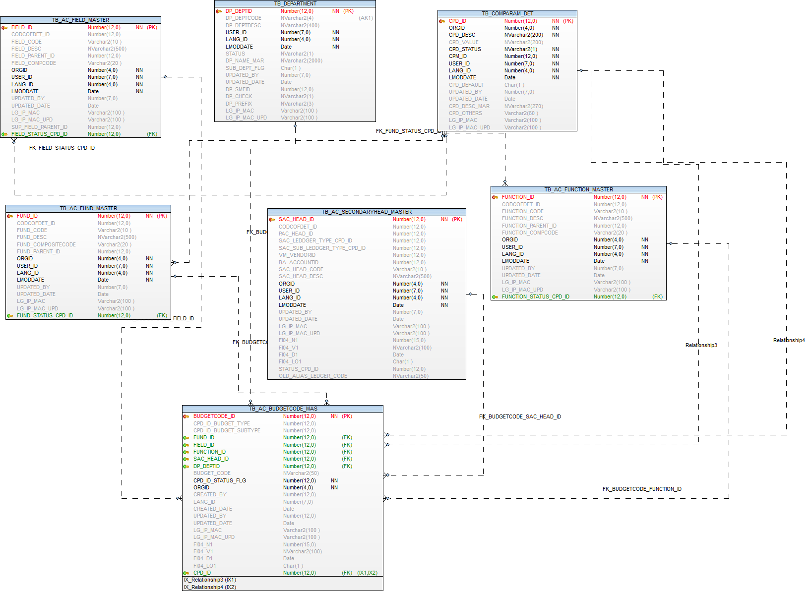

Cheque Book Leaf Master

Operations-→  Tables | Select | Insert | Edit | Delete
TB_AC_CHEQUEBOOKLEAF_MAS | Y | Y | Y | N
TB_AC_CHEQUEBOOKLEAF_DET | Y | Y | Y | N
TB_ORGANISATION | Y | N | N | N
TB_COMPARAM_MAS | Y | N | N | N
TB_COMPARAM_DET | Y | N | N | N
EMPLOYEE | Y | N | N | N
TB_BANK_ACCOUNT | Y | N | N | N
TB_ULB_BANK | Y | N | N | N

Prefixes used:
Prefix | Description | Remarks/use
CLR | Cheque Book Utilization | Cleared  Cancelled  Issued  Not Issued

TB_AC_CHEQUEBOOKLEAF_MAS

Purpose: - Table is used to store Cheque details and bank details.

Name | Type | Nullable | Default | Comments
CHEQUEBOOK_ID | NUMBER(12) |  |  | Generated checkbook id (primary key)
ULB_BANKID | NUMBER(12) | Y |  | Bank Id (Fk TB_ULB_BANK )
BA_ACCOUNTID | NUMBER(12) | Y |  | Account Id (Fk TB_BANK_ACCOUNT)
FROM_CHEQUE_NO | VARCHAR2(12) |  |  | From Cheque No.
TO_CHEQUE_NO | VARCHAR2(12) |  |  | To Cheque No.
EMPID | NUMBER(12) | Y |  | Emp Id (Fk employee)
CHECKBOOK_LEAVE | NUMBER(12) |  |  | No. of leaves in checkbook
RCPT_CHQBOOK_DATE | DATE | Y |  | Cheque book received date
ISSUER_EMPID | NUMBER(12) | Y |  | Issued Employee name Emp Id (Fk employee)
CHKBOOK_RTN_DATE | DATE | Y |  | Return date
CHECK_BOOK_RETURN | CHAR(1) | Y |  | Return Flag
ORGID | NUMBER(4) |  |  | Organization Id
USER_ID | NUMBER(7) |  |  | User Identity
LANG_ID | NUMBER(7) |  |  | Language Identity
LMODDATE | DATE |  |  | Last Modification Date
UPDATED_BY | NUMBER(7) | Y |  | User id who update the data
UPDATED_DATE | DATE | Y |  | Date on which data is going to update
LG_IP_MAC | VARCHAR2(100) | Y |  | Client Machine¿s Login Name | IP Address | Physical Address
LG_IP_MAC_UPD | VARCHAR2(100) | Y |  | Updated Client Machine¿s Login Name | IP Address | Physical Address
FI04_N1 | NUMBER(15) | Y |  | Additional number FI04_N1 to be used in future
FI04_V1 | NVARCHAR2(100) | Y |  | Additional nvarchar2 FI04_V1 to be used in future
FI04_D1 | DATE | Y |  | Additional Date FI04_D1 to be used in future
FI04_LO1 | CHAR(1) | Y |  | Additional Logical field FI04_LO1 to be used in future

Index (es):-

Index Name | Table Name | Field Name | Index Type
PK_CHEQUEBOOK_ID | TB_AC_CHEQUEBOOKLEAF_MAS | CHEQUEBOOK_ID | UNIQUE

Other Information:-

Key | Name | Field Name | Reference Table | Reference Field
Primary | PK_CHEQUEBOOK_ID | CHEQUEBOOK_ID
Foreign | FK_BANK_ID | ULB_BANKID | TB_ULB_BANK | ULB_BANKID
Foreign | FK_BA_ACCOUNTID_BANK | BA_ACCOUNTID | TB_BANK_ACCOUNT | BA_ACCOUNTID

TB_AC_CHEQUEBOOKLEAF_DET

Purpose: - Table is used to store Cheque Book Details.

Name | Type | Nullable | Default | Comments
CHEQUEBOOK_DETID | NUMBER(12) |  |  | Generated checkbook id (primary key)
CHEQUEBOOK_ID | NUMBER(12) | Y |  | Checkbook Id(Fk)
CHEQUE_NO | VARCHAR2(12) |  |  | Cheque No
CPD_IDSTATUS | NUMBER(12) | Y |  | Cpd_idstatus (Fk -TB_COMPARAM_DET )
VH_VOUCHERID | NUMBER(12) | Y |  | Voucher Id (Fk)
REMARK | VARCHAR2(500) | Y |  | Remark
STOP_PAY_FLAG | CHAR(1) | Y |  | Stop Payment Order as per MNAM
STOP_PAY_REMARK | VARCHAR2(500) | Y |  | Stop Payment Remark
STOPPAY_DATE | DATE | Y |  | Stop Payment Date
ORGID | NUMBER(4) |  |  | Organization Id
USER_ID | NUMBER(7) |  |  | User Identity
LANG_ID | NUMBER(7) |  |  | Language Identity
LMODDATE | DATE |  |  | Last Modification Date
UPDATED_BY | NUMBER(7) | Y |  | User id who update the data
UPDATED_DATE | DATE | Y |  | Last Modification Date
LG_IP_MAC | VARCHAR2(100) | Y |  | Client Machine¿s Login Name | IP Address | Physical Address
LG_IP_MAC_UPD | VARCHAR2(100) | Y |  | Updated Client Machine¿s Login Name | IP Address | Physical Address
FI04_N1 | NUMBER(15) | Y |  | Additional number FI04_N1 to be used in future
FI04_V1 | NVARCHAR2(100) | Y |  | Additional nvarchar2 FI04_V1 to be used in future
FI04_D1 | DATE | Y |  | Additional Date FI04_D1 to be used in future
FI04_LO1 | CHAR(1) | Y |  | Additional Logical field FI04_LO1 to be used in future

Index (es):-

Index Name | Table Name | Field Name | Index Type
PK_CHEQUEBOOK_DET | TB_AC_CHEQUEBOOKLEAF_DET | CHEQUEBOOK_DETID | Unique

Other Information:-

Key | Name | Field Name | Reference Table | Reference Field
Primary | PK_CHEQUEBOOK_DET | CHEQUEBOOK_DETID
Foreign | TB_AC_CHEQUEBOOKLEAF_DET | CHEQUEBOOK_ID | TB_AC_CHEQUEBOOKLEAF_MAS | CHEQUEBOOK_ID

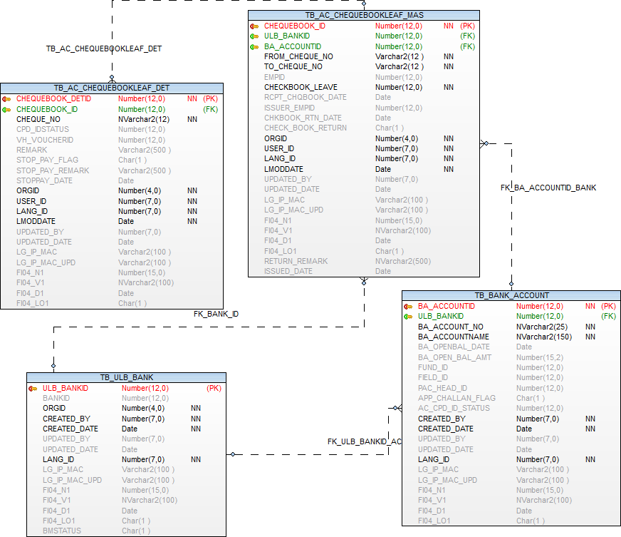

Bank Master, Bank Ulb Mapping and Bank account entry

Operations-→  Tables | Select | Insert | Edit | Delete
TB_BANK_MASTER | Y | N | N | N
TB_ULB_BANK | Y | Y | Y | N
TB_BANK_ACCOUNT | Y | Y | Y | N

Prefixes used:
Prefix | Description | Remarks/use
BAS | Bank Account Status | This Prefix is used for Bank Master Entry form - Account Status.
BAT | Bank Type | This Prefix is used for Bank Type  Nationalized Bank  Other Schedule Bank  Schedule Cooperative Bank
ACT | Bank Account Type | This Prefix is used for bank account type  Current,Saving,Fixed,Recurring
FTP | Fund type | Fund Type  Revenue  Capital

TB_BANK_MASTER

Purpose: - Table is used to store Bank details.

Name | Type | Nullable | Default | Comments
BANKID | NUMBER(12) |  |  | Primary Key
BANK | NVARCHAR2(500) | Y |  | Bank Name
IFSC | NVARCHAR2(11) | Y |  | IFSC Code
MICR | NVARCHAR2(9) | Y |  | MICR Code
BRANCH | NVARCHAR2(200) | Y |  | Bank Branch Name
ADDRESS | NVARCHAR2(1000) | Y |  | Bank Branch Address
CONTACT | NVARCHAR2(200) | Y |  | Bank Branch Contact, Mobile number, Email Id
CITY | NVARCHAR2(100) | Y |  | Bank Branch City
DISTRICT | NVARCHAR2(100) | Y |  | Bank Branch District
STATE | NVARCHAR2(100) | Y |  | Bank Branch State
CREATED_BY | NUMBER(7) |  |  | Created User Identity
CREATED_DATE | DATE |  |  | Created Date
UPDATED_BY | NUMBER(7) | Y |  | User id who update the data
UPDATED_DATE | DATE | Y |  | Date on which data is going to update
LANG_ID | NUMBER(7) |  |  | Language Identity
LG_IP_MAC | VARCHAR2(100) | Y |  | Client Machine is Login Name | IP Address | Physical Address
LG_IP_MAC_UPD | VARCHAR2(100) | Y |  | Updated Client Machine is Login Name | IP Address | Physical Address
FI04_N1 | NUMBER(15) | Y |  | Additional number FI04_N1 to be used in future
FI04_V1 | NVARCHAR2(100) | Y |  | Additional nvarchar2 FI04_V1 to be used in future
FI04_D1 | DATE | Y |  | Additional Date FI04_D1 to be used in future
FI04_LO1 | CHAR(1) | Y |  | Additional Logical field FI04_LO1 to be used in future

Index (es):-

Index Name | Table Name | Field Name | Index Type
PK_BANKCB_BANKID | TB_BANK_MASTER | BANKID | Unique

Other Information:-

Key | Name | Field Name | Reference Table | Reference Field
Primary | PK_BANKCB_BANKID | BANKID

TB_ULB_BANK

Purpose: - Table is used to store ULB Mapping and Bank master

Name | Type | Nullable | Default | Comments
ULB_BANKID | NUMBER(12) |  |  | Primary Key
BANKID | NUMBER(12) | Y |  | fk- TB_BANK_MASTER Code of the bank in which account exists coming from ulb Bank Master
ORGID | NUMBER(4) |  |  | Organization Id
CREATED_BY | NUMBER(7) |  |  | Created User Identity
CREATED_DATE | DATE |  |  | Created Date
UPDATED_BY | NUMBER(7) | Y |  | User id who update the data
UPDATED_DATE | DATE | Y |  | Date on which data is going to update
LANG_ID | NUMBER(7) |  |  | Language Identity
LG_IP_MAC | VARCHAR2(100) | Y |  | Client Machine is Login Name | IP Address | Physical Address
LG_IP_MAC_UPD | VARCHAR2(100) | Y |  | Updated Client Machine is Login Name | IP Address | Physical Address
FI04_N1 | NUMBER(15) | Y |  | Additional number FI04_N1 to be used in future
FI04_V1 | NVARCHAR2(100) | Y |  | Additional nvarchar2 FI04_V1 to be used in future
FI04_D1 | DATE | Y |  | Additional Date FI04_D1 to be used in future
FI04_LO1 | CHAR(1) | Y |  | Additional Logical field FI04_LO1 to be used in future
cpd_id_banktype | NUMBER(12) | Y |  | Bank type ref table tb_comparam_det

Index (es):-

Index Name | Table Name | Field Name | Index Type
PK_ULB_BANKID | TB_ULB_BANK | ULB_BANKID | Unique

Other Information:-

Key | Name | Field Name | Reference Table | Reference Field
Primary | PK_ULB_BANKID | ULB_BANKID
Foreign | FK_BANKID | BANKID | TB_BANK_MASTER | BANKID
Foreign | FK_ORGID_BANK | ORGID | TB_ORGANISATION | ORGID

TB_BANK_ACCOUNT

Purpose: - Table is used to store Ulb wise bank accounts details

Name | Type | Nullable | Default | Comments
BA_ACCOUNTID | NUMBER(12) |  |  | Primary Key
ULB_BANKID | NUMBER(12) | Y |  | fk- TB_BANK_MASTER Code of the bank in which account exists coming from ulb Bank Master
BA_ACCOUNT_NO | NVARCHAR2(25) |  |  | Bank Account number
CPD_ACCOUNTTYPE | NUMBER(12) |  |  | Type of account with each Bank C-Current,R-Recurring,S-Saving,F-Fixed
BA_ACCOUNTNAME | NVARCHAR2(150) |  |  | Bank Account Holder Name
BA_OPENBAL_DATE | DATE | Y |  | Opending Balance Date
BA_OPEN_BAL_AMT | NUMBER(15,2) | Y |  | Opending Balance amount
FUND_ID | NUMBER(12) | Y |  | Fund Master Reference key --TB_AC_FUND_MASTER
FIELD_ID | NUMBER(12) | Y |  | Field Master Reference key --TB_AC_FIELD_MASTER
PAC_HEAD_ID | NUMBER(12) | Y |  | Secondary Master Reference key -- tb_ac_secondaryhead_master
APP_CHALLAN_FLAG | CHAR(1) | Y |  | bank for challan
AC_CPD_ID_STATUS | NUMBER(12) | Y |  | Bank account status
CREATED_BY | NUMBER(7) |  |  | Created User Identity
CREATED_DATE | DATE |  |  | Created Date
UPDATED_BY | NUMBER(7) | Y |  | User id who update the data
UPDATED_DATE | DATE | Y |  | Date on which data is going to update
LANG_ID | NUMBER(7) |  |  | Language Identity
LG_IP_MAC | VARCHAR2(100) | Y |  | Client Machine is Login Name | IP Address | Physical Address
LG_IP_MAC_UPD | VARCHAR2(100) | Y |  | Updated Client Machine is Login Name | IP Address | Physical Address
FI04_N1 | NUMBER(15) | Y |  | Additional number FI04_N1 to be used in future
FI04_V1 | NVARCHAR2(100) | Y |  | Additional nvarchar2 FI04_V1 to be used in future
FI04_D1 | DATE | Y |  | Additional Date FI04_D1 to be used in future
FI04_LO1 | CHAR(1) | Y |  | Additional Logical field FI04_LO1 to be used in future

Index (es):-

Index Name | Table Name | Field Name | Index Type
PK_BANKBA_ACCOUNTID | TB_BANK_ACCOUNT | BA_ACCOUNTID | Unique

Other Information:-

Key | Name | Field Name | Reference Table | Reference Field
Primary | PK_BANKBA_ACCOUNTID | BA_ACCOUNTID
Foreign | FK_CPD_ACCOUNTTYPE | CPD_ACCOUNTTYPE | TB_COMPARAM_DET | CPD_ID
Foreign | FK_FIELD_ID_BANKAC | FIELD_ID | TB_AC_FIELD_MASTER | FIELD_ID
Foreign | FK_FUND_ID_BANKAC | FUND_ID | TB_AC_FUND_MASTER | FUND_ID
Foreign | FK_PAC_HEAD_ID_BANKAC | PAC_HEAD_ID | TB_AC_PRIMARYHEAD_MASTER | PAC_HEAD_ID
Foreign | FK_ULB_BANKID_ACCOUNT | ULB_BANKID | TB_ULB_BANK | ULB_BANKID

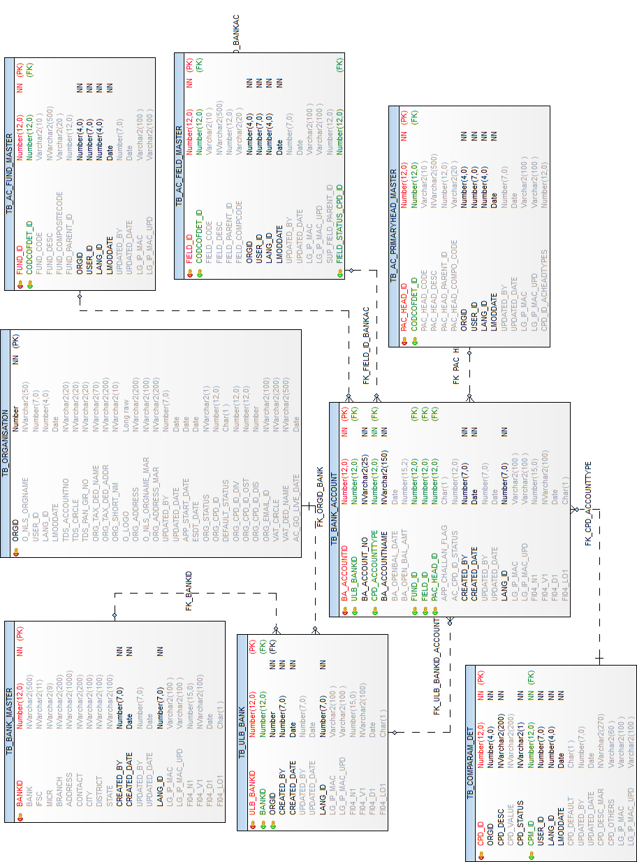

Vendor Master

Operations-→  Tables | Select | Insert | Edit | Delete
TB_VENDORMASTER | Y | Y | Y | N
TB_ORGANISATION | Y | N | N | N
TB_COMPARAM_MAS | Y | N | N | N
TB_COMPARAM_DET | Y | N | N | N
EMPLOYEE | Y | N | N | N
TB_BANK_MASTER | Y | N | N | N
TB_AC_PRIMARYHEAD_MASTER | Y | N | N | N
TB_AC_SECONDARYHEAD_MASTER | Y | N | N | N

Prefixes used:
Prefix | Description | Remarks/use
VNT | Vendor Type | Vendor type
VST | Vendor Status | Vendor Sub type
VSS | Vendor Status | Active / Inactive / Blacklist

TB_VENDORMASTER

Purpose: - This table stores all the details of the vendors.

Name | Type | Nullable | Default | Comments
VM_VENDORID | NUMBER(12) |  |  | Primary Key
VM_VENDORCODE | NVARCHAR2(7) | Y |  | Vendor code
CPD_VENDORTYPE | NUMBER(12) | Y |  | Vendor Type Id from common parameter master Prefix -VNT
CPD_VENDORSUBTYPE | NUMBER(12) | Y |  | Status -- Prefix -VST
VM_VENDORNAME | NVARCHAR2(200) | Y |  | Vendor Name
VM_VENDORADD | NVARCHAR2(200) | Y |  | Vendor Address
EMAIL_ID | NVARCHAR2(100) | Y |  | E mail Id
MOBILE_NO | NVARCHAR2(10) | Y |  | Mobile number
VM_PAN_NUMBER | NVARCHAR2(20) | Y |  | Pan Number
VM_UID_NO | NUMBER(12) | Y |  | Holds Adhar number of Vendor
TIN_NUMBER | NVARCHAR2(20) | Y |  | Tin Number
TAN_NUMBER | NVARCHAR2(20) | Y |  | Tan Number
BANKID | NUMBER(12) | Y |  | TB_BANK_MASTER Reference key
BANKACCOUNTNUMBER | NVARCHAR2(20) | Y |  | Bank Account Number (Vendor)
VM_VENDORNAME_PAYTO | NVARCHAR2(200) | Y |  | Vendor name Pay To used for Payment Voucher (Cheque)
IFSC_CODE | NVARCHAR2(20) | Y |  | IFSC CODE
VM_CPD_STATUS | NUMBER(12) | Y |  | Status - active,dactive,hold
REMARK | NVARCHAR2(200) | Y |  | Remark
ORGID | NUMBER(4) | Y |  | Organization Id
USER_ID | NUMBER(7) | Y |  | User Identity
LANG_ID | NUMBER(7) | Y |  | Language Identity
LMODDATE | DATE | Y |  | Last Modification Date
UPDATED_BY | NUMBER(7) | Y |  | User id who update the data
UPDATED_DATE | DATE | Y |  | Date on which data is going to update
LG_IP_MAC | VARCHAR2(100) | Y |  | Client Machine Login Name | IP Address | Physical Address
LG_IP_MAC_UPD | VARCHAR2(100) | Y |  | Updated Client Machine Login Name | IP Address | Physical Address
FI04_N1 | NUMBER(15) | Y |  | Additional number FI04_N1 to be used in future
FI04_V1 | NVARCHAR2(100) | Y |  | Additional nvarchar2 FI04_V1 to be used in future
FI04_D1 | DATE | Y |  | Additional Date FI04_D1 to be used in future
FI04_LO1 | CHAR(1) | Y |  | Additional Logical field FI04_LO1 to be used in future
RTGS_VENDOR_FLAG | CHAR(1) | Y |  | RTGS Vendor Flag
EMPID | NUMBER(12) | Y |  | Emp Id (Fk employee)
VM_AUTHO_ID | NUMBER(12) | Y |  | Authoer Id
VM_AUTHO_DATE | DATE | Y |  | Sysdate
VM_AUTHO_FLG | CHAR(1) | Y |  | Auth Flag Y/N
PAC_HEAD_ID | NUMBER(12) | Y |  | FK TB_AC_PRIMARYHEAD_MASTER

Index (es):-

Index Name | Table Name | Field Name | Index Type
PK_VENDORMASTER_VENDORID | TB_VENDORMASTER | VM_VENDORID | Unique
UK_VENDORMASTER_VENDORORG | TB_VENDORMASTER | VM_VENDORCODE, ORGID | Unique

Other Information:-

Key | Name | Field Name | Reference Table | Reference Field
Primary | PK_VENDORMASTER_VENDORID | VM_VENDORID
Unique | UK_VENDORMASTER_VENDORORG | VM_VENDORCODE, ORGID
Foreign | FK_VENDORMASTER_BANKID | BANKID | TB_BANK_MASTER | BANKID
Foreign | FK_VENDOR_EMPLOYEE | EMPID | EMPLOYEE | EMPID
Foreign | FK_VENDRO_PAC_HEAD_ID | PAC_HEAD_ID | TB_AC_PRIMARYHEAD_MASTER | PAC_HEAD_ID

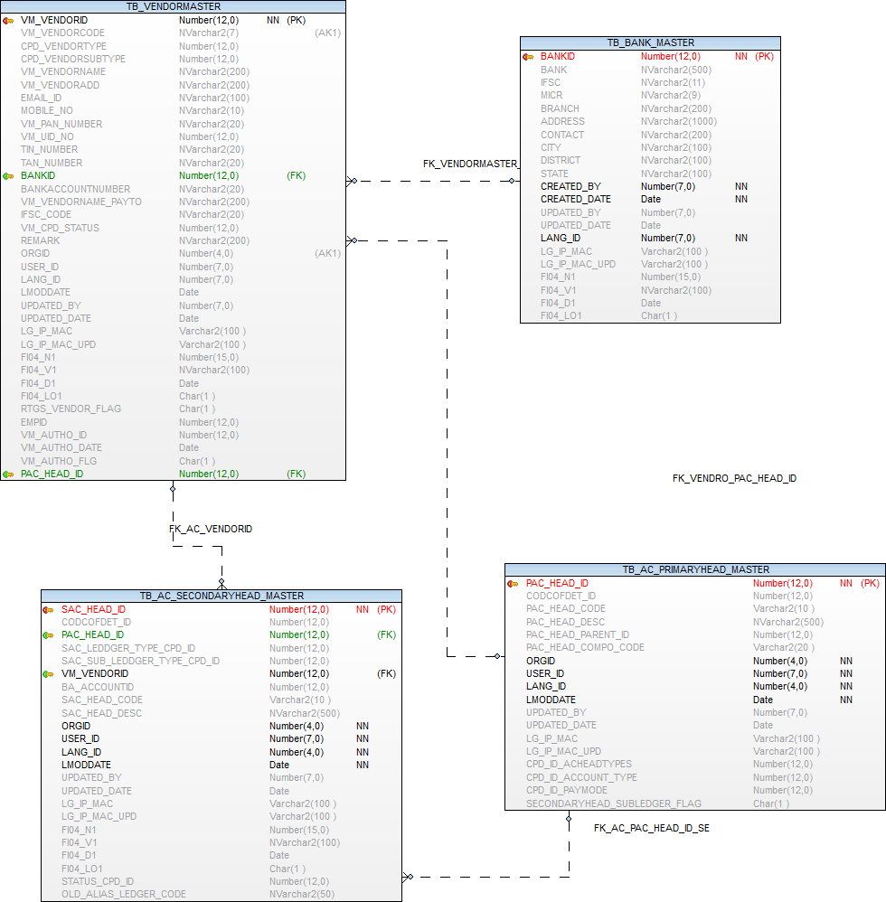

Statutory Deductions Mapping Entry

Operations-→  Tables | Select | Insert | Edit | Delete
TB_AC_TDS_TAXHEADS | Y | Y | Y | N
TB_ORGANISATION | Y | N | N | N
TB_COMPARAM_MAS | Y | N | N | N
TB_COMPARAM_DET | Y | N | N | N
EMPLOYEE | Y | N | N | N
TB_AC_BUDGETCODE_MAS | Y | N | N | N

Prefixes used:
Prefix | Description | Remarks/use
TDS | List of Tax Deductions | Tax deduction list for Income tax,  Surcharge etc

TB_AC_TDS_TAXHEADS

Purpose:- Table is used to store link between TDS Head and account Head

Name | Type | Nullable | Default | Comments
TDS_ID | NUMBER(12) |  |  | Primary Key
ORGID | NUMBER(4) |  |  | Organisation id
TDS_ENTRYDATE | DATE |  |  | Entry Date
BUDGETCODE_ID | NUMBER(12) |  |  | FK - tb_ac_budgetcode_mas
CPD_ID_DEDUCTION_TYPE | NUMBER(12) | Y |  | Comparam det Reference key -tb_comparam_det for deduction type , Income Tax , Surcharge Head etc.
TDS_DESCRIPTION | NVARCHAR2(100) | Y |  | Description of heads, purposely kept so that meaning full description can be given against heads, rather than heads description
TDS_STATUS_FLG | NVARCHAR2(1) |  |  | A- Active / I-Inactive
USER_ID | NUMBER(7) |  |  | User Identity
LANG_ID | NUMBER(7) |  |  | Language Identity
LMODDATE | DATE |  |  | Last Modification Date
UPDATED_BY | NUMBER(7) | Y |  | User id who update the data
UPDATED_DATE | DATE | Y |  | Date on which data is going to update
LG_IP_MAC | VARCHAR2(100) | Y |  | Client Machine?s Login Name | IP Address | Physical Address
LG_IP_MAC_UPD | VARCHAR2(100) | Y |  | Updated Client Machine?s Login Name | IP Address | Physical Address
FI04_N1 | NUMBER(15) | Y |  | Additional number FI04_N1 to be used in future
FI04_V1 | NVARCHAR2(100) | Y |  | Additional nvarchar2 FI04_V1 to be used in future
FI04_D1 | DATE | Y |  | Additional Date FI04_D1 to be used in future
FI04_LO1 | CHAR(1) | Y |  | Additional Logical field FI04_LO1 to be used in future

Index (es):-

Index Name | Table Name | Field Name | Index Type
PK_AC_TDS_ID | TB_AC_TDS_TAXHEADS | TDS_ID | Unique

Other Information:-

Key | Name | Field Name | Reference Table | Reference Field
Primary | PK_AC_TDS_ID | TDS_ID
Foreign | FK_TDS_TAXHEADS_CPD_IDDEDTYPE | CPD_ID_DEDUCTION_TYPE | TB_COMPARAM_DET | CPD_ID
Foreign | FK_TDS_TAXHEAD_BUDGETCODE_ID | BUDGETCODE_ID | TB_AC_BUDGETCODE_MAS | BUDGETCODE_ID

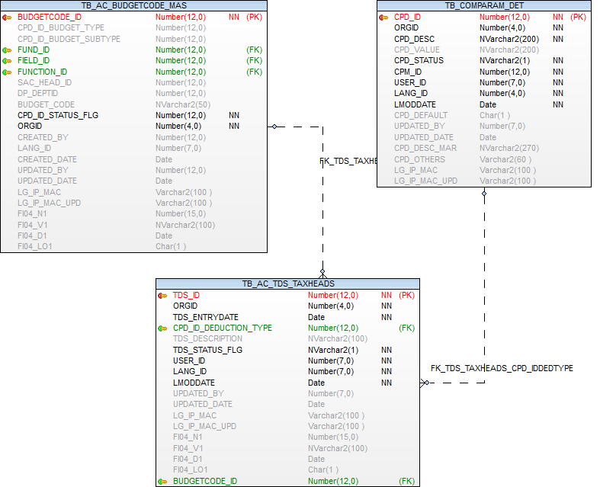

Budget Head Opening Balance
Operations-→  Tables | Select | Insert | Edit | Delete
TB_AC_BUGOPEN_BALANCE | Y | Y | Y | N
TB_ORGANISATION | Y | N | N | N
TB_COMPARAM_MAS | Y | N | N | N
TB_COMPARAM_DET | Y | N | N | N
EMPLOYEE | Y | N | N | N
TB_AC_FIELD_MASTER | Y | N | N | N
TB_AC_FUNCTION_MASTER | Y | N | N | N
TB_AC_FUND_MASTER | Y | N | N | N
TB_AC_PRIMARYHEAD_MASTER | Y | N | N | N
TB_AC_SECONDARYHEAD_MASTER | Y | N | N | N

Prefixes used:
Prefix | Description | Remarks/use
DCR | Debit / Credit Type | Dr. / Cr. Type
SLI | Setting or Live Mode | CPD_DESC CPD_VALUE  Setting Mode S  Live Mode L

TB_AC_BUGOPEN_BALANCE

Purpose:- Table is used to store opening balnce for financial statement

Name | Type | Nullable | Default | Comments
OPN_ID | NUMBER(12) |  |  | Primary Key
OPN_ENTRYDATE | DATE |  |  | Open Balance entry Date
FUND_ID | NUMBER(12) | Y |  | Fund Master Reference key --TB_AC_FUND_MASTER
FUNCTION_ID | NUMBER(12) | Y |  | Function Master Reference key --TB_AC_FUNCTION_MASTER
FIELD_ID | NUMBER(12) | Y |  | Field Master Reference key --TB_AC_FIELD_MASTER
PAC_HEAD_ID | NUMBER(12) | Y |  | Primary head Master Reference key -TB_AC_PRIMARYHEAD_MASTER
SAC_HEAD_ID | NUMBER(12) | Y |  | Secondary Master Reference key -- tb_ac_secondaryhead_master
OPENBAL_AMT | NUMBER(15,2) | Y |  | Opening Balance Amount
CPD_ID_DRCR | NUMBER(12) | Y |  | Opening Balance Type Dr/ Cr. Prefix -DCR
FINALIZED_FLAG | CHAR(1) | Y |  | Finalized Balance
FA_YEARID | NUMBER(12) | Y |  | Financial year id
ORGID | NUMBER(4) |  |  | Organisation id
USER_ID | NUMBER(7) |  |  | User Identity
LANG_ID | NUMBER(7) |  |  | Language Identity
LMODDATE | DATE |  |  | Last Modification Date
UPDATED_BY | NUMBER(7) | Y |  | User id who update the data
UPDATED_DATE | DATE | Y |  | Date on which data is going to update
LG_IP_MAC | VARCHAR2(100) | Y |  | Client Machine?s Login Name | IP Address | Physical Address
LG_IP_MAC_UPD | VARCHAR2(100) | Y |  | Updated Client Machine?s Login Name | IP Address | Physical Address
FI04_N1 | NUMBER(15) | Y |  | Additional number FI04_N1 to be used in future
FI04_V1 | NVARCHAR2(100) | Y |  | Additional nvarchar2 FI04_V1 to be used in future
FI04_D1 | DATE | Y |  | Additional Date FI04_D1 to be used in future
FI04_LO1 | CHAR(1) | Y |  | Additional Logical field FI04_LO1 to be used in future

Index (es):-

Index Name | Table Name | Field Name | Index Type
PK_AC_OPN_ID | TB_AC_BUGOPEN_BALANCE | OPN_ID | Unique

Other Information:-

Key | Name | Field Name | Reference Table | Reference Field
Primary | PK_AC_OPN_ID | OPN_ID
Foreign | FK_BUGOPEN_BALANCE_FIELD_ID | FIELD_ID | TB_AC_FIELD_MASTER | FIELD_ID
Foreign | FK_BUGOPEN_BALANCE_FUNCTION_ID | FUNCTION_ID | TB_AC_FUNCTION_MASTER | FUNCTION_ID
Foreign | FK_BUGOPEN_BALANCE_FUND_ID | FUND_ID | TB_AC_FUND_MASTER | FUND_ID
Foreign | FK_BUGOPEN_BALANCE_HEAD_ID | PAC_HEAD_ID | TB_AC_PRIMARYHEAD_MASTER | PAC_HEAD_ID
Foreign | FK_BUGOPEN_BALSA_HEAD_ID | SAC_HEAD_ID | TB_AC_SECONDARYHEAD_MASTER | SAC_HEAD_ID
Foreign | FK_BUGOPEN_DRCRTYPE | CPD_ID_DRCR | TB_COMPARAM_DET | CPD_ID
Foreign | FK_BUGOPEN_FINYEARID | FA_YEARID | TB_FINANCIALYEAR | FA_YEARID

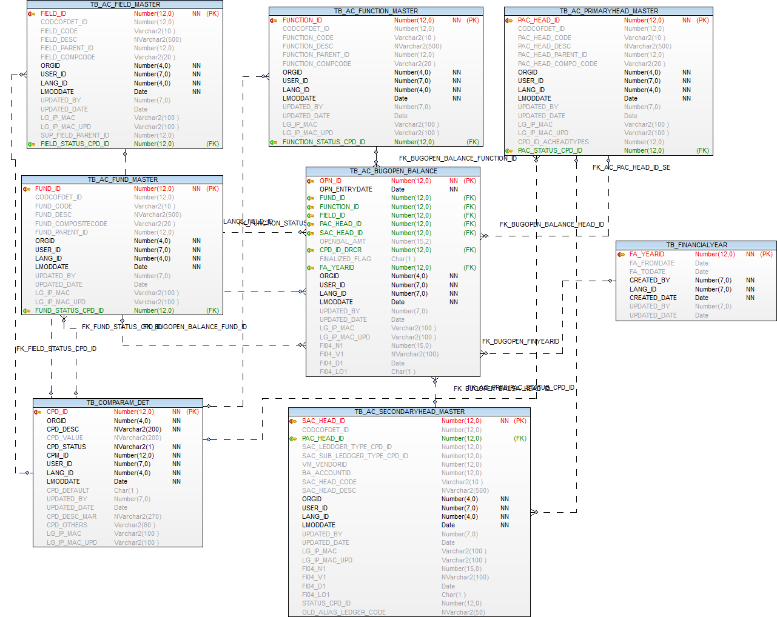

Validation on Budget Head Opening Balance Form

Column Name | Validation
Financial Year * | Mandatory column,  Financial Year Field must be selected on current financial year and before all financial years only/-
Balance Type * | Balance Type field must be a mandatory  And Balance Type field will be showing on Liability/Assets only, Based on the selected Balance type the entire data (Primary Head Code,Secondary Head Code) will be generated automatically.
Primary Head Code * | Primary Head Code Must be a mandatory field, and primary head code -list populate form Primary Head master table, and primary head code will be generated based on the Balance Type(Liability/Assets) only
Secondary Head Code * | Secondary Head Code Must be a mandatory field, and secondary head code will be shows depending up on all Primary Head master and internally Balance Type(Liability/Assets) and generated secondary head master -list populate form Secondary Head master table
Opening Balance * | Opening Balance Field must be a mandatory,  And it will be a enterable field, it’s Allowing only numbers, Accept only maximum 13 digits.
Finalized * | Finalized selected field is mandary,  In this case we are selecting one by one or click on SelectAll option button also.

Bank Master Entry For TDS

Operations-→  Tables | Select | Insert | Edit | Delete
TB_AC_PAY_TO_BANK | Y | Y | Y | N
TB_ORGANISATION | Y | N | N | N
EMPLOYEE | Y | N | N | N

TB_AC_PAY_TO_BANK
Purpose: - Table is used to store Bank Mater entry for TDS Information

Name | Type | Nullable | Default | Comments
PTB_ID | NUMBER(12) |  |  | Primary Key
ORGID | NUMBER(4) |  |  | Organisation id
PTB_ENTRYDATE | DATE |  |  | Entry Date
PTB_BANKCODE | NUMBER(12) |  |  | Bank Code
PTB_BANKNAME | NVARCHAR2(500) |  |  | Bank Name
PTB_BANKBRANCH | NVARCHAR2(100) |  |  | Bank Branch
PTB_BANKADDRESS | NVARCHAR2(200) |  |  | Bank Address
USER_ID | NUMBER(7) |  |  | User Identity
LANG_ID | NUMBER(7) |  |  | Language Identity
LMODDATE | DATE | Y |  | Last Modification Date
UPDATED_BY | NUMBER(7) | Y |  | User id who update the data
UPDATED_DATE | DATE | Y |  | Date on which data is going to update
PTB_BSRCODE | VARCHAR2(15) | Y |  | Bank Unique code
LG_IP_MAC | VARCHAR2(100) | Y |  | Client Machine?s Login Name | IP Address | Physical Address
LG_IP_MAC_UPD | VARCHAR2(100) | Y |  | Updated Client Machine?s Login Name | IP Address | Physical Address
FI04_N1 | NUMBER(15) | Y |  | Additional number FI04_N1 to be used in future
FI04_V1 | NVARCHAR2(100) | Y |  | Additional nvarchar2 FI04_V1 to be used in future
FI04_D1 | DATE | Y |  | Additional Date FI04_D1 to be used in future
FI04_LO1 | CHAR(1) | Y |  | Additional Logical field FI04_LO1 to be used in future

Index (es):-

Index Name | Table Name | Field Name | Index Type
PK_AC_PTB_ID | TB_AC_PAY_TO_BANK | PTB_ID | Unique
UK_AC_PTB_BKCODE | TB_AC_PAY_TO_BANK | PTB_BANKCODE

Other Information:-

Key | Name | Field Name | Reference Table | Reference Field
Primary | PK_AC_PTB_ID | PTB_ID
Unique | UK_AC_PTB_BKCODE | PTB_BANKCODE

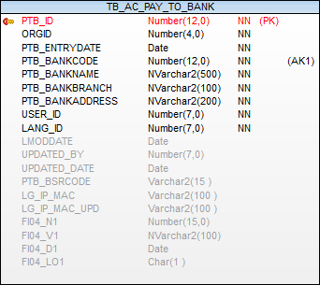

Deposits and Advanced Heads Mapping Entry

Operations-→  Tables | Select | Insert | Edit | Delete
TB_AC_DEPOADV_MAS | Y | Y | Y | N
TB_ORGANISATION | Y | N | N | N
TB_COMPARAM_MAS | Y | N | N | N
TB_COMPARAM_DET | Y | N | N | N
EMPLOYEE | Y | N | N | N
TB_AC_DEPOADV_MAS | Y | N | N | N
TB_DEPARTMENT | Y | N | N | N

Prefixes used:
Prefix | Description | Remarks/use
HDM | Account Head Mapping | Deposit Head Mapping  Advance Head Mapping
DTY | Type of Deposits | Octroi Deposit(Current Account)  Security Deposits
ATY | Advance Type | Vehicle Purchase Advance  Festival Advance  Standing Advance  Family Walfare Advance  Advance given to Employee  Contractors Advance  Other Advance

TB_AC_DEPOADV_MAS

Purpose: - Table is used to store link between deposits and advance Head mapping

Name | Type | Nullable | Default | Comments
DAMPP_ID | NUMBER(12) |  |  | Primary Key
CPD_ID_HDM | NUMBER(12) | Y |  | Reference key TB_COMPARAM_DET
CPD_ID_DTY_ATY | NUMBER(12) | Y |  | Reference key TB_COMPARAM_DET (Deposit Prifix DTY) (Advance Prifix ATY)
CPD_ID | NUMBER(12) | Y |  | Reference key TB_COMPARAM_DET
DEPT_ID | NUMBER(12) | Y |  | Department id
BUDGETCODE_ID | NUMBER(12) | Y |  | FK - tb_ac_budgetcode_mas
REMARK_DESCRIPTION | NVARCHAR2(500) | Y |  | Desription
STATUS | NVARCHAR2(1) | Y |  | Record Status
ORGID | NUMBER(4) |  |  | Organisation id
USER_ID | NUMBER(7) |  |  | User Identity
LANG_ID | NUMBER(7) |  |  | Language Identity
LMODDATE | DATE |  |  | Last Modification Date
UPDATED_BY | NUMBER(7) | Y |  | Updated User Identity
UPDATED_DATE | DATE | Y |  | Updated Modification Date
LG_IP_MAC | VARCHAR2(100) | Y |  | Client Machine?s Login Name | IP Address | Physical Address
LG_IP_MAC_UPD | VARCHAR2(100) | Y |  | Updated Client Machine?s Login Name | IP Address | Physical Address
FI04_N1 | NUMBER(15) | Y |  | Additional number FI04_N1 to be used in future
FI04_V1 | NVARCHAR2(100) | Y |  | Additional nvarchar2 FI04_V1 to be used in future
FI04_D1 | DATE | Y |  | Additional Date FI04_D1 to be used in future
FI04_LO1 | CHAR(1) | Y |  | Additional Logical field FI04_LO1 to be used in future

Index (es):-

Index Name | Table Name | Field Name | Index Type
PK_TB_AC_DEPOADV_MAS_DAMPP_ID | TB_AC_DEPOADV_MAS | DAMPP_ID | Unique

Other Information:-

Key | Name | Field Name | Reference Table | Reference Field
Primary | PK_TB_AC_DEPOADV_MAS_DAMPP_ID | DAMPP_ID
Foreign | FK_DEPARTMENT_DEPT_ID | DEPT_ID | TB_DEPARTMENT | DP_DEPTID
Foreign | FK_DEPOADV_CPD_ID | CPD_ID | TB_COMPARAM_DET | CPD_ID
Foreign | FK_DEPOADV_DTY_ATY_CPD_ID | CPD_ID_DTY_ATY | TB_COMPARAM_DET | CPD_ID
Foreign | FK_DEPOADV_BUDGETCODE_ID | BUDGETCODE_ID | TB_AC_BUDGETCODE_MAS | BUDGETCODE_ID

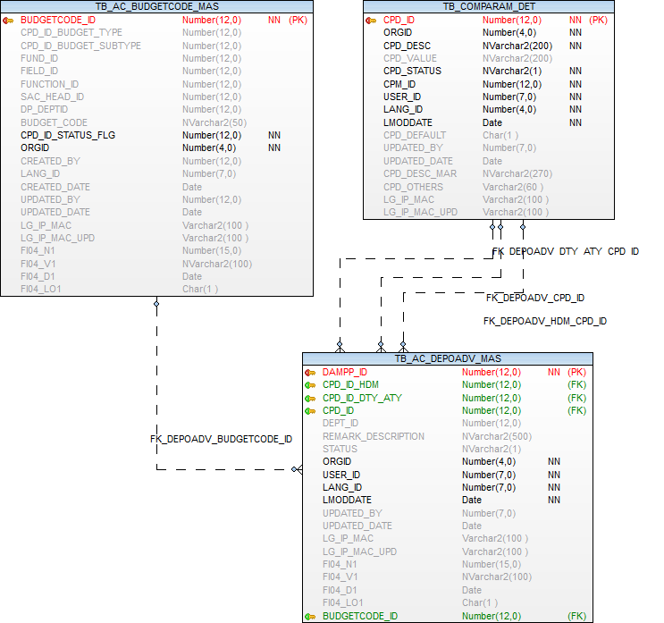

Voucher Template Entry
Operations-→  Tables | Select | Insert | Edit | Delete
TB_AC_VOUCHERTEMPLATE_MAS | Y | Y | Y | N
TB_AC_VOUCHERTEMPLATE_DET | Y | Y | Y | N
TB_AC_BUDGETCODE_MAS | Y | N | N | N
TB_ORGANISATION | Y | N | N | N
TB_COMPARAM_MAS | Y | N | N | N
TB_COMPARAM_DET | Y | N | N | N
EMPLOYEE | Y | N | N | N
TB_DEPARTMENT | Y | N | N | N
TB_FINANCIALYEAR | Y | N | N | N

Prefixes used:
Prefix | Description | Remarks/use
PVA | Payment Voucher
JV | Journal Voucher
CV | Contra Voucher
RV | Receipt Voucher
PAY | PAYMENT MODE
MTP | Mapping type

TB_AC_VOUCHERTEMPLATE_MAS

Purpose: - This table is used for store accounting entry template entry.

Name | Type | Nullable | Default | Comments
TEMPLATE_ID | NUMBER(12) |  |  | Primary Key
CPD_ID_MAPPING_TYPE | NUMBER(12) | Y |  | Permanent / Financial year wise prifix -"MTP"
FA_YEARID | NUMBER(12) | Y |  | Financial Year ID
CPD_ID_VOUCHER_TYPE | NUMBER(12) | Y |  | Prefix "VOT"
DP_DEPTID | NUMBER(12) | Y |  | fk -TB_DEPARTMENT
CPD_ID_TEMPLATE_FOR | NUMBER(12) | Y |  | Prefix "TDP"
CPD_ID_STATUS_FLG | NUMBER(12) |  |  | Prefix - 'ACN'
ORGID | NUMBER(4) |  |  | Organisation id
CREATED_BY | NUMBER(12) |  |  | User Identity
LANG_ID | NUMBER(7) |  |  | Language Identity
CREATED_DATE | DATE |  |  | Last Modification Date
UPDATED_BY | NUMBER(7) | Y |  | User id who update the data
UPDATED_DATE | DATE | Y |  | Date on which data is going to update
LG_IP_MAC | VARCHAR2(100) | Y |  | Client Machine?s Login Name | IP Address | Physical Address
LG_IP_MAC_UPD | VARCHAR2(100) | Y |  | Updated Client Machine?s Login Name | IP Address | Physical Address
FI04_N1 | NUMBER(15) | Y |  | Additional number FI04_N1 to be used in future
FI04_V1 | NVARCHAR2(100) | Y |  | Additional nvarchar2 FI04_V1 to be used in future
FI04_D1 | DATE | Y |  | Additional Date FI04_D1 to be used in future
FI04_LO1 | CHAR(1) | Y |  | Additional Logical field FI04_LO1 to be used in future

Index (es):-

Index Name | Table Name | Field Name | Index Type
PK_TEMPLATE_ID | TB_AC_VOUCHERTEMPLATE_MAS | TEMPLATE_ID | Unique

Other Information:-

Key | Name | Field Name | Reference Table | Reference Field
Primary | PK_TEMPLATE_ID | TEMPLATE_ID
Foreign | FK_CPD_ID_MAPPING_TYPE | CPD_ID_MAPPING_TYPE | TB_COMPARAM_DET | CPD_ID
Foreign | FK_TEMPLATE_DP_DEPTID | DP_DEPTID | TB_DEPARTMENT | DP_DEPTID
Foreign | FK_TEMPLATE_FA_YEARID | FA_YEARID | TB_FINANCIALYEAR | FA_YEARID
Foreign | FK_TEMPL_CPD_ID_TEMPLATE_FOR | CPD_ID_TEMPLATE_FOR | TB_COMPARAM_DET | CPD_ID

TB_AC_VOUCHERTEMPLATE_DET

Purpose: - This table is used for store voucher template entry details

Name | Type | Nullable | Default | Comments
TEMPLATE_ID_DET | NUMBER(12) |  |  | Primary Key
TEMPLATE_ID | NUMBER(12) | Y |  | fk -TB_AC_VOUCHERTEMPLATE_MAS
CPD_ID_ACCOUNT_TYPE | NUMBER(12) | Y |  | fk - TB_COMPARAM_DET Prefix - COA
CPD_ID_DRCR | NUMBER(12) | Y |  | fk- TB_COMPARAM_DET Prefix "DCR"
CPD_ID_PAY_MODE | NUMBER(12) | Y |  | fk -TB_COMPARAM_DET Prefix "PAY"
BUDGETCODE_ID | NUMBER(12) | Y |  | fk TB_AC_BUDGETCODE_MAS
CPD_STATUS_FLG | NUMBER(12) |  |  | fk -TB_COMPARAM_DET Prefix - 'ACN'
ORGID | NUMBER(4) |  |  | Organisation id
CREATED_BY | NUMBER(12) |  |  | User Identity
LANG_ID | NUMBER(7) |  |  | Language Identity
CREATED_DATE | DATE |  |  | Last Modification Date
UPDATED_BY | NUMBER(7) | Y |  | User id who update the data
UPDATED_DATE | DATE | Y |  | Date on which data is going to update
LG_IP_MAC | VARCHAR2(100) | Y |  | Client Machine?s Login Name | IP Address | Physical Address
LG_IP_MAC_UPD | VARCHAR2(100) | Y |  | Updated Client Machine?s Login Name | IP Address | Physical Address
FI04_N1 | NUMBER(15) | Y |  | Additional number FI04_N1 to be used in future
FI04_V1 | NVARCHAR2(100) | Y |  | Additional nvarchar2 FI04_V1 to be used in future
FI04_D1 | DATE | Y |  | Additional Date FI04_D1 to be used in future
FI04_LO1 | CHAR(1) | Y |  | Additional Logical field FI04_LO1 to be used in future

Index (es):-

Index Name | Table Name | Field Name | Index Type
PK_TEMPLATE_ID_DET | TB_AC_VOUCHERTEMPLATE_DET | TEMPLATE_ID_DET | Unique

Other Information:-

Key | Name | Field Name | Reference Table | Reference Field
Primary | PK_TEMPLATE_ID_DET | TEMPLATE_ID_DET
Foreign | FK_TEMP_BUDGETCODE_ID | BUDGETCODE_ID | TB_AC_BUDGETCODE_MAS | BUDGETCODE_ID
Foreign | FK_TEMP_CPD_ID_ACCOUNT_TYPE | CPD_ID_ACCOUNT_TYPE | TB_COMPARAM_DET | CPD_ID
Foreign | FK_TEMP_CPD_ID_DRCR | CPD_ID_DRCR | TB_COMPARAM_DET | CPD_ID
Foreign | FK_TEMP_CPD_ID_PAY_MODE | CPD_ID_PAY_MODE | TB_COMPARAM_DET | CPD_ID
Foreign | FK_TEMP_TEMPLATE_ID | TEMPLATE_ID | TB_AC_VOUCHERTEMPLATE_MAS | TEMPLATE_ID

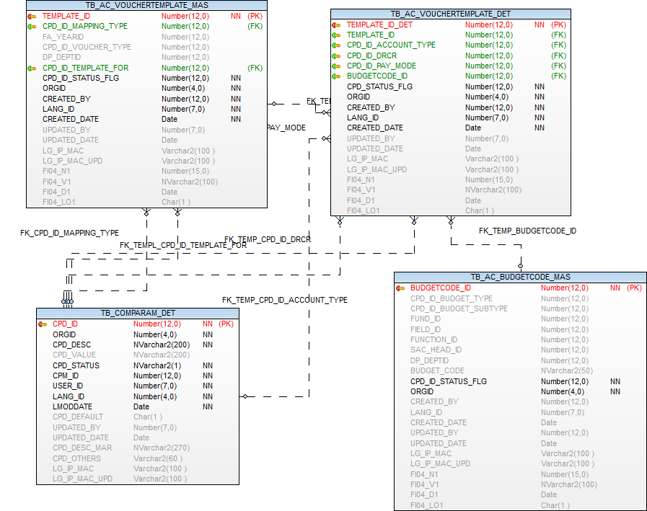

Financial year Entry
Operations-→  Tables | Select | Insert | Edit | Delete
TB_FINANCIALYEAR | Y | Y | Y | N
TB_FINCIALYEARORG_MAP | Y | Y | Y | N
TB_ORGANISATION | Y | N | N | N
TB_COMPARAM_MAS | Y | N | N | N
TB_COMPARAM_DET | Y | N | N | N
EMPLOYEE | Y | N | N | N

Prefixes used:
Prefix | Description | Remarks/use
YOC | Financial year Status

TB_FINANCIALYEAR

Purpose: - This table is used for store Financial year entry.

Name | Type | Nullable | Default | Comments
FA_YEARID | NUMBER(12) |  |  | Primary Key
FA_FROMDATE | DATE | Y |  | Start date of the financial year
FA_TODATE | DATE | Y |  | End date of the financial year
CREATED_BY | NUMBER(7) |  |  | User Identity
LANG_ID | NUMBER(7) |  |  | Language Identity
CREATED_DATE | DATE |  |  | Last Modification Date
UPDATED_BY | NUMBER(7) | Y |  | Updated by
UPDATED_DATE | DATE | Y |  | Updated Date

Index (es):-

Index Name | Table Name | Field Name | Index Type
PK_FINANCIALYEAR_YEARID | TB_FINANCIALYEAR | FA_YEARID | Unique

Other Information:-

Key | Name | Field Name | Reference Table | Reference Field
Primary | PK_FINANCIALYEAR_YEARID | FA_YEARID

TB_FINCIALYEARORG_MAP

Purpose: - This table is used for store financial year organisation wise mapping.

Name | Type | Nullable | Default | Comments
MAP_ID | NUMBER(12)
FA_YEARID | NUMBER(12)
ORGID | NUMBER(4) |  |  | ORGANISATION ID
YA_TYPE_CPD_ID | NUMBER(12) | Y
MAP_STATUS | CHAR(1) | Y |  | ORGNIZATION STATUS IS ACTIVE OR INACTIVE
REMARK | NVARCHAR2(300) | Y
CREATED_BY | NUMBER(7) |  |  | USER ID
LANG_ID | NUMBER(7) |  |  | LANGUAGE ID
CREATED_DATE | DATE |  |  | CREATION DATE
UPDATED_BY | NUMBER(7) | Y |  | UPDATED BY USER ID
UPDATED_DATE | DATE | Y |  | UPDATION DATE
COM_V1 | NVARCHAR2(100) | Y
COM_V2 | NVARCHAR2(100) | Y
COM_V3 | NVARCHAR2(100) | Y
COM_V4 | NVARCHAR2(100) | Y
COM_V5 | NVARCHAR2(100) | Y
COM_N1 | NUMBER(15) | Y
COM_N2 | NUMBER(15) | Y
COM_N3 | NUMBER(15) | Y
COM_N4 | NUMBER(15) | Y
COM_N5 | NUMBER(15) | Y
COM_D1 | DATE | Y
COM_D2 | DATE | Y
COM_D3 | DATE | Y
COM_LO1 | CHAR(1) | Y
COM_LO2 | CHAR(1) | Y
COM_LO3 | CHAR(1) | Y

Index (es):-

Index Name | Table Name | Field Name | Index Type
PK_FINMAPID | TB_FINCIALYEARORG_MAP | MAP_ID | Unique

Other Information:-

Key | Name | Field Name | Reference Table | Reference Field
Primary | PK_FINMAPID | MAP_ID
Foreign | FK_YEARID | FA_YEARID | TB_FINANCIALYEAR | FA_YEARID

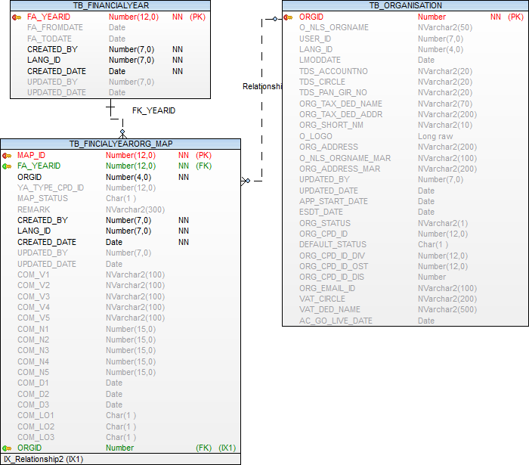

Tax Master (Accounts head linkage)

Operations-→  Tables | Select | Insert | Edit | Delete
TB_TAX_MAS | Y | Y | Y | N
TB_AC_FUNCTION_MASTER | Y | N | N | N
TB_AC_FUND_MASTER | Y | N | N | N
TB_AC_PRIMARYHEAD_MASTER | Y | N | N | N
TB_AC_SECONDARYHEAD_MASTER | Y | N | N | N
TB_ORGANISATION | Y | N | N | N
EMPLOYEE | Y | N | N | N

TB_TAX_MAS

Name | Type | Nullable | Default | Comments
TAX_ID | NUMBER(12) |  |  | Primary Key Tax ID
TAX_DESC | NVARCHAR2(50) |  |  | Tax Description
TAX_METHOD | NVARCHAR2(30) |  |  | Tax Method Flat or Slab
TAX_FROM_DATE | DATE | Y |  | From date
TAX_TO_DATE | DATE | Y |  | To date
TAX_VALUE_TYPE | NVARCHAR2(30) | Y |  | Value type Amount or Percentage
PARENT_CODE | NUMBER(12) | Y |  | Printing Code
TAX_FREQUENCY | NVARCHAR2(2) | Y |  | Frequency for tax
PRIMARY_TAX | NVARCHAR2(1) | Y
TAX_GROUP | NVARCHAR2(50) | Y
TAX_PRINT_ON1 | NVARCHAR2(50) | Y
TAX_CODE | NVARCHAR2(50) | Y |  | TAX CODE
TAX_DISPLAY_SEQ | NUMBER | Y |  | Dispaly Sequence
DP_DEPTID | NUMBER | Y |  | Departement Id From TB_DEPARTMENT
COLL_MTD | NUMBER | Y |  | Collection Method from Prefix RAB
COLL_SEQ | NUMBER | Y |  | Collection Sequence
ORGID | NUMBER(4) | Y |  | Org id
USER_ID | NUMBER(7) | Y |  | User Id
LANG_ID | NUMBER(7) | Y |  | Language Id
LMODDATE | DATE | Y |  | Created Date
UPDATED_BY | NUMBER(7) | Y |  | Updated By
UPDATED_DATE | DATE | Y |  | Updated Date
TAX_CATEGORY1 | NUMBER(12) | Y |  | WTG Prefix used
TAX_CATEGORY2 | NUMBER(12) | Y |  | WTG Prefix used
TAX_CATEGORY3 | NUMBER(12) | Y |  | WTG Prefix used
TAX_CATEGORY4 | NUMBER(12) | Y |  | WTG Prefix used
TAX_CATEGORY5 | NUMBER(12) | Y |  | WTG Prefix used
TAX_APPLICABLE | NUMBER(12) | Y |  | TAX APPLICABLE AT
SM_SERVICE_ID | NUMBER(12) | Y |  | SERVICE ID
TAX_PRINT_ON2 | NVARCHAR2(50) | Y
TAX_PRINT_ON3 | NVARCHAR2(50) | Y
FUND_ID | NUMBER(12) | Y |  | Fund Master Reference key --TB_AC_FUND_MASTER
FUNCTION_ID | NUMBER(12) | Y |  | Function Master Reference key --TB_AC_FUNCTION_MASTER
PAC_HEAD_ID | NUMBER(12) | Y |  | Primary head Master Reference key -TB_AC_PRIMARYHEAD_MASTER
SAC_HEAD_ID | NUMBER(12) | Y |  | Secondary Master Reference key -- tb_ac_secondaryhead_master
PAC_HEAD_ID_LIB | NUMBER(12) | Y
SAC_HEAD_ID_LIB | NUMBER(12) | Y

Index (es):-

Index Name | Table Name | Field Name | Index Type
PK_TAX_ID_MAS | TB_TAX_MAS | TAX_ID | Unique

Other Information:-

Key | Name | Field Name | Reference Table | Reference Field
Primary | PK_TAX_ID_MAS | TAX_ID
Foreign | FK_DP_DEPID | DP_DEPTID | TB_DEPARTMENT | DP_DEPTID
Foreign | FK_TAX_HEADMAPPING_FUNCTION_ID | FUNCTION_ID | TB_AC_FUNCTION_MASTER | FUNCTION_ID
Foreign | FK_TAX_HEADMAPPING_FUND_ID | FUND_ID | TB_AC_FUND_MASTER | FUND_ID
Foreign | FK_TAX_HEADMAPPING_HEADID_L | PAC_HEAD_ID_LIB | TB_AC_PRIMARYHEAD_MASTER | PAC_HEAD_ID
Foreign | FK_TAX_HEADMAPPING_HEAD_ID | PAC_HEAD_ID | TB_AC_PRIMARYHEAD_MASTER | PAC_HEAD_ID
Foreign | FK_TAX_HEADMAPPING_SAC_HEAD_ID | SAC_HEAD_ID | TB_AC_SECONDARYHEAD_MASTER | SAC_HEAD_ID
Foreign | FK_TAX_HMAPPING_SACHEADID_L | SAC_HEAD_ID_LIB | TB_AC_SECONDARYHEAD_MASTER | SAC_HEAD_ID

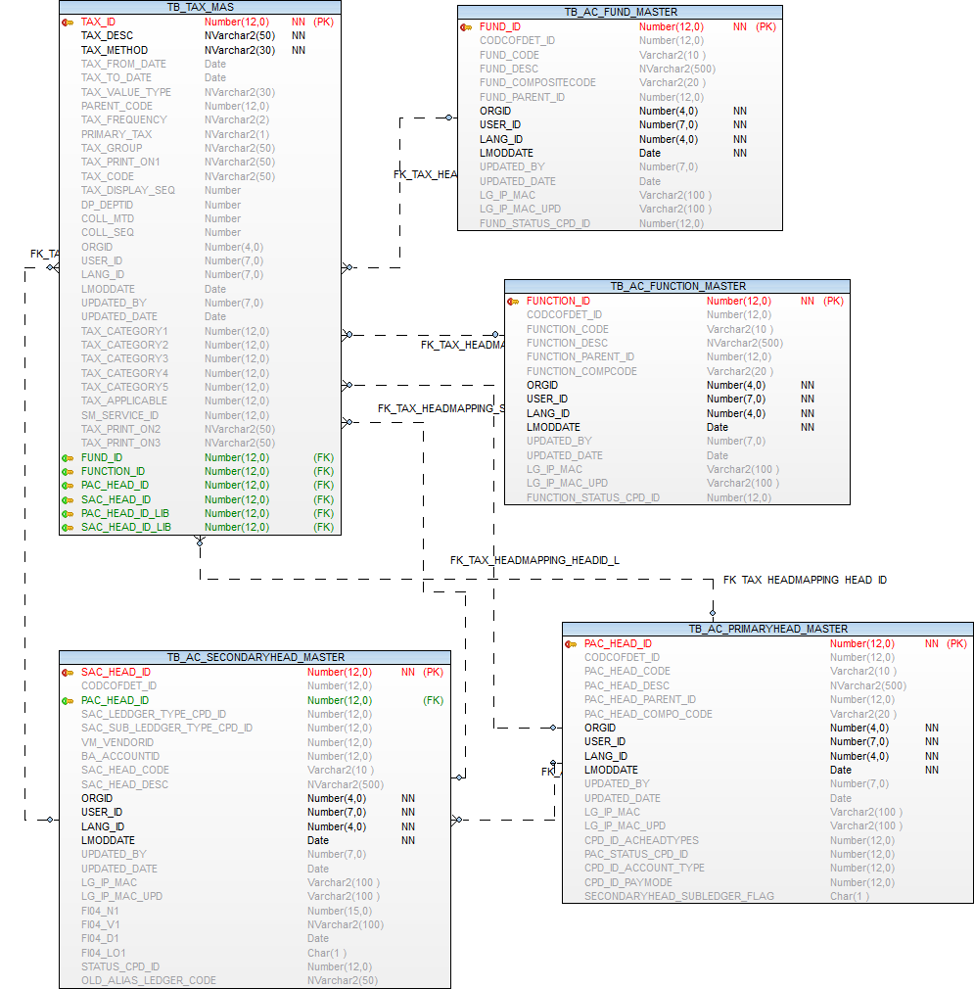

Standard Account Heads Mapping

Operations-→  Tables | Select | Insert | Edit | Delete
TB_AC_PRIMARYHEAD_MASTER | Y | N | Y | N

Prefixes used:
Prefix | Description | Remarks/use
SAM | Standard Account Types | Pay Mode PAY  Banks BK  Vendors VN  Deposits DP  Advances AD  Loans LO  Investments IN  Statutory Deductions SD  Assets AS
PAY | PAYMENT MODE | Cash C  Pay Order P  Bank B  Rebate R  User Discount UD  RTGS RT  FDR F  Demand Draft D  Cheque Q  Transfer T  Adjustment A  User Adjustment U  WEB W  NEFT N
BAT | Bank Type | Other Schedule Bank OS  Nationalized Bank NB  Schedule Cooperative Bank SCB

TB_AC_PRIMARYHEAD_MASTER

This column update from standard account heads mapping form

CPD_ID_PAYMODE
SECONDARYHEAD_SUBLEDGER_FLAG

Transation

Original Budget for Revenues
Operations-→  Tables | Select | Insert | Edit | Delete
TB_AC_PROJECTEDREVENUE | Y | Y | Y | N
TB_AC_BUDGETCODE_MAS | Y | N | N | N
TB_ORGANISATION | Y | N | N | N
EMPLOYEE | Y | N | N | N
TB_DEPARTMENT | Y | N | N | N
TB_FINANCIALYEAR | Y | N | N | N

Prefixes used:
Prefix | Description | Remarks/use

TB_AC_PROJECTEDREVENUE

Purpose: - This table is used for defind projected revenue

Name | Type | Nullable | Default | Comments
PR_PROJECTIONID | NUMBER(12) |  |  | Primary Key
FA_YEARID | NUMBER(12) |  |  | Year Id from financial Year
BUDGETCODE_ID | NUMBER(12) | Y |  | fk -TB_AC_BUDGETCODE_MAS
ORGINAL_ESTAMT | NUMBER(15,2) | Y |  | Original Estimate amount
PR_PROJECTED | NUMBER(15,2) |  |  | Projected revenue amount
REVISED_ESTAMT | NUMBER(15,2) | Y |  | Revised Estimate amount
NXT_YR_OE | NUMBER(15,2) | Y |  | Original estimate for next year
PR_COLLECTED | NUMBER(15,2) | Y |  | Targeted revenue amount
ORGID | NUMBER(4) |  |  | Organization Id
USER_ID | NUMBER(7) |  |  | User Identity
LANG_ID | NUMBER(7) |  |  | Language Identity
LMODDATE | DATE |  |  | Last Modification Date
UPDATED_BY | NUMBER(7) | Y |  | User id who update the data
UPDATED_DATE | DATE | Y |  | Date on which data is going to update
LG_IP_MAC | VARCHAR2(100) | Y |  | Client Machine?s Login Name | IP Address | Physical Address
LG_IP_MAC_UPD | VARCHAR2(100) | Y |  | Updated Client Machine?s Login Name | IP Address | Physical Address
FI04_N1 | NUMBER(15) | Y |  | Additional number FI04_N1 to be used in future
FI04_V1 | NVARCHAR2(100) | Y |  | Additional nvarchar2 FI04_V1 to be used in future
FI04_D1 | DATE | Y |  | Additional Date FI04_D1 to be used in future
FI04_LO1 | CHAR(1) | Y |  | Additional Logical field FI04_LO1 to be used in future
DP_DEPTID | NUMBER(12) | Y |  | Department id

Index (es):-

Index Name | Table Name | Field Name | Index Type
IND_PROJECTED_REVENUE_FINYEAR | TB_AC_PROJECTEDREVENUE | FA_YEARID | Normal
PK_PROJECTEDREVENUE_PROJID | TB_AC_PROJECTEDREVENUE | PR_PROJECTIONID | Unique

Other Information:-

Key | Name | Field Name | Reference Table | Reference Field
Primary | PK_PROJECTEDREVENUE_PROJID | PR_PROJECTIONID
Foreign | FK_DEPARTMENT_ID_PROJID | DP_DEPTID | TB_DEPARTMENT | DP_DEPTID
Foreign | FK_PROJECTEDREVENUE_YEARID | FA_YEARID | TB_FINANCIALYEAR | FA_YEARID
Foreign | FK_PROJBUDGETCODE_MAS | BUDGETCODE_ID | TB_AC_BUDGETCODE_MAS | BUDGETCODE_ID

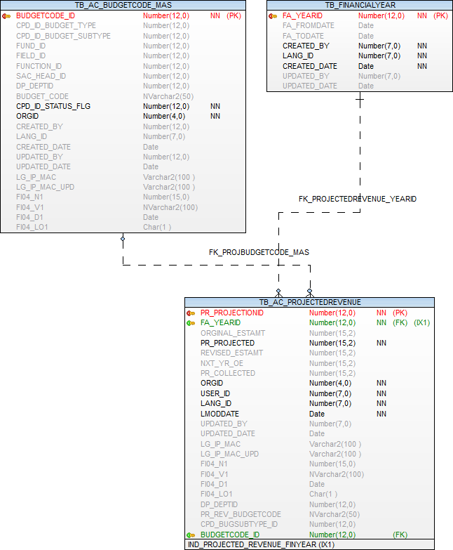

Validation on Projected Revenues Form

Column Name | Validation
Financial Year * | Mandatory column,  Financial Year Field must be selected on current financial year and before all financial years only/-
Fund Code | Fund Code must not be a mandatory field, and Fund code- list populate form Fund master table
Field Code | Field Code Must not be a mandatory field, and Field code -list populate form Field master table
Function Code | Function Code Must not be a mandatory field, and Function code -list populate form Function master table
Primary Head Code * | Primary Head Code Must be a mandatory field, and primary head code -list populate form Primary Head master table
Secondary Head Code * | Secondary Head Code Must be a mandatory field, and secondary head code will be shows depending up on all Primary Head master and generated secondary head master -list populate form Secondary Head master table
Original Estimate * | Original Estimate Field must be a mandatory,  And it will be a enterable field, it’s Allowing only numbers, Accept only maximum 13 digits.
Projected Revenue * | Projected Revenue Field must be a mandatory,  And it will be a showing field(read only column), it’s Allowing only numbers ,This Amount will be generated automatically -depending up on original estimate amount, Accept only maximum 13 digits
Collected | Collected Amount Field must not be a mandatory, And it will be a showing field(read only column), it’s Allowing only numbers, Accept only maximum 13 digits  (Logic is pending now)
Pr_rev_budgetcode | Buget code  I000001  E000001  L000001  A000001

Original Budget for Expenditure
Operations-→  Tables | Select | Insert | Edit | Delete
TB_AC_PROJECTED_EXPENDITURE | Y | Y | Y | N
TB_AC_BUDGETCODE_MAS | Y | N | N | N
TB_ORGANISATION | Y | N | N | N
EMPLOYEE | Y | N | N | N
TB_DEPARTMENT | Y | N | N | N
TB_FINANCIALYEAR | Y | N | N | N

Prefixes used:
Prefix | Description | Remarks/use

TB_AC_PROJECTED_EXPENDITURE

Purpose: - This table is used for defind projected expenditure details

Name | Type | Nullable | Default | Comments
PR_EXPENDITUREID | NUMBER(12) |  |  | Primary Key
FA_YEARID | NUMBER(12) |  |  | Year Id from financial Year
BUDGETCODE_ID | NUMBER(12) | Y |  | fk -TB_AC_BUDGETCODE_MAS
ORGINAL_ESTAMT | NUMBER(15,2) | Y |  | Original Estimate amount
REVISED_ESTAMT | NUMBER(15,2) | Y |  | Revised Estimate amount
EXPENDITURE_AMT | NUMBER(15,2) | Y
PR_BALANCE_AMT | NUMBER(15,2) | Y
ORGID | NUMBER(4) |  |  | Organization Id
USER_ID | NUMBER(7) |  |  | User Identity
LANG_ID | NUMBER(7) |  |  | Language Identity
LMODDATE | DATE |  |  | Last Modification Date
UPDATED_BY | NUMBER(7) | Y |  | User id who update the data
UPDATED_DATE | DATE | Y |  | Date on which data is going to update
LG_IP_MAC | VARCHAR2(100) | Y |  | Client Machine?s Login Name | IP Address | Physical Address
LG_IP_MAC_UPD | VARCHAR2(100) | Y |  | Updated Client Machine?s Login Name | IP Address | Physical Address
FI04_N1 | NUMBER(15) | Y |  | Additional number FI04_N1 to be used in future
FI04_V1 | NVARCHAR2(100) | Y |  | Additional nvarchar2 FI04_V1 to be used in future
FI04_D1 | DATE | Y |  | Additional Date FI04_D1 to be used in future
FI04_LO1 | CHAR(1) | Y |  | Additional Logical field FI04_LO1 to be used in future
DP_DEPTID | NUMBER(12) | Y |  | Department id
PR_EXP_BUDGETCODE | NVARCHAR2(50) | Y |  | Budget code

Index (es):-

Index Name | Table Name | Field Name | Index Type
PK_PROJECTEDEXPENDITURE_EXPEID | TB_AC_PROJECTED_EXPENDITURE | PR_EXPENDITUREID | Unique

Other Information:-

Key | Name | Field Name | Reference Table | Reference Field
Primary | PK_PROJECTEDEXPENDITURE_EXPEID | PR_EXPENDITUREID
Foreign | FK_DEPARTMENT_ID_PROJEXPID | DP_DEPTID | TB_DEPARTMENT | DP_DEPTID
Foreign | FK_PROJECTEDEXP_YEARID | FA_YEARID | TB_FINANCIALYEAR | FA_YEARID
Foreign | FK_PROJECTEDEXP_BUDGETCODE_ID | BUDGETCODE_ID | TB_AC_BUDGETCODE_MAS | BUDGETCODE_ID
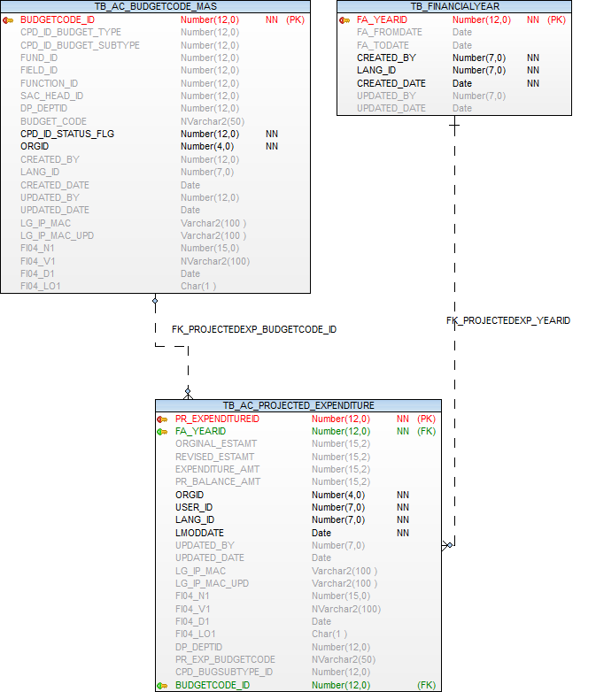

Validation on Projected Expenditure Form

Column Name | Validation
Financial Year * | Mandatory column,  Financial Year Field must be selected on current financial year and before all financial years only/-
Fund Code | Fund Code must not be a mandatory field, and Fund code- list populate form Fund master table
Field Code | Field Code Must not be a mandatory field, and  Field code- list populate form Field master table
Function Code | Function Code Must not be a mandatory field, and Function code -list populate form Function master table
Primary Head Code * | Primary Head Code Must be a mandatory field, and primary head code -list populate form Primary Head master table
Secondary Head Code * | Secondary Head Code Must be a mandatory field, and secondary head code will be shows depending up on all Primary Head master and generated secondary head master -list populate form Secondary Head master table
Original Estimate * | Original Estimate Field must be a mandatory,  And it will be a enterable field, it’s Allowing only numbers, Accept only maximum 13 digits.
Revised Estimate | Revised Estimate Field must not be a mandatory,  And it will be a showing field(read only column), it’s Allowing only numbers, Accept only maximum 13 digits (Logic is Pending)
Expenditure Amount | Expenditure Amount Field must not be a mandatory,  And it will be a showing field(read only column), it’s Allowing only numbers, Accept only maximum 13 digits (Logic is pending)
Balance Provision | Balance Provision Amount Field must not be a mandatory, And it will be a showing field(read only column), it’s Allowing only numbers, Accept only maximum 13 digits,This Amount will be generated automatically -depending up on original estimate amount
PR_EXP_BUDGETCODE | Buget code  I000002  E000002  L000002  A000002

Budget Allocation
Operations-→  Tables | Select | Insert | Edit | Delete
TB_AC_BUDGETALLOCATION | Y | Y | Y | N
TB_ORGANISATION | Y | N | N | N
EMPLOYEE | Y | N | N | N
TB_COMPARAM_DET | Y | N | N | N
TB_AC_PROJECTEDREVENUE | Y | N | N | N
TB_AC_PROJECTED_EXPENDITURE | Y | N | N | N
TB_FINANCIALYEAR | Y | N | N | N
TB_AC_BUDGETCODE_MAS | Y | N | N | N
TB_DEPARTMENT | Y | N | N | N
TB_AC_BUDGETALLOCATION_HIST | Y | Y | N | N

Prefixes used:
Prefix | Description | Remarks/use
REX | Revenue/Expenditure Type

TB_AC_BUDGETALLOCATION

Purpose: - This table is used for store projected revenue and expenditure budget allocation to department.

Name | Type | Nullable | Default | Comments
BA_ID | NUMBER(12) |  |  | Primary Key
BA_ENTRYDATE | DATE |  |  | Date of entry of the budget allocation
FA_YEARID | NUMBER(12) | Y |  | Reference key-TB_FINANCIALYEAR
CPD_BUGTYPE_ID | NUMBER(12) |  |  | Bugdet type, Reference key-TB_COMPARAM_DET Prefix "REX" Revenue/Expenditure Type
PR_PROJECTIONID | NUMBER(12) | Y |  | Reference key -TB_AC_PROJECTEDREVENUE
PR_EXPENDITUREID | NUMBER(12) | Y |  | Reference key-TB_AC_PROJECTED_EXPENDITURE
DP_DEPTID | NUMBER(12) | Y |  | Reference key-TB_department
BUDGETCODE_ID | NUMBER(12) | Y |  | FK - tb_ac_budgetcode_mas
VALIDTILL_DATE | DATE | Y |  | DDO will set restriction as ULB required. Default value is 31st march of budget year%
RELEASE_PER | NUMBER(7,2) | Y |  | Release Percentage
AUTHO_FLG | CHAR(1) | Y |  | Flag
AUTHO_ID | NUMBER(7) | Y |  | Authoer Id
AUTHO_DATE | DATE | Y |  | Sysdate
ORGID | NUMBER(4) |  |  | Organisation id
CREATED_BY | NUMBER(7) |  |  | Created User Identity
CREATED_DATE | DATE |  |  | Created Date
UPDATED_BY | NUMBER(7) | Y |  | User id who update the data
UPDATED_DATE | DATE | Y |  | Date on which data is going to update
LANG_ID | NUMBER(7) |  |  | Language Identity
LG_IP_MAC | VARCHAR2(100) | Y |  | Client Machine?s Login Name | IP Address | Physical Address
LG_IP_MAC_UPD | VARCHAR2(100) | Y |  | Updated Client Machine?s Login Name | IP Address | Physical Address
FI04_N1 | NUMBER(15) | Y |  | Additional number FI04_N1 to be used in future
FI04_V1 | NVARCHAR2(100) | Y |  | Additional nvarchar2 FI04_V1 to be used in future
FI04_D1 | DATE | Y |  | Additional Date FI04_D1 to be used in future
FI04_LO1 | CHAR(1) | Y |  | Additional Logical field FI04_LO1 to be used in future

Index (es):-

Index Name | Table Name | Field Name | Index Type
PK_BUDGETALLOCATIONBA_ID | TB_AC_BUDGETALLOCATION | BA_ID | Unique

Other Information:-

Key | Name | Field Name | Reference Table | Reference Field
Primary | PK_BUDGETALLOCATIONBA_ID | BA_ID
Foreign | FK_BUALLCPD_BUGTYPE_ID | CPD_BUGTYPE_ID | TB_COMPARAM_DET | CPD_ID
Foreign | FK_BUALLPROJADJ_ID | PR_PROJECTIONID | TB_AC_PROJECTEDREVENUE | PR_PROJECTIONID
Foreign | FK_BUALL_EXPENDITUREID | PR_EXPENDITUREID | TB_AC_PROJECTED_EXPENDITURE | PR_EXPENDITUREID
Foreign | FK_BUALL_FA_YEARID | FA_YEARID | TB_FINANCIALYEAR | FA_YEARID
Foreign | FK_BUALL_BUDGETCODE_ID | BUDGETCODE_ID | TB_AC_BUDGETCODE_MAS | BUDGETCODE_ID
Foreign | FK_DEPARTMENT_ID | DP_DEPTID | TB_DEPARTMENT | DP_DEPTID

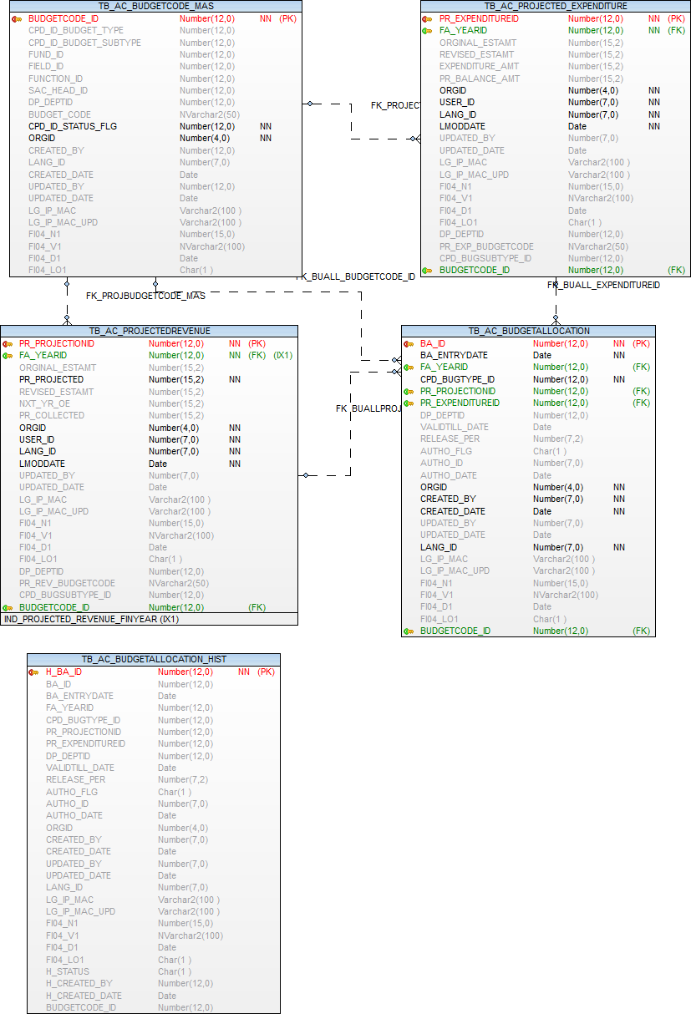

Validation on Budget Allocation Form

Column Name | Validation
Entry Date * | Mandary Column,  And it will be a showing field (Read only Field),  Entry date field must be showing automatically depending on System Date.
Financial Year * | Mandatory column,  Financial Year Field must be selected on current financial year and before all financial years only/-
Budget Type * | Budget Type field must be a mandatory,  And Budget Type field will be showing on Revenue/Expenditure only, Based on the selected Budget type and financial year the entire data will be generated internally
Department * | Department Field must be a mandatory, and select department field on saving time.
Fund Code | Fund Code must not be a mandatory field, and all Fund code- list populated based on financial year and budget type(Revenue/Enpenditure) only
Field Code | Field Code Must not be a mandatory field, and all  Field code- list populated based on financial year and budget type(Revenue/Enpenditure) only
Function Code | Function Code Must not be a mandatory field, and all Function code- list populated based on financial year and budget type(Revenue/Enpenditure) only
Primary Head Code * | Primary Head Code Must be a mandatory field, and all primary head code -list populated based on financial year and budget type(Revenue/Enpenditure) only
Secondary Head Code * | Secondary Head Code Must be a mandatory field, and all secondary head code will be shows depending up on all Primary Head master and generated secondary head master -list populated based on financial year and budget type(Revenue/Enpenditure) only
Valid Till Date * | Valid Till Date Field Must be a mandatory,  Based on the selected financial year and allowing/showing the valid till date given financial year date only
Release Percentage * | Release Percentage Column must be a Mandatory, it’s Allowing only numbers,  And it will be allowing maximum 100% Release Percentage only
Confirm | Confirm filed must not be a Mandatory,  And saving time only checks the confirm filed is selected or not

TB_AC_BUDGETALLOCATION_HIST

Purpose: - This table is used for store budget allocation history or audit record.

Name | Type | Nullable | Default | Comments
H_BA_ID | NUMBER(12) |  |  | Primary key
BA_ID | NUMBER(12) | Y
BA_ENTRYDATE | DATE | Y
FA_YEARID | NUMBER(12) | Y
CPD_BUGTYPE_ID | NUMBER(12) | Y
PR_PROJECTIONID | NUMBER(12) | Y
PR_EXPENDITUREID | NUMBER(12) | Y
DP_DEPTID | NUMBER(12) | Y
BUDGETCODE_ID | NUMBER(12) | Y
VALIDTILL_DATE | DATE | Y
RELEASE_PER | NUMBER(7,2) | Y
AUTHO_FLG | CHAR(1) | Y
AUTHO_ID | NUMBER(7) | Y
AUTHO_DATE | DATE | Y
ORGID | NUMBER(4) | Y
CREATED_BY | NUMBER(7) | Y
CREATED_DATE | DATE | Y
UPDATED_BY | NUMBER(7) | Y
UPDATED_DATE | DATE | Y
LANG_ID | NUMBER(7) | Y
LG_IP_MAC | VARCHAR2(100) | Y
LG_IP_MAC_UPD | VARCHAR2(100) | Y
FI04_N1 | NUMBER(15) | Y
FI04_V1 | NVARCHAR2(100) | Y
FI04_D1 | DATE | Y
FI04_LO1 | CHAR(1) | Y
H_STATUS | CHAR(1) | Y |  | updated flag 'U' and delete flag 'D'
H_CREATED_BY | NUMBER(12) | Y |  | hist created user id
H_CREATED_DATE | DATE | Y |  | hist created date

Index (es):-

Index Name | Table Name | Field Name | Index Type
PK_H_BA_ID | TB_AC_BUDGETALLOCATION_HIST | H_BA_ID | Unique

Other Information:-

Key | Name | Field Name | Reference Table | Reference Field
Primary | PK_H_BA_ID | H_BA_ID

Re-Appropriation of Budget

Operations-→  Tables | Select | Insert | Edit | Delete
TB_AC_PROJECTEDPROVISIONADJ | Y | Y | Y | N
TB_AC_PROJECTEDPROVISIONADJ_TR | Y | Y | Y | N
TB_ORGANISATION | Y | N | N | N
EMPLOYEE | Y | N | N | N
TB_COMPARAM_DET | Y | N | N | N
TB_AC_PROJECTEDREVENUE | Y | N | N | N
TB_AC_PROJECTED_EXPENDITURE | Y | N | N | N
TB_FINANCIALYEAR | Y | N | N | N
TB_AC_BUDGETCODE_MAS | Y | N | N | N
TB_DEPARTMENT | Y | N | N | N

Prefixes used:
Prefix | Description | Remarks/use
REX | Revenue/Expenditure Type
PRV | PROVISION TYPE

TB_AC_PROJECTEDPROVISIONADJ

Purpose: - This table is used for store projected revenue and expenditure budget re-appropriaton (from budget)

Name | Type | Nullable | Default | Comments
PA_ADJID | NUMBER(12) |  |  | Primary Key
PA_ENTRYDATE | DATE |  |  | Date of entry of the transfer
CPD_BUGTYPE_ID | NUMBER(12) |  |  | Bugdet type, Reference key-TB_COMPARAM_DET Prefix "REX" Revenue/Expenditure Type
CPD_PROVTYPE_ID | NUMBER(12) |  |  | Bugdet type, Reference key-TB_COMPARAM_DET Prefix "PRV" PROVISION TYPE Provision type i.e. Prov. Adjustment or Add. Provision
FA_YEARID | NUMBER(12) | Y |  | Reference key-TB_FINANCIALYEAR
PR_PROJECTIONID | NUMBER(12) | Y |  | Reference key -TB_AC_PROJECTEDREVENUE
PR_EXPENDITUREID | NUMBER(12) | Y |  | Reference key-TB_AC_PROJECTED_EXPENDITURE
BUDGETCODE_ID | NUMBER(12) | Y |  | FK - tb_ac_budgetcode_mas
PROVISION_OLDAMT | NUMBER(15,2) | Y |  | Provison old amt
ORG_REV_BALAMT | NUMBER(15,2) | Y |  | OE and RE balance amount
TRANSFER_AMOUNT | NUMBER(15,2) | Y |  | Total Transfer amount /Additional Budget Provision
NEW_ORG_REV_AMOUNT | NUMBER(15,2) | Y |  | New OE/RE Amount
APPROVED_BY | NUMBER(12) | Y |  | Approved by field
REMARK | NVARCHAR2(200) | Y |  | Remark
ORGID | NUMBER(4) |  |  | Organisation id
USER_ID | NUMBER(7) |  |  | User Identity
LANG_ID | NUMBER(7) |  |  | Language Identity
LMODDATE | DATE |  |  | Last Modification Date
UPDATED_BY | NUMBER(7) | Y |  | User id who update the data
UPDATED_DATE | DATE | Y |  | Date on which data is going to update
LG_IP_MAC | VARCHAR2(100) | Y |  | Client Machine?s Login Name | IP Address | Physical Address
LG_IP_MAC_UPD | VARCHAR2(100) | Y |  | Updated Client Machine?s Login Name | IP Address | Physical Address
FI04_N1 | NUMBER(15) | Y |  | Additional number FI04_N1 to be used in future
FI04_V1 | NVARCHAR2(100) | Y |  | Additional nvarchar2 FI04_V1 to be used in future
FI04_D1 | DATE | Y |  | Additional Date FI04_D1 to be used in future
FI04_LO1 | CHAR(1) | Y |  | Additional Logical field FI04_LO1 to be used in future
DP_DEPTID | NUMBER(12) | Y |  | Reference key-tb_department
CPD_ID_BUDGETSUBTYPE | NUMBER(12) | Y |  | Reference key-TB_COMPARAM_DET Prefix "FTP"
BUDGET_IDENTIFY_FLAG | CHAR(1) | Y |  | Ra appropriation 'R' and Additional / Supplementary Budget 'A' Budget transaction identification flag

Index (es):-

Index Name | Table Name | Field Name | Index Type
PK_PROVIPROJREVEXPADJ_ADJID | TB_AC_PROJECTEDPROVISIONADJ | PA_ADJID | Unique

Other Information:-

Key | Name | Field Name | Reference Table | Reference Field
Primary | PK_PROVIPROJREVEXPADJ_ADJID | PA_ADJID
Foreign | FI_PROJREVEXPADJ_DP_DEPTID | DP_DEPTID | TB_DEPARTMENT | DP_DEPTID
Foreign | FK_APPROVED_BY_EMP_ID | APPROVED_BY | EMPLOYEE | EMPID
Foreign | FK_CPD_BUGTYPE_ID | CPD_BUGTYPE_ID | TB_COMPARAM_DET | CPD_ID
Foreign | FK_CPD_PROVTYPE_ID | CPD_PROVTYPE_ID | TB_COMPARAM_DET | CPD_ID
Foreign | FK_PROJECTEDADJ_EXPENDITUREID | PR_EXPENDITUREID | TB_AC_PROJECTED_EXPENDITURE | PR_EXPENDITUREID
Foreign | FK_PROJECTEDPROVISIONADJ_ID | PR_PROJECTIONID | TB_AC_PROJECTEDREVENUE | PR_PROJECTIONID
Foreign | FK_PROJREVEXPADJ_BUDGETCODE_ID | BUDGETCODE_ID | TB_AC_BUDGETCODE_MAS | BUDGETCODE_ID
Foreign | FK__PROJREVEXPADJ_FA_YEARID | FA_YEARID | TB_FINANCIALYEAR | FA_YEARID

TB_AC_PROJECTEDPROVISIONADJ_TR

Purpose: - This table is used for store projected revenue and expenditure budget re-appropriaton (to budget)

Name | Type | Nullable | Default | Comments
PA_ADJID_TR | NUMBER(12) |  |  | Primary Key
PA_ADJID | NUMBER(12) | Y |  | fk ref key -TB_AC_PROJECTEDPROVISIONADJ
PR_PROJECTIONID | NUMBER(12) | Y |  | fk ref key - tb_ac_projectedrevenue
PR_EXPENDITUREID | NUMBER(12) | Y |  | fk ref key -tb_ac_projected_expenditure
BUDGETCODE_ID | NUMBER(12) | Y |  | FK - tb_ac_budgetcode_mas
PROVISION_OLDAMT | NUMBER(15,2) | Y |  | Old projected amt
TRANSFER_AMOUNT | NUMBER(15,2) | Y |  | Transfer amount
NEW_ORG_REV_AMOUNT | NUMBER(15,2) | Y |  | Balanc amt
ORGID | NUMBER(4) |  |  | Organisation id
USER_ID | NUMBER(7) |  |  | User Identity
LANG_ID | NUMBER(7) |  |  | Language Identity
LMODDATE | DATE |  |  | Last Modification Date
UPDATED_BY | NUMBER(7) | Y |  | User id who update the data
UPDATED_DATE | DATE | Y |  | Date on which data is going to update
LG_IP_MAC | VARCHAR2(100) | Y |  | Client Machine?s Login Name | IP Address | Physical Address
LG_IP_MAC_UPD | VARCHAR2(100) | Y |  | Updated Client Machine?s Login Name | IP Address | Physical Address
FI04_N1 | NUMBER(15) | Y |  | Additional number FI04_N1 to be used in future
FI04_V1 | NVARCHAR2(100) | Y |  | Additional nvarchar2 FI04_V1 to be used in future
FI04_D1 | DATE | Y |  | Additional Date FI04_D1 to be used in future
FI04_LO1 | CHAR(1) | Y |  | Additional Logical field FI04_LO1 to be used in future
DP_DEPTID | NUMBER(12) | Y |  | Department id

Index (es):-

Index Name | Table Name | Field Name | Index Type
PK_PA_ADJID_TR | TB_AC_PROJECTEDPROVISIONADJ_TR | PA_ADJID_TR | Unique

Other Information:-

Key | Name | Field Name | Reference Table | Reference Field
Primary | PK_PA_ADJID_TR | PA_ADJID_TR
Foreign | FI_PROJREVEXPA_TR_DP_DEPTID | DP_DEPTID | TB_DEPARTMENT | DP_DEPTID
Foreign | FK_PA_ADJID | PA_ADJID | TB_AC_PROJECTEDPROVISIONADJ | PA_ADJID
Foreign | FK_PROJECTEDADJ_TR_EXPID | PR_EXPENDITUREID | TB_AC_PROJECTED_EXPENDITURE | PR_EXPENDITUREID
Foreign | FK_PROJECTEDPROVISIONADJ_TR_ID | PR_PROJECTIONID | TB_AC_PROJECTEDREVENUE | PR_PROJECTIONID
Foreign | FK_PROJECTEDADJ_BUDGETCODE_ID | BUDGETCODE_ID | TB_AC_BUDGETCODE_MAS | BUDGETCODE_ID

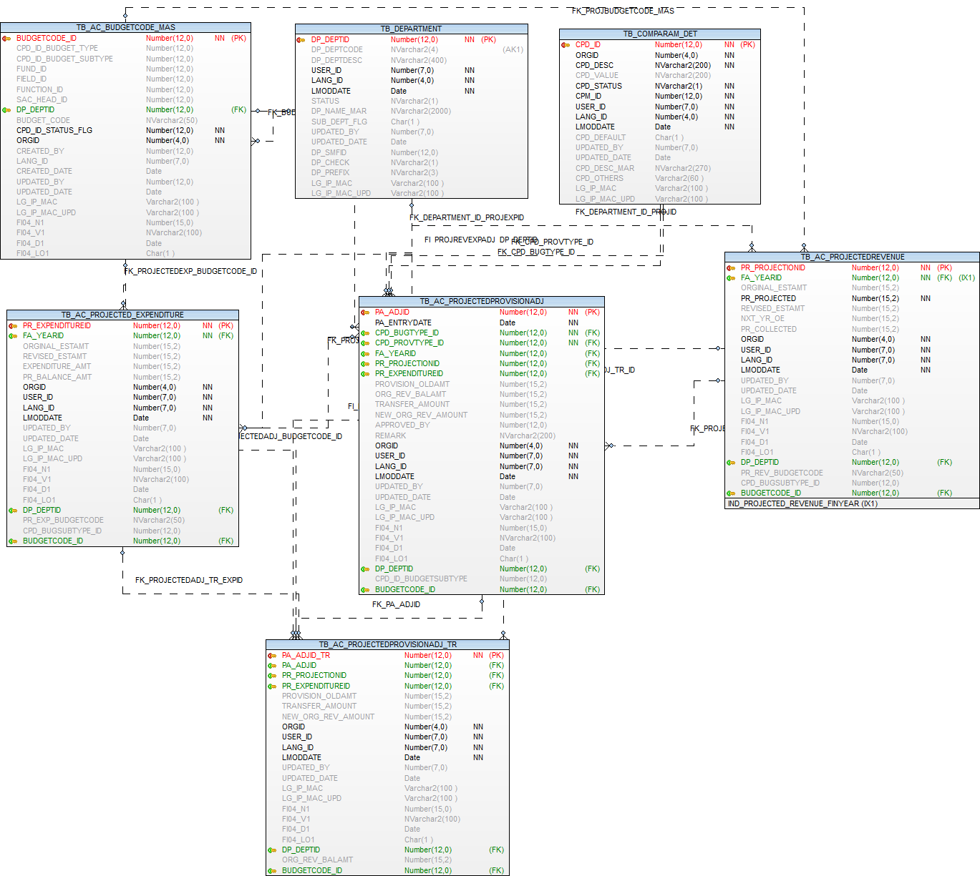

Validation on Re-Appropriation Of Budget Form

Column Name | Validation
Entry Date * | Mandary Column,  And it will be a showing field (Read only Field),  Entry date field must be showing automatically depending on System Date.
Financial Year * | Mandatory column,  Financial Year Field must be selected on current financial year and before all financial years only/-
Budget Type * | Budget Type field must be a mandatory,  And Budget Type field will be showing on Revenue/Expenditure only, Based on the selected Budget type and financial year the entire data will be generated internally
To-Case | Tranfer Amount in To-case
Fund Code | Fund Code must not be a mandatory field, and all Fund code- list populated based on financial year and budget type(Revenue/Enpenditure) only
Field Code | Field Code Must not be a mandatory field, and all  Field code- list populated based on financial year and budget type(Revenue/Enpenditure) only
Function Code | Function Code Must not be a mandatory field, and all Function code- list populated based on financial year and budget type(Revenue/Enpenditure) only
Primary Head Code * | Primary Head Code Must be a mandatory field, and all primary head code -list populated based on financial year and budget type(Revenue/Enpenditure) only
Secondary Head Code * | Secondary Head Code Must be a mandatory field, and all secondary head code will be shows depending up on all Primary Head master and generated secondary head master -list populated based on financial year and budget type(Revenue/Enpenditure) only
Original Estimate * | Original Estimate Field must be a mandatory,  And it will be Showing field(Read only), it’s Allowing only numbers, Accept only maximum 13 digits.  Whenever we are selecting the fund, field, function, primary head code and secondary head code all combination and automatically generated original estimate amount based on the budget type and financial year.
Balance Provision * | Balance Provision Field must be a mandatory,  And it will be Showing field (Read only), it’s Allowing only numbers, Accept only maximum 13 digits.  Whenever we are selecting the fund, field, function, primary head code and secondary head code all combination and automatically generated original estimate amount based on the budget type and financial year  (Logic is Pending now)
Old Original Amount | Old Original Amount filed must not be a Mandatory,  And it will be Showing field (Read only), it’s Allowing only numbers, Accept only maximum 13 digits.  Whenever we are selecting the fund, field, function, primary head code and secondary head code all combination and automatically generated original estimate amount based on the budget type and financial year,  Depending up on original estimate amount is automatically generated same as old original amount
From-Case | Tranfer Amount in From-case
Fund Code | Fund Code must not be a mandatory field, and all Fund code- list populated based on financial year and budget type(Revenue/Enpenditure) only
Field Code | Field Code Must not be a mandatory field, and all  Field code- list populated based on financial year and budget type(Revenue/Enpenditure) only
Function Code | Function Code Must not be a mandatory field, and all Function code- list populated based on financial year and budget type(Revenue/Enpenditure) only
Primary Head Code * | Primary Head Code Must be a mandatory field,  and all primary head code -list populated based on financial year and budget type(Revenue/Enpenditure) only
Secondary Head Code * | Secondary Head Code Must be a mandatory field, and all secondary head code will be shows depending up on all Primary Head master and generated secondary head master -list populated based on financial year and budget type(Revenue/Enpenditure) only
Balance Amount* | Balance Amount Field must be a mandatory,  And it will be Showing field(Read only), it’s Allowing only numbers, Accept only maximum 13 digits.  Whenever we are selecting the fund, field, function, primary head code and secondary head code all combination and automatically generated balance amount based on the budget type and financial year.  (Logic is Pending)
Transfer Amount * | Transfer Amount field must be a mandatory,  And it will be Enterable Field, it’s Allowing only numbers, Accept only maximum 13 digits.  The Transfer Amount allowed must be less then Balance Amount only
Add/Remove | Add/Remove button must not be a mandatory,  We are sending multiple transactions in From-case click the add button and not required click on remove button,  but not allowing the duplicate combinations in To-Case and From-Case also (both cases)
Total Transfer Provision * | Total Transfer Provision amount must be Mandatory,  And it will be Showing field(Read only), it’s Allowing only numbers, Accept only maximum 13 digits.  Whenever we are Entering the transfer Amount automatically showing same amount in Total Transfer Amount Field.
New Amount * | New Amount amount must be Mandatory,  And it will be Showing field(Read only), it’s Allowing only numbers, Accept only maximum 13 digits.  Whenever we are Entering the transfer Amount automatically showing (Total Tranfer Amount + Old Original Amount = New Amount) in New Amount Field.

Remark * | Mandary Column,  And it will be a Enterable Field,  Saving time its checks the remark field is empty or not, Entering the text data for identification/remembering purpose only
Approved By* | Mandatory column,  Approved By column are using the which selected Employee is approved by entired Form Transaction.

Additional / Supplemental Budget

Operations-→  Tables | Select | Insert | Edit | Delete
TB_AC_PROJECTEDPROVISIONADJ | Y | Y | Y | N
TB_DEPARTMENT | Y | N | N | N
EMPLOYEE | Y | N | N | N
TB_COMPARAM_DET | Y | N | N | N
TB_AC_PROJECTED_EXPENDITURE | Y | N | N | N
TB_AC_PROJECTEDREVENUE | Y | N | N | N
TB_AC_BUDGETCODE_MAS | Y | N | N | N
TB_FINANCIALYEAR | Y | N | N | N

Prefixes used:
Prefix | Description | Remarks/use
FTP | Fund Type | Revenue  Capital

TB_AC_PROJECTEDPROVISIONADJ

Purpose: - This table is used for store additional / suppliemental budget entry

Name | Type | Nullable | Default | Comments
PA_ADJID | NUMBER(12) |  |  | Primary Key
PA_ENTRYDATE | DATE |  |  | Date of entry of the transfer
CPD_BUGTYPE_ID | NUMBER(12) |  |  | Bugdet type, Reference key-TB_COMPARAM_DET Prefix "REX" Revenue/Expenditure Type
CPD_PROVTYPE_ID | NUMBER(12) |  |  | Bugdet type, Reference key-TB_COMPARAM_DET Prefix "PRV" PROVISION TYPE Provision type i.e. Prov. Adjustment or Add. Provision
FA_YEARID | NUMBER(12) | Y |  | Reference key-TB_FINANCIALYEAR
PR_PROJECTIONID | NUMBER(12) | Y |  | Reference key -TB_AC_PROJECTEDREVENUE
PR_EXPENDITUREID | NUMBER(12) | Y |  | Reference key-TB_AC_PROJECTED_EXPENDITURE
BUDGETCODE_ID | NUMBER(12) | Y |  | FK - tb_ac_budgetcode_mas
PROVISION_OLDAMT | NUMBER(15,2) | Y |  | Provison old amt
ORG_REV_BALAMT | NUMBER(15,2) | Y |  | OE and RE balance amount
TRANSFER_AMOUNT | NUMBER(15,2) | Y |  | Total Transfer amount /Additional Budget Provision
NEW_ORG_REV_AMOUNT | NUMBER(15,2) | Y |  | New OE/RE Amount
APPROVED_BY | NUMBER(12) | Y |  | Approved by field
REMARK | NVARCHAR2(200) | Y |  | Remark
ORGID | NUMBER(4) |  |  | Organisation id
USER_ID | NUMBER(7) |  |  | User Identity
LANG_ID | NUMBER(7) |  |  | Language Identity
LMODDATE | DATE |  |  | Last Modification Date
UPDATED_BY | NUMBER(7) | Y |  | User id who update the data
UPDATED_DATE | DATE | Y |  | Date on which data is going to update
LG_IP_MAC | VARCHAR2(100) | Y |  | Client Machine?s Login Name | IP Address | Physical Address
LG_IP_MAC_UPD | VARCHAR2(100) | Y |  | Updated Client Machine?s Login Name | IP Address | Physical Address
FI04_N1 | NUMBER(15) | Y |  | Additional number FI04_N1 to be used in future
FI04_V1 | NVARCHAR2(100) | Y |  | Additional nvarchar2 FI04_V1 to be used in future
FI04_D1 | DATE | Y |  | Additional Date FI04_D1 to be used in future
FI04_LO1 | CHAR(1) | Y |  | Additional Logical field FI04_LO1 to be used in future
DP_DEPTID | NUMBER(12) | Y |  | Reference key-tb_department
CPD_ID_BUDGETSUBTYPE | NUMBER(12) | Y |  | Reference key-TB_COMPARAM_DET Prefix "FTP"

Index (es):-
Index Name | Table Name | Field Name | Index Type
PK_PROVIPROJREVEXPADJ_ADJID | TB_AC_PROJECTEDPROVISIONADJ | PA_ADJID | Unique

Other Information:-

Key | Name | Field Name | Reference Table | Reference Field
Primary | PK_PROVIPROJREVEXPADJ_ADJID | PA_ADJID
Foreign | FI_PROJREVEXPADJ_DP_DEPTID | DP_DEPTID | TB_DEPARTMENT | DP_DEPTID
Foreign | FK_APPROVED_BY_EMP_ID | APPROVED_BY | EMPLOYEE | EMPID
Foreign | FK_CPD_BUGTYPE_ID | CPD_BUGTYPE_ID | TB_COMPARAM_DET | CPD_ID
Foreign | FK_CPD_PROVTYPE_ID | CPD_PROVTYPE_ID | TB_COMPARAM_DET | CPD_ID
Foreign | FK_PROJECTEDADJ_EXPENDITUREID | PR_EXPENDITUREID | TB_AC_PROJECTED_EXPENDITURE | PR_EXPENDITUREID
Foreign | FK_PROJECTEDPROVISIONADJ_ID | PR_PROJECTIONID | TB_AC_PROJECTEDREVENUE | PR_PROJECTIONID
Foreign | FK_PROJREVEXPADJ_BUDGETCODE_ID | BUDGETCODE_ID | TB_AC_BUDGETCODE_MAS | BUDGETCODE_ID
Foreign | FK__PROJREVEXPADJ_FA_YEARID | FA_YEARID | TB_FINANCIALYEAR | FA_YEARID

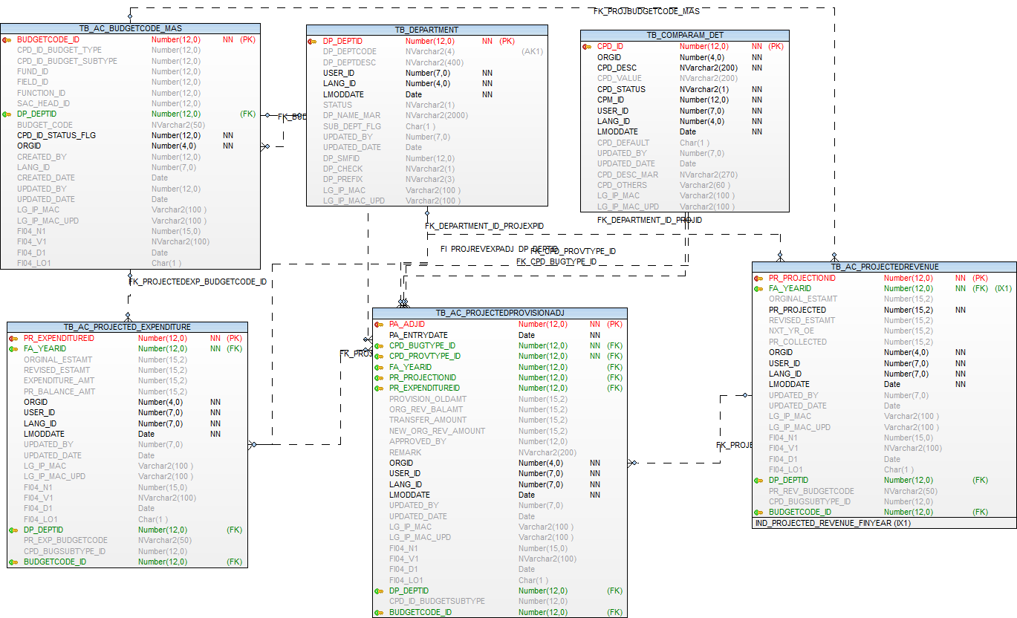

Validation on Additional/Supplemental Of Budget Form

Column Name | Validation
Entry Date * | Mandary Column,  And it will be a showing field (Read only Field),  Entry date field must be showing automatically depending on System Date.
Financial Year * | Mandatory column,  Financial Year Field must be selected on current financial year and before all financial years only/-
Budget Type * | Budget Type field must be a mandatory,  And Budget Type field will be showing on Revenue/Expenditure only, Based on the selected Budget type and financial year the entire data will be generated internally
Budget Sub Type * | Budget Sub Type field must be a mandatory,  And Budget Sub Type field will be showing on Revenue/capital only, Based on the selected Budget Type,Budget Sub type and financial year the Primary Head data will be generated internally
Department * | Department Field must be a mandatory, and select department field on saving time.
Fund Code | Fund Code must not be a mandatory field, and all Fund code- list populated based on financial year and budget type(Revenue/Enpenditure) only
Field Code | Field Code Must not be a mandatory field, and all  Field code- list populated based on financial year and budget type(Revenue/Enpenditure) only
Function Code | Function Code Must not be a mandatory field, and all Function code- list populated based on financial year and budget type(Revenue/Enpenditure) only
Primary Head Code * | Primary Head Code Must be a mandatory field, and all primary head code -list populated based on financial year and budget type(Revenue/Enpenditure) and budget sub type (Revenue/capital) only
Secondary Head Code * | Secondary Head Code Must be a mandatory field, and all secondary head code will be shows depending up on all Primary Head master and generated secondary head master -list populated based on financial year and budget type(Revenue/Enpenditure) only
Budget Provision * | Budget Provision Field must be a mandatory,  And it will be Showing field (Read only), it’s Allowing only numbers, Accept only maximum 13 digits.  Whenever we are selecting the fund, field, function, primary head code and secondary head code all combination and automatically generated Budget Provision amount based on the budget type and financial year  (Logic is Pending now)
Balance provision * | Balance Provision Field must be a mandatory,  And it will be Showing field(Read only), it’s Allowing only numbers, Accept only maximum 13 digits.  Whenever we are selecting the fund, field, function, primary head code and secondary head code all combination and automatically generated balance provision based on the budget type and financial year.  (Logic is Pending)
Additional Provision * | Transfer Provision field must be a mandatory,  And it will be Enterable Field, it’s Allowing only numbers, Accept only maximum 13 digits.
Final Provision * | Final Provision amount must be Mandatory,  And it will be Showing field(Read only), it’s Allowing only numbers, Accept only maximum 13 digits.  Whenever we are Entering the Additional Provision Amount automatically showing (Additional Provision Amount + Budget provision Amount = Final Provision Amount) in Final Provision Field.
Remark * | Mandary Column,  And it will be a Enterable Field,  Saving time its checks the remark field is empty or not, Entering the text data for identification/remembering purpose only
Approved By* | Mandatory column,  Approved By column are using the which selected Employee is approved by entired Form Transaction.

Budgetory Revision

Operations-→  Tables | Select | Insert | Edit | Delete
TB_AC_BUDGETORY_REVISED | Y | Y | Y | N
TB_DEPARTMENT | Y | N | N | N
EMPLOYEE | Y | N | N | N
TB_COMPARAM_DET | Y | N | N | N
TB_AC_BUDGETCODE_MAS | Y | N | N | N
TB_FINANCIALYEAR | Y | N | N | N
TB_ORGANISATION | Y | N | N | N

Prefixes used:
Prefix | Description | Remarks/use
FTP | Fund Type | Revenue  Capital
REX | Revenue/Expenditure Type | Revenue  Expenditure

TB_AC_BUDGETORY_REVISED

Purpose: - This table is used for store revision budgetary.

Name | Type | Nullable | Default | Comments
BUGREV_ID | NUMBER(12) |  |  | Primary Key
FA_YEARID | NUMBER(12) | Y |  | Reference key-TB_FINANCIALYEAR
CPD_BUGTYPE_ID | NUMBER(12) |  |  | Bugdet type, Reference key-TB_COMPARAM_DET Prefix "REX" Revenue/Expenditure Type
CPD_BUGSUBTYPE_ID | NUMBER(12) |  |  | Bugdet type, Reference key-TB_COMPARAM_DET Prefix "PRV" PROVISION TYPE Provision type i.e. Prov. Adjustment or Add. Provision
DP_DEPTID | NUMBER(12) | Y |  | Reference key-tb_department
BUDGETCODE_ID | NUMBER(12) | Y |  | FK - tb_ac_budgetcode_ma
LAST_YEAR_COUNT | NUMBER(3) | Y |  | Last year count
REVISED_AMOUNT | NUMBER(15,2) | Y |  | Revised Amount
ORGID | NUMBER(4) |  |  | Organisation id
LANG_ID | NUMBER(7) |  |  | Language Identity
CREATED_BY | NUMBER(7) |  |  | User Identity
CREATED_DATE | DATE |  |  | Date on which data is going to create
UPDATED_BY | NUMBER(7) | Y |  | User id who update the data
UPDATED_DATE | DATE | Y |  | Last Modification Date
LG_IP_MAC | VARCHAR2(100) | Y |  | Client Machine?s Login Name | IP Address | Physical Address
LG_IP_MAC_UPD | VARCHAR2(100) | Y |  | Updated Client Machine?s Login Name | IP Address | Physical Address
FI04_N1 | NUMBER(15) | Y |  | Additional number FI04_N1 to be used in future
FI04_V1 | NVARCHAR2(100) | Y |  | Additional nvarchar2 FI04_V1 to be used in future
FI04_D1 | DATE | Y |  | Additional Date FI04_D1 to be used in future
FI04_LO1 | CHAR(1) | Y |  | Additional Logical field FI04_LO1 to be used in future

Index (es):-

Index Name | Table Name | Field Name | Index Type
PK_REVISED_ID | TB_AC_BUDGETORY_REVISED | BUGREV_ID | Unique

Other Information:-

Key | Name | Field Name | Reference Table | Reference Field
Primary | PK_REVISED_ID | BUGREV_ID
Foreign | FK_BUDBUGTYPE_ID | CPD_BUGTYPE_ID | TB_COMPARAM_DET | CPD_ID
Foreign | FK_BUDGREVISED_FA_YEARID | FA_YEARID | TB_FINANCIALYEAR | FA_YEARID
Foreign | FK_BUDGREVISED_BUDGETCODE_ID | BUDGETCODE_ID | TB_AC_BUDGETCODE_MAS | BUDGETCODE_ID
Foreign | FK_BUDGREVISED_ID | CPD_BUGSUBTYPE_ID | TB_COMPARAM_DET | CPD_ID
Foreign | FK_BUGTYPE_DP_DEPTID | DP_DEPTID | TB_DEPARTMENT | DP_DEPTID

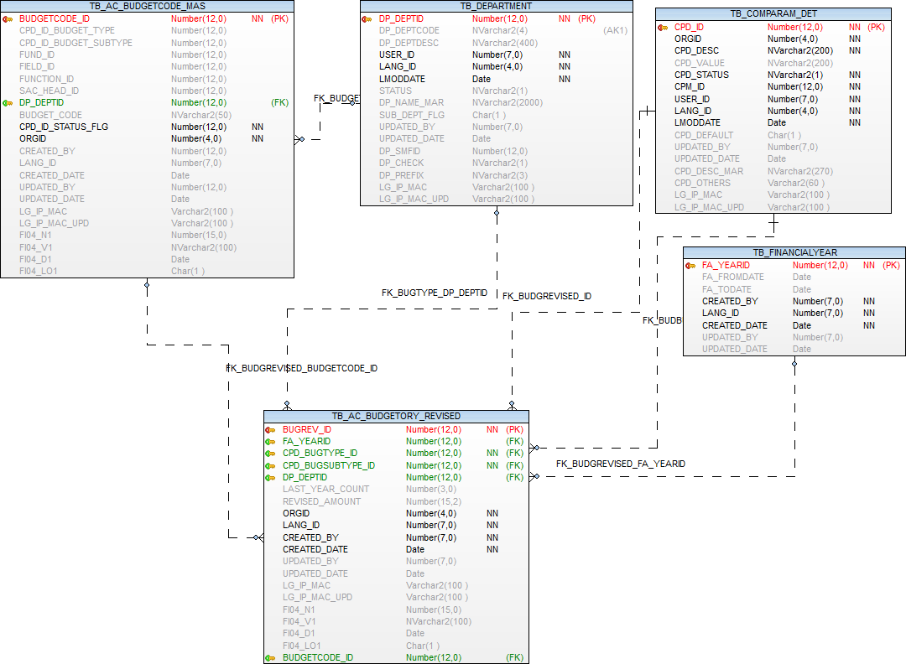

Validation on Budgetory Revision Form
Column Name | Validation
Financial Year * | Mandatory column,  Financial Year Field must be selected on current financial year and before all financial years only/-
Budget Type * | Budget Type field must be a mandatory,  And Budget Type field will be showing on Revenue/Expenditure only, Based on the selected Budget type and financial year the entire data will be generated internally
Budget Sub Type * | Budget Sub Type field must be a mandatory,  And Budget Sub Type field will be showing on Revenue/capital only, Based on the selected Budget Type,Budget Sub type and financial year the Primary Head data will be generated internally(condition based)
Department * | Department Field must be a mandatory, and select department field on saving time.
Last Year Count | Entered Last Year Count value Field is Mandatory,  And based on the count value to displaying/generated the Actual of Last Years Count Amount
Fund Code | Fund Code must not be a mandatory field, and all Fund code- list populated based on financial year and budget type(Revenue/Enpenditure) only
Field Code | Field Code Must not be a mandatory field, and all  Field code- list populated based on financial year and budget type(Revenue/Enpenditure) only
Function Code | Function Code Must not be a mandatory field, and all Function code- list populated based on financial year and budget type(Revenue/Enpenditure) only
Primary Head Code * | Primary Head Code Must be a mandatory field, and all primary head code -list populated based on financial year and budget type(Revenue/Enpenditure) only
Secondary Head Code * | Secondary Head Code Must be a mandatory field, and all secondary head code will be shows depending up on all Primary Head master and generated secondary head master -list populated based on financial year and budget type(Revenue/Enpenditure) only
Actuals of Last Years Data | Based on the Enter last Year Count Value to be the Actual of Last Years Data will be generated Dynamically, this is display field
Basic Budget | Selected on the Financial Year the Original Estimate Amount value will showing in the Basic Budget field automatically/dynamically,this is display field
Actual Till Nov 2015 | Actual Till Nov field is Displayable Field and this field is not a mandatory.
Budgeted From Dec 15 to Mar 16 | The Budgeted From Dec to Mar Field is Display Field, And the Field id not a mandatory.
Revised | Revised is a Enterable Field and this field is not a mandatory.

Estimation Preparation

Operations-→  Tables | Select | Insert | Edit | Delete
TB_AC_BUDGETORY_ESTIMATE | Y | Y | Y | N
TB_DEPARTMENT | Y | N | N | N
EMPLOYEE | Y | N | N | N
TB_COMPARAM_DET | Y | N | N | N
TB_AC_BUDGETCODE_MAS | Y | N | N | N
TB_FINANCIALYEAR | Y | N | N | N
TB_ORGANISATION | Y | N | N | N

Prefixes used:
Prefix | Description | Remarks/use
FTP | Fund Type | Revenue  Capital
REX | Revenue/Expenditure Type | Revenue  Expenditure

TB_AC_BUDGETORY_ESTIMATE

Purpose: - This table is used for store budget estimate entry.

Name | Type | Nullable | Default | Comments
BUGEST_ID | NUMBER(12) |  |  | Primary Key
FA_YEARID | NUMBER(12) | Y |  | Reference key-TB_FINANCIALYEAR
CPD_BUGTYPE_ID | NUMBER(12) |  |  | Bugdet type, Reference key-TB_COMPARAM_DET Prefix "REX" Revenue/Expenditure Type
CPD_BUGSUBTYPE_ID | NUMBER(12) |  |  | Bugdet type, Reference key-TB_COMPARAM_DET Prefix "PRV" PROVISION TYPE Provision type i.e. Prov. Adjustment or Add. Provision
DP_DEPTID | NUMBER(12) | Y |  | Reference key-tb_department
BUDGETCODE_ID | NUMBER(12) | Y |  | FK - tb_ac_budgetcode_ma
LAST_YEAR_COUNT | NUMBER(3) | Y |  | Last year count
ESTIMATE_FOR_NEXTYEAR | NUMBER(15,2) | Y |  | ULB Estimates for Next Year
APPR_BUG_STAND_COM | NUMBER(15,2) | Y |  | Approval Budget ( Standing Committee )
FINALIZED_BUG_GEN_BODY | NUMBER(15,2) | Y |  | Finalized Budget ( General Body)
ORGID | NUMBER(4) |  |  | Organisation id
LANG_ID | NUMBER(7) |  |  | Language Identity
CREATED_BY | NUMBER(7) |  |  | User Identity
CREATED_DATE | DATE |  |  | Date on which data is going to create
UPDATED_BY | NUMBER(7) | Y |  | User id who update the data
UPDATED_DATE | DATE | Y |  | Last Modification Date
LG_IP_MAC | VARCHAR2(100) | Y |  | Client Machine?s Login Name | IP Address | Physical Address
LG_IP_MAC_UPD | VARCHAR2(100) | Y |  | Updated Client Machine?s Login Name | IP Address | Physical Address
FI04_N1 | NUMBER(15) | Y |  | Additional number FI04_N1 to be used in future
FI04_V1 | NVARCHAR2(100) | Y |  | Additional nvarchar2 FI04_V1 to be used in future
FI04_D1 | DATE | Y |  | Additional Date FI04_D1 to be used in future
FI04_LO1 | CHAR(1) | Y |  | Additional Logical field FI04_LO1 to be used in future

Index (es):-
Index Name | Table Name | Field Name | Index Type
PK_BUDG_ESTIMATE_ID | TB_AC_BUDGETORY_ESTIMATE | BUGEST_ID | Unique

Other Information:-

Key | Name | Field Name | Reference Table | Reference Field
Primary | PK_BUDG_ESTIMATE_ID | BUGEST_ID
Foreign | FK_BUDGESTIMATE_FA_YEARID | FA_YEARID | TB_FINANCIALYEAR | FA_YEARID
Foreign | FK_BUDGREVISED_BUDGETCODE_ID | BUDGETCODE_ID | TB_AC_BUDGETCODE_MAS | BUDGETCODE_ID
Foreign | FK_BUDGESTIMATE_ID | CPD_BUGSUBTYPE_ID | TB_COMPARAM_DET | CPD_ID
Foreign | FK_BUDGESTIMATE_SACHD_ID | SAC_HEAD_ID | TB_AC_SECONDARYHEAD_MASTER | SAC_HEAD_ID
Foreign | FK_BUDGETOR_ID | CPD_BUGTYPE_ID | TB_COMPARAM_DET | CPD_ID
Foreign | FK_BUGESTIMATEC_DP_DEPTID | DP_DEPTID | TB_DEPARTMENT | DP_DEPTID

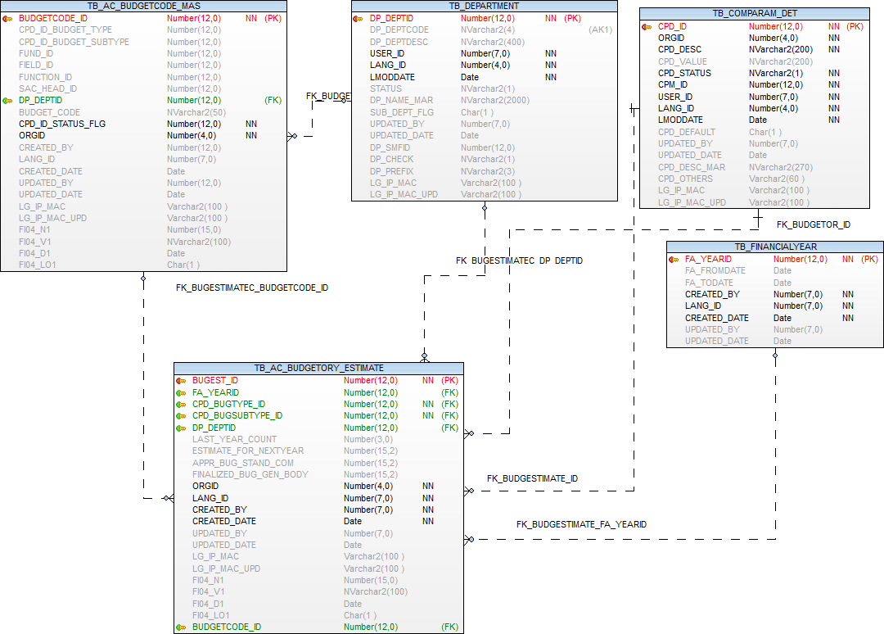

Validation on Estimation Preparation Form

Column Name | Validation
Financial Year * | Mandatory column,  Financial Year Field must be selected on current financial year and before all financial years only/-
Budget Type * | Budget Type field must be a mandatory,  And Budget Type field will be showing on Revenue/Expenditure only, Based on the selected Budget type and financial year the entire data will be generated internally
Budget Sub Type * | Budget Sub Type field must be a mandatory,  And Budget Sub Type field will be showing on Revenue/capital only, Based on the selected Budget Type,Budget Sub type and financial year the Primary Head data will be generated internally(condition based)
Department * | Department Field must be a mandatory, and select department field on saving time.
Last Year Count | Entered Last Year Count value Field is Mandatory,  And based on the count value to displaying/generated the Actual of Last Years Count Amount
Fund Code | Fund Code must not be a mandatory field, and all Fund code- list populated based on financial year and budget type(Revenue/Enpenditure) only
Field Code | Field Code Must not be a mandatory field, and all  Field code- list populated based on financial year and budget type(Revenue/Enpenditure) only
Function Code | Function Code Must not be a mandatory field, and all Function code- list populated based on financial year and budget type(Revenue/Enpenditure) only
Primary Head Code * | Primary Head Code Must be a mandatory field, and all primary head code -list populated based on financial year and budget type(Revenue/Enpenditure) only
Secondary Head Code * | Secondary Head Code Must be a mandatory field, and all secondary head code will be shows depending up on all Primary Head master and generated secondary head master -list populated based on financial year and budget type(Revenue/Enpenditure) only
Actuals of Last Years Data | Based on the Enter last Year Count Value to be the Actual of Last Years Data will be generated Dynamically, this is display field
Current Year Budget | Selected on the Financial Year the Original Estimate Amount value will showing in the current year Budget field automatically/dynamically,this is display field
ULB Estimates for Next Year | Estimates for Next Year Amount field is Enterable Field and this field is not a mandatory.
Approval Budget (Standing Committee) | The Approval Budget (Standing Committee) Field is Display Field, And the Field id not a mandatory.  And Enter the ULB Estimates for Next Year Amount,Same Amount will be automatically displayed in Approval Budget Field
Finalized Budget (General Body) | The Finalized Budget (General Body) Field is Display Field, And the Field id not a mandatory.  And Enter the ULB Estimates for Next Year Amount,Same Amount will be automatically displayed in Finalized Budget Field

Accounts Receipt and Receipt Reversal

Operations-→  Tables | Select | Insert | Edit | Delete
TB_RECEIPT_MAS | Y | Y | Y | N
TB_RECEIPT_DET | Y | Y | Y | N
TB_RECEIPT_MODE | Y | Y | Y | N
TB_DEPARTMENT | Y | N | N | N
EMPLOYEE | Y | N | N | N
TB_COMPARAM_DET | Y | N | N | N
TB_AC_FIELD_MASTER | Y | N | N | N
TB_AC_BUDGETCODE_MAS | Y | N | N | N
TB_FINANCIALYEAR | Y | N | N | N
TB_ORGANISATION | Y | N | N | N
TB_AC_BANK_DEPOSITSLIP_MASTER | Y | N | N | N
TB_BANK_ACCOUNT | Y | N | N | N
TB_BANK_MASTER | Y | N | N | N

Prefixes used:
Prefix | Description | Remarks/use
PAY | Pay mode

TB_RECEIPT_MAS
Purpose: - This table is used for store receipt master entry

Name | Type | Nullable | Default | Comments
RM_RCPTID | NUMBER(12) |  |  | Generated Id
RM_RCPTNO | NUMBER(12) | Y |  | Receipt no
RM_DATE | DATE | Y |  | Receipt date
APM_APPLICATION_ID | NUMBER(16) | Y |  | Application Id
RM_RECEIPTCATEGORY_ID | NUMBER(12) | Y |  | Receipt category
RM_AMOUNT | NUMBER(12,2) | Y |  | Receipt amount
CM_COLLNID | NUMBER(12) | Y |  | Collection Id
CU_COUNTERID | NUMBER(12) | Y |  | Counter Id
RM_RECEIVEDFROM | NVARCHAR2(100) | Y |  | Received from
RM_NARRATION | NVARCHAR2(200) | Y |  | Narration
RM_COLNCNT_RCPTNO | NUMBER(12) | Y |  | Collection receipt no
RM_COUNTER_RCPTNO | NUMBER(12) | Y |  | Counter receipt no
SM_SERVICE_ID | NUMBER(12) | Y |  | Service Id
ORGID | NUMBER(4) |  |  | Org ID
CREATED_BY | NUMBER(7) | Y |  | user id who created the record
LANG_ID | NUMBER(7) | Y |  | Lang ID
CREATED_DATE | DATE | Y |  | record creation date
UPDATED_BY | NUMBER(7) | Y |  | User id who update the data
UPDATED_DATE | DATE | Y |  | Date on which data is going to update
LG_IP_MAC | VARCHAR2(100) | Y |  | Client MachineÃ¢â¿¬â¿¢s Login Name | IP Address | Physical Address
LG_IP_MAC_UPD | VARCHAR2(100) | Y |  | Updated Client MachineÃ¢â¿¬â¿¢s Login Name | IP Address | Physical Address
RM_V1 | NVARCHAR2(100) | Y |  | Additional nvarchar2 RM_V1 to be used in future
RM_V2 | NVARCHAR2(100) | Y |  | Additional nvarchar2 RM_V2 to be used in future
RM_V3 | NVARCHAR2(100) | Y |  | Additional nvarchar2 RM_V3 to be used in future
RM_V4 | NVARCHAR2(100) | Y |  | Additional nvarchar2 RM_V4 to be used in future
RM_V5 | NVARCHAR2(100) | Y |  | Additional nvarchar2 RM_V5 to be used in future
RM_N1 | NUMBER(15) | Y |  | Additional number RM_N1 to be used in future
RM_N2 | NUMBER(15) | Y |  | Additional number RM_N2 to be used in future
RM_N3 | NUMBER(15) | Y |  | Additional number RM_N3 to be used in future
RM_N4 | NUMBER(15) | Y |  | Additional number RM_N4 to be used in future
RM_N5 | NUMBER(15) | Y |  | Additional number RM_N5 to be used in future
RM_D1 | DATE | Y |  | Additional Date RM_D1 to be used in future
RM_D2 | DATE | Y |  | Additional Date RM_D2 to be used in future
RM_D3 | DATE | Y |  | Additional Date RM_D3 to be used in future
RM_LO1 | CHAR(1) | Y |  | Additional Logical field RM_LO1 to be used in future
RM_LO2 | CHAR(1) | Y |  | Additional Logical field RM_LO2 to be used in future
RM_LO3 | CHAR(1) | Y |  | Additional Logical field RM_LO3 to be used in future
RM_LOI_NO | NVARCHAR2(16) | Y |  | loi number form Tb_loi_mas
COD_DWZID1 | NUMBER(12) | Y |  | ward zone
COD_DWZID2 | NUMBER(12) | Y |  | ward zone
COD_DWZID3 | NUMBER(12) | Y |  | ward zone
COD_DWZID4 | NUMBER(12) | Y |  | ward zone
COD_DWZID5 | NUMBER(12) | Y |  | ward zone
ADDITIONAL_REF_NO | VARCHAR2(15) | Y |  | BILL ID FROM Bill master table of any module
DP_DEPTID | NUMBER(12) | Y
MANUALRECEIPTNO | NUMBER(12) | Y |  | Manual Receipt No
VM_VENDORID | NUMBER(12) | Y |  | fk Ref. Vendor id tb_vendormaster
MOBILE_NUMBER | NVARCHAR2(10) | Y |  | Mobile Number
EMAIL_ID | NVARCHAR2(100) | Y |  | Email Id
RECEIPT_DEL_FLAG | CHAR(1) | Y |  | Y for delete recept
RECEIPT_DEL_DATE | DATE | Y |  | Receipt Deletion Date (system date)
RECEIPT_DEL_POSTING_DATE | DATE | Y |  | Deleted RV Posting Date
RECEIPT_DEL_REMARK | VARCHAR2(500) | Y |  | Deleted Receipt Remark
FIELD_ID | NUMBER(12) | Y |  | Field Master Reference key --TB_AC_FIELD_MASTER
CHALLAN_ID | NUMBER(12) | Y |  | fk. tb_challan_master
REF_ID | NUMBER(12) | Y |  | 1. Reversal payment voucher  payment id
RECEIPT_TYPE_FLAG | CHAR(1) | Y |  | "R"- Receipt  "C"- Contra (internal receipt)  receipt number is separate for internal receipt  "P"- Payment voucher delete (internal receipt)

Index (es):-

Index Name | Table Name | Field Name | Index Type
PK_SRCPT_ID | TB_RECEIPT_MAS | RM_RCPTID | Unique

Other Information:-

Key | Name | Field Name | Reference Table | Reference Field
Primary | PK_SRCPT_ID | RM_RCPTID
Foreign | FKDEPT_TB_SERVICE_RECEIPT | DP_DEPTID | TB_DEPARTMENT | DP_DEPTID
Foreign | FK_FIELD_ID_RECEIPT | FIELD_ID | TB_AC_FIELD_MASTER | FIELD_ID

TB_RECEIPT_DET
Purpose: - This table is used for store receipt tax wise details

Name | Type | Nullable | Default | Comments
RF_FEEID | NUMBER(12) |  |  | Generated Id
RM_RCPTID | NUMBER(12) | Y |  | Receipt id
TAX_ID | NUMBER(12) | Y |  | Tax id from tax master table
RF_FEEAMOUNT | NUMBER(12,2) | Y |  | Fees amount
ORGID | NUMBER(4) |  |  | Org ID
CREATED_BY | NUMBER(7) | Y |  | User ID
LANG_ID | NUMBER(7) | Y |  | Lang ID
CREATED_DATE | DATE | Y |  | Last Modification Date
UPDATED_BY | NUMBER(7) | Y |  | User id who update the data
UPDATED_DATE | DATE | Y |  | Date on which data is going to update
LG_IP_MAC | VARCHAR2(100) | Y |  | Client MachineÃ¢â¿¬â¿¢s Login Name | IP Address | Physical Address
LG_IP_MAC_UPD | VARCHAR2(100) | Y |  | Updated Client MachineÃ¢â¿¬â¿¢s Login Name | IP Address | Physical Address
RF_V1 | NVARCHAR2(100) | Y |  | Additional nvarchar2 RF_V1 to be used in future
RF_V2 | NVARCHAR2(100) | Y |  | Additional nvarchar2 RF_V2 to be used in future
RF_V3 | NVARCHAR2(100) | Y |  | Additional nvarchar2 RF_V3 to be used in future
RF_V4 | NVARCHAR2(100) | Y |  | Additional nvarchar2 RF_V4 to be used in future
RF_V5 | NVARCHAR2(100) | Y |  | Additional nvarchar2 RF_V5 to be used in future
RF_N2 | NUMBER(15) | Y |  | Additional number RF_N2 to be used in future
RF_N3 | NUMBER(15) | Y |  | Additional number RF_N3 to be used in future
RF_N4 | NUMBER(15) | Y |  | Additional number RF_N4 to be used in future
RF_N5 | NUMBER(15) | Y |  | Additional number RF_N5 to be used in future
RF_D1 | DATE | Y |  | Additional Date RF_D1 to be used in future
RF_D2 | DATE | Y |  | Additional Date RF_D2 to be used in future
RF_D3 | DATE | Y |  | Additional Date RF_D3 to be used in future
RF_LO1 | CHAR(1) | Y |  | Additional Logical field RF_LO1 to be used in future
RF_LO2 | CHAR(1) | Y |  | Additional Logical field RF_LO2 to be used in future
RF_LO3 | CHAR(1) | Y |  | Additional Logical field RF_LO3 to be used in future
BILLDET_ID | NUMBER(12) | Y |  | Department wise bill details id Water(BD_BILLDETID)/ Assessment ()
BUDGETCODE_ID | number(12) | y |  | FK - tb_ac_budgetcode_mas
DPS_SLIPID | number(12) | y |  | Ref. key -TB_AC_BANK_DEPOSLIP_MASTER

Index (es):-

Index Name | Table Name | Field Name | Index Type
PK_SRCPTFEEDET_RF_FEEID | TB_RECEIPT_DET | RF_FEEID | Unique

Other Information:-

Key | Name | Field Name | Reference Table | Reference Field
Primary | PK_SRCPTFEEDET_RF_FEEID | RF_FEEID
Foreign | FK_RECEIPT_BUDGETCODE_ID | BUDGETCODE_ID | TB_AC_BUDGETCODE_MAS | BUDGETCODE_ID

TB_RECEIPT_MODE

Purpose: - This table is used for store receipt mode wise details

Name | Type | Nullable | Default | Comments
RD_MODESID | NUMBER(12) |  |  | Generated Id
RM_RCPTID | NUMBER(12) | Y |  | Receipt Id
CPD_FEEMODE | NUMBER(12) | Y |  | Fees mode
RD_CHEQUEDDNO | NUMBER(12) | Y |  | Cheque or DD no
RD_CHEQUEDDDATE | DATE | Y |  | Cheque or DD date
RD_DRAWNON | NVARCHAR2(200) | Y |  | Drawn on
BANKID | NUMBER(12) | Y |  | BANKID
RD_AMOUNT | NUMBER(12,2) | Y |  | Received amount
ORGID | NUMBER(4) |  |  | Org ID
CREATED_BY | NUMBER(7) | Y |  | User ID
LANG_ID | NUMBER(7) | Y |  | Lang ID
CREATED_DATE | DATE | Y |  | Last Modification Date
UPDATED_BY | NUMBER(7) | Y |  | User id who update the data
UPDATED_DATE | DATE | Y |  | Date on which data is going to update
LG_IP_MAC | VARCHAR2(100) | Y |  | Client MachineÃ¢â¿¬â¿¢s Login Name | IP Address | Physical Address
LG_IP_MAC_UPD | VARCHAR2(100) | Y |  | Updated Client MachineÃ¢â¿¬â¿¢s Login Name | IP Address | Physical Address
RD_V1 | NVARCHAR2(100) | Y |  | Additional nvarchar2 RD_V1 to be used in future
RD_V2 | NVARCHAR2(100) | Y |  | Additional nvarchar2 RD_V2 to be used in future
RD_V3 | NVARCHAR2(100) | Y |  | Additional nvarchar2 RD_V3 to be used in future
RD_V4 | NVARCHAR2(100) | Y |  | Additional nvarchar2 RD_V4 to be used in future
RD_V5 | NVARCHAR2(100) | Y |  | Additional nvarchar2 RD_V5 to be used in future
RD_N1 | NUMBER(15) | Y |  | Additional number RD_N1 to be used in future
RD_N2 | NUMBER(15) | Y |  | Additional number RD_N2 to be used in future
RD_N3 | NUMBER(15) | Y |  | Additional number RD_N3 to be used in future
RD_N4 | NUMBER(15) | Y |  | Additional number RD_N4 to be used in future
RD_N5 | NUMBER(15) | Y |  | Additional number RD_N5 to be used in future
RD_D1 | DATE | Y |  | Additional Date RD_D1 to be used in future
RD_D2 | DATE | Y |  | Additional Date RD_D2 to be used in future
RD_D3 | DATE | Y |  | Additional Date RD_D3 to be used in future
RD_LO1 | CHAR(1) | Y |  | Additional Logical field RD_LO1 to be used in future
RD_LO2 | CHAR(1) | Y |  | Additional Logical field RD_LO2 to be used in future
RD_LO3 | CHAR(1) | Y |  | Additional Logical field RD_LO3 to be used in future
RD_SR_CHK_DIS | CHAR(1) | Y |  | flag for check disowner
RD_OUTSTATION_CHQ | NVARCHAR2(1) | Y |  | Outstation cheque or local
RD_SR_CHK_DATE | DATE | Y |  | CHEQUE CLEARED OR DISHONOR DATE
RD_SR_CHK_DIS_CHG | NUMBER(12,2) | Y |  | cheque dishonor charges
BA_ACCOUNTID | NUMBER(12) | Y |  | Ref key- TB_BANK_ACCOUNT for Bank , RTGS , NEFT and WEB
TRAN_REF_NUMBER | NVARCHAR2(22) | Y |  | Bank , RTGS , NEFT and WEB system should be able to capture ULB account bank details, transaction reference number
TRAN_REF_DATE | DATE | Y |  | Bank , RTGS , NEFT and WEB transaction reference date
DISCREPANCY_FLAG | CHAR(1) | Y | N | Update from Reconciliation form - if discrepancy is found update "Y" else default "N"
DISCREPANCYDETAILS | NVARCHAR2(500) | Y |  | Update from Reconciliation form - if discrepancy is found then enter discrepancy details.
BUDGETCODE_ID | NUMBER(12) | Y |  | FK - tb_ac_budgetcode_mas

Index (es):-

Index Name | Table Name | Field Name | Index Type
PK_MODESID | TB_RECEIPT_MODE | RD_MODESID | Unique

Other Information:-

Key | Name | Field Name | Reference Table | Reference Field
Primary | PK_MODESID | RD_MODESID
Foreign | FK_RECEIPT_BA_ACCOUNTID | BA_ACCOUNTID | TB_BANK_ACCOUNT | BA_ACCOUNTID

Validation on Receipt Form

Column Name | Validation
Receipt Number * | Mandatory column,  The receipt no. will be system generated on the click of save button  Receipt number reset department wise Financial year wise.
Collection Center No
Manual Receipt No. | Number column ,  Accept only maximum 12 digit
Receipt Date * | Defult entry date,  Readonly column
Received From | List column,  List Populate form vendor master,  After selected vendor name, same vendor name copy into Name column  Table “tb_vendormaster”
Name * | Input column,  Maxlength 200 ,  Mandatory column,
Mobile No. | Accept only maximum 10 digit
Department Name * | List Populate form Deparment master,  Mandatory column,  Default accounts department show,  Table “tb_department”
Email Id | Validate an email address  Accept only lower case
Narration * | Mandatory column,  Accept maximum 200 nvarchar
Field | List populate from field master
Receipt Collection Details

Fund | List Populate form Fund master,
Function* | List Populate form Function master,  Mandatory column,
Account Head | Primary Account Code + Secondry Head code + Description
Receipt Amount* | Number column ,  Accept only maximum 15 digit ,
Payment Mode * | List Populate form Prefix master, Prefix – “PAY”  Mandatory column  Validation  Cash/FRD  - Only amount column showing,  - Amount -readonly column  Cheque/DD  - Drawn On (Customer Bank list showing- TB_BANK_MASTER)  - Cheque / DD No./ Pay Order  - Accept maximum 8 char  - Cheque / DD / Date  - Cheque date validation – 1. Cheque date should not be greater than Todays Date 2. Cheque Date should not be older than three months  - Amount -readonly column  NEFT/RTGS/BANK/WEB  - ULB Bank Account List showing (TB_BANK_ACCOUNT)  - Transaction Ref Number (Accept maximum 22 nvarchar)  - Transaction Ref Date  - Amount -readonly column
Drawn On | Customer Bank list showing- TB_BANK_MASTER
Cheque / DD No./ Pay Order | Accept maximum 8 char
Cheque / DD / Date | Cheque date validation – 1. Cheque date should not be greater than Todays Date 2. Cheque Date should not be older than three months
Amount * | Total payment amount will be the total of receipt collection details,  Readonly column
ULB Bank Account | ULB Bank Account List showing ()  TB_BANK_ACCOUNT
Transaction Ref Number | Transaction Ref Number (Accept maximum 22 nvarchar)
Transaction Ref Date | Transaction Ref Date

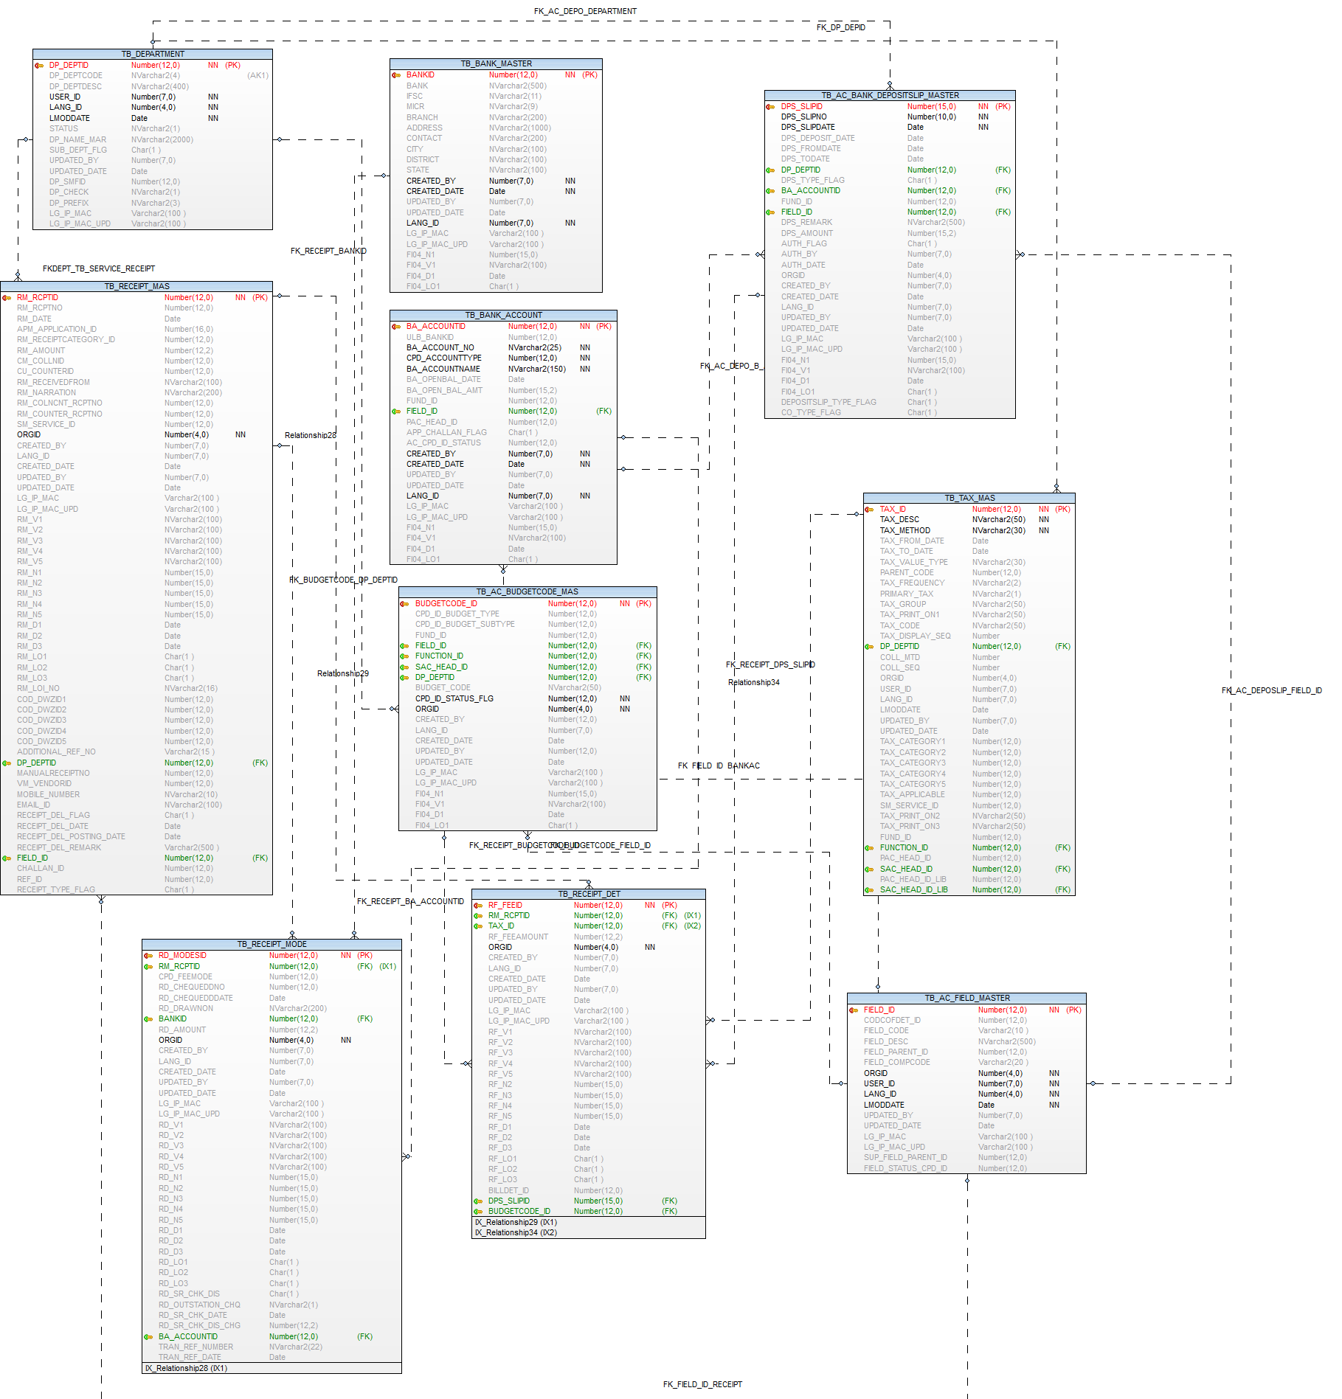

Account Receipt Reversal

Column Name | Validation
Reason for Deletion * | Mandatory column,  Accept maximum 500 nvarchar
Deletion Date * | Mandatory column,  Defult system date,  Readonly column

Contra Entry form

Operations-→  Tables | Select | Insert | Edit | Delete
TB_AC_BANK_DEPOSITSLIP_MASTER | Y | Y | Y | N
TB_AC_BANK_DEPOSITSLIP_DENOM | Y | Y | Y | N
TB_RECEIPT_MAS | Y | Y | Y | N
TB_RECEIPT_DET | Y | Y | Y | N
TB_RECEIPT_MODE | Y | Y | Y | N
TB_AC_PAYMENT_MAS | Y | Y | Y | N
EMPLOYEE | Y | N | N | N
TB_DEPARTMENT | Y | N | N | N
TB_COMPARAM_DET | Y | N | N | N
TB_ORGANISATION | Y | N | N | N
TB_COMPARAM_DET | Y | N | N | N
TB_BANK_ACCOUNT | Y | N | N | N

Prefixes used:
Prefix | Description | Remarks/use
PAY | Pay mode | Values C,Q
DEN | List of Cash Deposite Denomination | Ten 10  Hundred 100  Fifty 50  Twenty 20  Five 5  Two 2  One Thousand 1000  Five Hundred 500  One 1

TB_AC_BANK_DEPOSITSLIP_MASTER

Name | ORACLE DATATYPE | MySql DATATYPE | Nullable | Comments
DPS_SLIPID | NUMBER(15) | BIGINT(15) |  | Primary key
DPS_SLIPNO | NUMBER(10) | BIGINT (10) |  | Deposit Number
DPS_SLIPDATE | DATE | DATE |  | Deposit Slip Date
DPS_DEPOSIT_DATE | DATE | DATE | Y | Deposit Date
DPS_FROMDATE | DATE | DATE | Y | From Date
DPS_TODATE | DATE | DATE | Y | To Date
DP_DEPTID | NUMBER(12) | BIGINT (12) | Y | Department id - Fk Ref.-tb_department
DPS_TYPE_FLAG | CHAR(1) | CHAR(1) | Y | Deposit flag C- Cash and Q-Deposit cheque/DD
BA_ACCOUNTID | NUMBER(12) | BIGINT (12) | Y | Receipt Bank Account ID tb_bank_account
FUND_ID | NUMBER(12) | BIGINT (12) | Y | Fund Master Reference key --TB_AC_FUND_MASTER
FIELD_ID | NUMBER(12) | BIGINT (12) | Y | Field Master Reference key --TB_AC_FIELD_MASTER
DPS_REMARK | NVARCHAR2(500) | VARCHAR2(500) | Y | Remark
DPS_AMOUNT | NUMBER(15,2) | DECIMAL(15,2) | Y | Total Deposit Amount
AUTH_FLAG | CHAR(1) | CHAR(1) | Y | Authorization Flag 'Y' for authorised
AUTH_BY | NUMBER(7) | BIGINT(12) | Y | Authorised User Identity
AUTH_DATE | DATE | DATE | Y | Authorised Date
ORGID | NUMBER(4) | BIGINT(12) | Y | Organization Id
CREATED_BY | NUMBER(7) | BIGINT(12) | Y | User Identity
CREATED_DATE | DATE | DATE | Y | Created Date
LANG_ID | NUMBER(7) | NUMBER(7) | Y | Language Identity(removed)
UPDATED_BY | NUMBER(7) | BIGINT(12) | Y | updated by
UPDATED_DATE | DATE | DATE | Y | updated Date
LG_IP_MAC | VARCHAR2(100) | VARCHAR2(100) | Y | Client Machine?s Login Name | IP Address | Physical Address
LG_IP_MAC_UPD | VARCHAR2(100) | VARCHAR2(100) | Y | Updated Client Machine?s Login Name | IP Address | Physical Address
PS_DEL_AUTH_BY | NUMBER(15) | BIGINT(12) | Y | Deposite Slip Authorisation By
DPS_DEL_FLAG | NVARCHAR2(100) | VARCHAR2(1) | Y | DepositSlip Deletion flag
DPS_DEL_DATE | DATE | DATE | Y | DepositeSlip Deletion Date
DPS_DEL_ORDER_NO | CHAR(1) | VARCHAR(45) | Y | Deposite Deletion Order No
DEPOSITSLIP_TYPE_FLAG | CHAR(1) | CHAR(1) | Y | flag "D"-Deposit Slip  "C"- Contra
CO_TYPE_FLAG | CHAR(1) | CHAR(1) | Y | CONTRA TYPE flag - T -TRANSFER ENTRY , C-CASH WITHDRAWAL ENTRY, D-CASH DEPOSIT ENTRY
DPS_DEL_REMARK |  | VARCHAR(500) |  | Deposite Slip Deletion Remark

TB_AC_BANK_DEPOSITSLIP_DENOM

Name | Type | Nullable | Default | Comments
CASHDEP_DET_ID | NUMBER(12) |  |  | Cash Deposit Detail Id
DPS_SLIPID | NUMBER(15) | Y |  | Fk. Ref. id Tb_Ac_bank_deposlip_master
CPD_DENOMID | NUMBER(12) | Y |  | Deposit Denomination Id cpd id "DEN" Prefix
DENOM_COUNT | NUMBER(12,2) | Y |  | Denomination Count
ORGID | NUMBER(4) | Y |  | Organization Id
CREATED_BY | NUMBER(7) | Y |  | User Identity
CREATED_DATE | DATE | Y |  | Created Date
LANG_ID | NUMBER(7) | Y |  | Language Identity
UPDATED_BY | NUMBER(7) | Y |  | updated by
UPDATED_DATE | DATE | Y |  | updated Date
LG_IP_MAC | VARCHAR2(100) | Y |  | Client Machine?s Login Name | IP Address | Physical Address
LG_IP_MAC_UPD | VARCHAR2(100) | Y |  | Updated Client Machine?s Login Name | IP Address | Physical Address
FI04_N1 | NUMBER(15) | Y |  | Additional number FI04_N1 to be used in future
FI04_V1 | NVARCHAR2(100) | Y |  | Additional nvarchar2 FI04_V1 to be used in future
FI04_D1 | DATE | Y |  | Additional Date FI04_D1 to be used in future
FI04_LO1 | CHAR(1) | Y |  | Additional Logical field FI04_LO1 to be used in future

TB_RECEIPT_MAS

Name | Type | Nullable | Default | Comments
RM_RCPTID | NUMBER(12) |  |  | Generated Id
RM_RCPTNO | NUMBER(12) | Y |  | Receipt no
RM_DATE | DATE | Y |  | Receipt date
APM_APPLICATION_ID | NUMBER(16) | Y |  | Application Id
RM_RECEIPTCATEGORY_ID | NUMBER(12) | Y |  | Receipt category
RM_AMOUNT | NUMBER(12,2) | Y |  | Receipt amount
CM_COLLNID | NUMBER(12) | Y |  | Collection Id
CU_COUNTERID | NUMBER(12) | Y |  | Counter Id
RM_RECEIVEDFROM | NVARCHAR2(100) | Y |  | Received from
RM_NARRATION | NVARCHAR2(200) | Y |  | Narration
RM_COLNCNT_RCPTNO | NUMBER(12) | Y |  | Collection receipt no
RM_COUNTER_RCPTNO | NUMBER(12) | Y |  | Counter receipt no
SM_SERVICE_ID | NUMBER(12) | Y |  | Service Id
ORGID | NUMBER(4) |  |  | Org ID
CREATED_BY | NUMBER(7) | Y |  | User ID
LANG_ID | NUMBER(7) | Y |  | Lang ID
CREATED_DATE | DATE | Y |  | Last Modification Date
UPDATED_BY | NUMBER(7) | Y |  | User id who update the data
UPDATED_DATE | DATE | Y |  | Date on which data is going to update
LG_IP_MAC | VARCHAR2(100) | Y |  | Client MachineÃ¢â¿¬â¿¢s Login Name | IP Address | Physical Address
LG_IP_MAC_UPD | VARCHAR2(100) | Y |  | Updated Client MachineÃ¢â¿¬â¿¢s Login Name | IP Address | Physical Address
RM_V1 | NVARCHAR2(100) | Y |  | Additional nvarchar2 RM_V1 to be used in future
RM_V2 | NVARCHAR2(100) | Y |  | Additional nvarchar2 RM_V2 to be used in future
RM_V3 | NVARCHAR2(100) | Y |  | Additional nvarchar2 RM_V3 to be used in future
RM_V4 | NVARCHAR2(100) | Y |  | Additional nvarchar2 RM_V4 to be used in future
RM_V5 | NVARCHAR2(100) | Y |  | Additional nvarchar2 RM_V5 to be used in future
RM_N1 | NUMBER(15) | Y |  | Additional number RM_N1 to be used in future
RM_N2 | NUMBER(15) | Y |  | Additional number RM_N2 to be used in future
RM_N3 | NUMBER(15) | Y |  | Additional number RM_N3 to be used in future
RM_N4 | NUMBER(15) | Y |  | Additional number RM_N4 to be used in future
RM_N5 | NUMBER(15) | Y |  | Additional number RM_N5 to be used in future
RM_D1 | DATE | Y |  | Additional Date RM_D1 to be used in future
RM_D2 | DATE | Y |  | Additional Date RM_D2 to be used in future
RM_D3 | DATE | Y |  | Additional Date RM_D3 to be used in future
RM_LO1 | CHAR(1) | Y |  | Additional Logical field RM_LO1 to be used in future
RM_LO2 | CHAR(1) | Y |  | Additional Logical field RM_LO2 to be used in future
RM_LO3 | CHAR(1) | Y |  | Additional Logical field RM_LO3 to be used in future
RM_LOI_NO | NVARCHAR2(16) | Y |  | loi number form Tb_loi_mas
COD_DWZID1 | NUMBER(12) | Y |  | ward zone
COD_DWZID2 | NUMBER(12) | Y |  | ward zone
COD_DWZID3 | NUMBER(12) | Y |  | ward zone
COD_DWZID4 | NUMBER(12) | Y |  | ward zone
COD_DWZID5 | NUMBER(12) | Y |  | ward zone
ADDITIONAL_REF_NO | VARCHAR2(15) | Y |  | additional ref no
DP_DEPTID | NUMBER(12) | Y |  | add comment --Department id - Fk Ref.-tb_department
MANUALRECEIPTNO | NUMBER(12) | Y |  | Manual Receipt No
VM_VENDORID | NUMBER(12) | Y |  | fk Ref. Vendor id tb_vendormaster
MOBILE_NUMBER | NVARCHAR2(10) | Y |  | Mobile Number
EMAIL_ID | NVARCHAR2(100) | Y |  | Email Id
RECEIPT_DEL_FLAG | CHAR(1) | Y |  | Y for delete recept
RECEIPT_DEL_DATE | DATE | Y |  | Receipt Deletion Date (system date)
RECEIPT_DEL_POSTING_DATE | DATE | Y |  | Deleted RV Posting Date
RECEIPT_DEL_REMARK | VARCHAR2(500) | Y |  | Deleted Receipt Remark
FIELD_ID | NUMBER(12) | Y |  | Field Master Reference key --TB_AC_FIELD_MASTER
CHALLAN_ID | NUMBER(12) | Y |  | added new column fk. tb_challan_master
REF_ID | NUMBER(12) | Y |  | 1. Reversal payment voucher  payment id
RECEIPT_TYPE_FLAG | CHAR(1) | Y |  | "R"- Receipt  "C"- Contra (internal receipt)  receipt number is separate for internal receipt  "P"- Payment voucher delete (internal receipt)

TB_RECEIPT_DET

Name | Type | Nullable | Default | Comments
RF_FEEID | NUMBER(12) |  |  | Generated Id
RM_RCPTID | NUMBER(12) | Y |  | Receipt id
TAX_ID | NUMBER(12) | Y |  | Tax id from tax master table
RF_FEEAMOUNT | NUMBER(12,2) | Y |  | Fees amount
ORGID | NUMBER(4) |  |  | Org ID
CREATED_BY | NUMBER(7) | Y |  | User ID
LANG_ID | NUMBER(7) | Y |  | Lang ID
CREATED_DATE | DATE | Y |  | Last Modification Date
UPDATED_BY | NUMBER(7) | Y |  | User id who update the data
UPDATED_DATE | DATE | Y |  | Date on which data is going to update
LG_IP_MAC | VARCHAR2(100) | Y |  | Client MachineÃ¢â¿¬â¿¢s Login Name | IP Address | Physical Address
LG_IP_MAC_UPD | VARCHAR2(100) | Y |  | Updated Client MachineÃ¢â¿¬â¿¢s Login Name | IP Address | Physical Address
RF_V1 | NVARCHAR2(100) | Y |  | Additional nvarchar2 RF_V1 to be used in future
RF_V2 | NVARCHAR2(100) | Y |  | Additional nvarchar2 RF_V2 to be used in future
RF_V3 | NVARCHAR2(100) | Y |  | Additional nvarchar2 RF_V3 to be used in future
RF_V4 | NVARCHAR2(100) | Y |  | Additional nvarchar2 RF_V4 to be used in future
RF_V5 | NVARCHAR2(100) | Y |  | Additional nvarchar2 RF_V5 to be used in future
RF_N2 | NUMBER(15) | Y |  | Additional number RF_N2 to be used in future
RF_N3 | NUMBER(15) | Y |  | Additional number RF_N3 to be used in future
RF_N4 | NUMBER(15) | Y |  | Additional number RF_N4 to be used in future
RF_N5 | NUMBER(15) | Y |  | Additional number RF_N5 to be used in future
RF_D1 | DATE | Y |  | Additional Date RF_D1 to be used in future
RF_D2 | DATE | Y |  | Additional Date RF_D2 to be used in future
RF_D3 | DATE | Y |  | Additional Date RF_D3 to be used in future
RF_LO1 | CHAR(1) | Y |  | Additional Logical field RF_LO1 to be used in future
RF_LO2 | CHAR(1) | Y |  | Additional Logical field RF_LO2 to be used in future
RF_LO3 | CHAR(1) | Y |  | Additional Logical field RF_LO3 to be used in future
BILLDET_ID | NUMBER(12) | Y |  | Department wise bill details id Water(BD_BILLDETID)/ Assessment ()
DPS_SLIPID | NUMBER(12) | Y |  | Ref. key -TB_AC_BANK_DEPOSLIP_MASTER
BUDGETCODE_ID | NUMBER(12) | Y |  | FK - tb_ac_budgetcode_mas

TB_RECEIPT_MODE

Name | Type | Nullable | Default | Comments
RD_MODESID | NUMBER(12) |  |  | Generated Id
RM_RCPTID | NUMBER(12) | Y |  | Receipt Id
CPD_FEEMODE | NUMBER(12) | Y |  | Fees mode
RD_CHEQUEDDNO | NUMBER(12) | Y |  | Cheque or DD no
RD_CHEQUEDDDATE | DATE | Y |  | Cheque or DD date
RD_DRAWNON | NVARCHAR2(200) | Y |  | Drawn on
BANKID | NUMBER(12) | Y |  | Bank Id ref key --tb_bank_master
RD_AMOUNT | NUMBER(12,2) | Y |  | Received amount
ORGID | NUMBER(4) |  |  | Org ID
CREATED_BY | NUMBER(7) | Y |  | User ID
LANG_ID | NUMBER(7) | Y |  | Lang ID
CREATED_DATE | DATE | Y |  | Last Modification Date
UPDATED_BY | NUMBER(7) | Y |  | User id who update the data
UPDATED_DATE | DATE | Y |  | Date on which data is going to update
LG_IP_MAC | VARCHAR2(100) | Y |  | Client MachineÃ¢â¿¬â¿¢s Login Name | IP Address | Physical Address
LG_IP_MAC_UPD | VARCHAR2(100) | Y |  | Updated Client MachineÃ¢â¿¬â¿¢s Login Name | IP Address | Physical Address
RD_V1 | NVARCHAR2(100) | Y |  | Additional nvarchar2 RD_V1 to be used in future
RD_V2 | NVARCHAR2(100) | Y |  | Additional nvarchar2 RD_V2 to be used in future
RD_V3 | NVARCHAR2(100) | Y |  | Additional nvarchar2 RD_V3 to be used in future
RD_V4 | NVARCHAR2(100) | Y |  | Additional nvarchar2 RD_V4 to be used in future
RD_V5 | NVARCHAR2(100) | Y |  | Additional nvarchar2 RD_V5 to be used in future
RD_N1 | NUMBER(15) | Y |  | Additional number RD_N1 to be used in future
RD_N2 | NUMBER(15) | Y |  | Additional number RD_N2 to be used in future
RD_N3 | NUMBER(15) | Y |  | Additional number RD_N3 to be used in future
RD_N4 | NUMBER(15) | Y |  | Additional number RD_N4 to be used in future
RD_N5 | NUMBER(15) | Y |  | Additional number RD_N5 to be used in future
RD_D1 | DATE | Y |  | Additional Date RD_D1 to be used in future
RD_D2 | DATE | Y |  | Additional Date RD_D2 to be used in future
RD_D3 | DATE | Y |  | Additional Date RD_D3 to be used in future
RD_LO1 | CHAR(1) | Y |  | Additional Logical field RD_LO1 to be used in future
RD_LO2 | CHAR(1) | Y |  | Additional Logical field RD_LO2 to be used in future
RD_LO3 | CHAR(1) | Y |  | Additional Logical field RD_LO3 to be used in future
RD_SR_CHK_DIS | CHAR(1) | Y |  | flag for check disowner
RD_OUTSTATION_CHQ | NVARCHAR2(1) | Y |  | Outstation cheque or local
RD_SR_CHK_DATE | DATE | Y |  | CHEQUE CLEARED OR DISHONOR DATE
RD_SR_CHK_DIS_CHG | NUMBER(12,2) | Y |  | cheque dishonor charges
BA_ACCOUNTID | NUMBER(12) | Y |  | Ref key- TB_BANK_ACCOUNTfor Bank , RTGS , NEFT and WEB
TRAN_REF_NUMBER | NVARCHAR2(22) | Y |  | Bank , RTGS , NEFT and WEB system should be able to capture ULB account bank details, transaction reference number
TRAN_REF_DATE | DATE | Y |  | Bank , RTGS , NEFT and WEB transaction reference date

TB_AC_PAYMENT_MAS

Name | Type | Nullable | Default | Comments
PAYMENT_ID | NUMBER(12) |  |  | Primary Key
PAYMENT_NO | NVARCHAR2(12) | Y |  | Payment number system generated
PAYMENT_DATE | DATE | Y |  | payment Date
CPD_ID_BILLTYPE | NUMBER(12) | Y |  | Bill type prefix BBT - ref tb_comparam_det
DPS_SLIPID | NUMBER(12) | Y
VM_VENDORID | NUMBER(12) | Y |  | Vendor id- ref tb_vendormaster
CPD_ID_PAYMENT_MODE | NUMBER(12) | Y |  | Payment Mode from PAY prefix
BA_ACCOUNTID | NUMBER(12) | Y |  | Ref. Key -TB_BANK_ACCOUN
INSTRUMENT_NUMBER | NUMBER(12) | Y |  | Cheque Number/ RTGS ref. Number/ NFT ref. Number etc.
INSTRUMENT_DATE | DATE | Y |  | Cheque Date/ RTGS Date/ NFT Date etc.
PAYMENT_AMOUNT | NUMBER(15,2) | Y |  | Payment Amount
NARRATION | NVARCHAR2(1000) | Y |  | Narration / Remark
ORGID | NUMBER(4) | Y |  | Organisation Id
CREATED_BY | NUMBER(7) |  |  | Created User Identity
CREATED_DATE | DATE |  |  | Created Date
UPDATED_BY | NUMBER(7) | Y |  | User id who update the data
UPDATED_DATE | DATE | Y |  | Date on which data is going to update
LANG_ID | NUMBER(7) |  |  | Language Identity
LG_IP_MAC | VARCHAR2(100) | Y |  | Client Machine?s Login Name | IP Address | Physical Address
LG_IP_MAC_UPD | VARCHAR2(100) | Y |  | Updated Client Machine?s Login Name | IP Address | Physical Address
AUTHO_ID | NUMBER(7) | Y |  | Authoer Id
AUTHO_DATE | DATE | Y |  | Sysdate
AUTHO_FLG | CHAR(1) | Y |  | Flag
FI04_N1 | NUMBER(15) | Y |  | Additional number FI04_N1 to be used in future
FI04_V2 | NVARCHAR2(100) | Y |  | Additional nvarchar2 FI04_V2 to be used in future
FI04_D1 | DATE | Y |  | Additional Date FI04_D1 to be used in future
FI04_LO1 | CHAR(1) | Y |  | Additional Logical field FI04_LO1 to be used in future

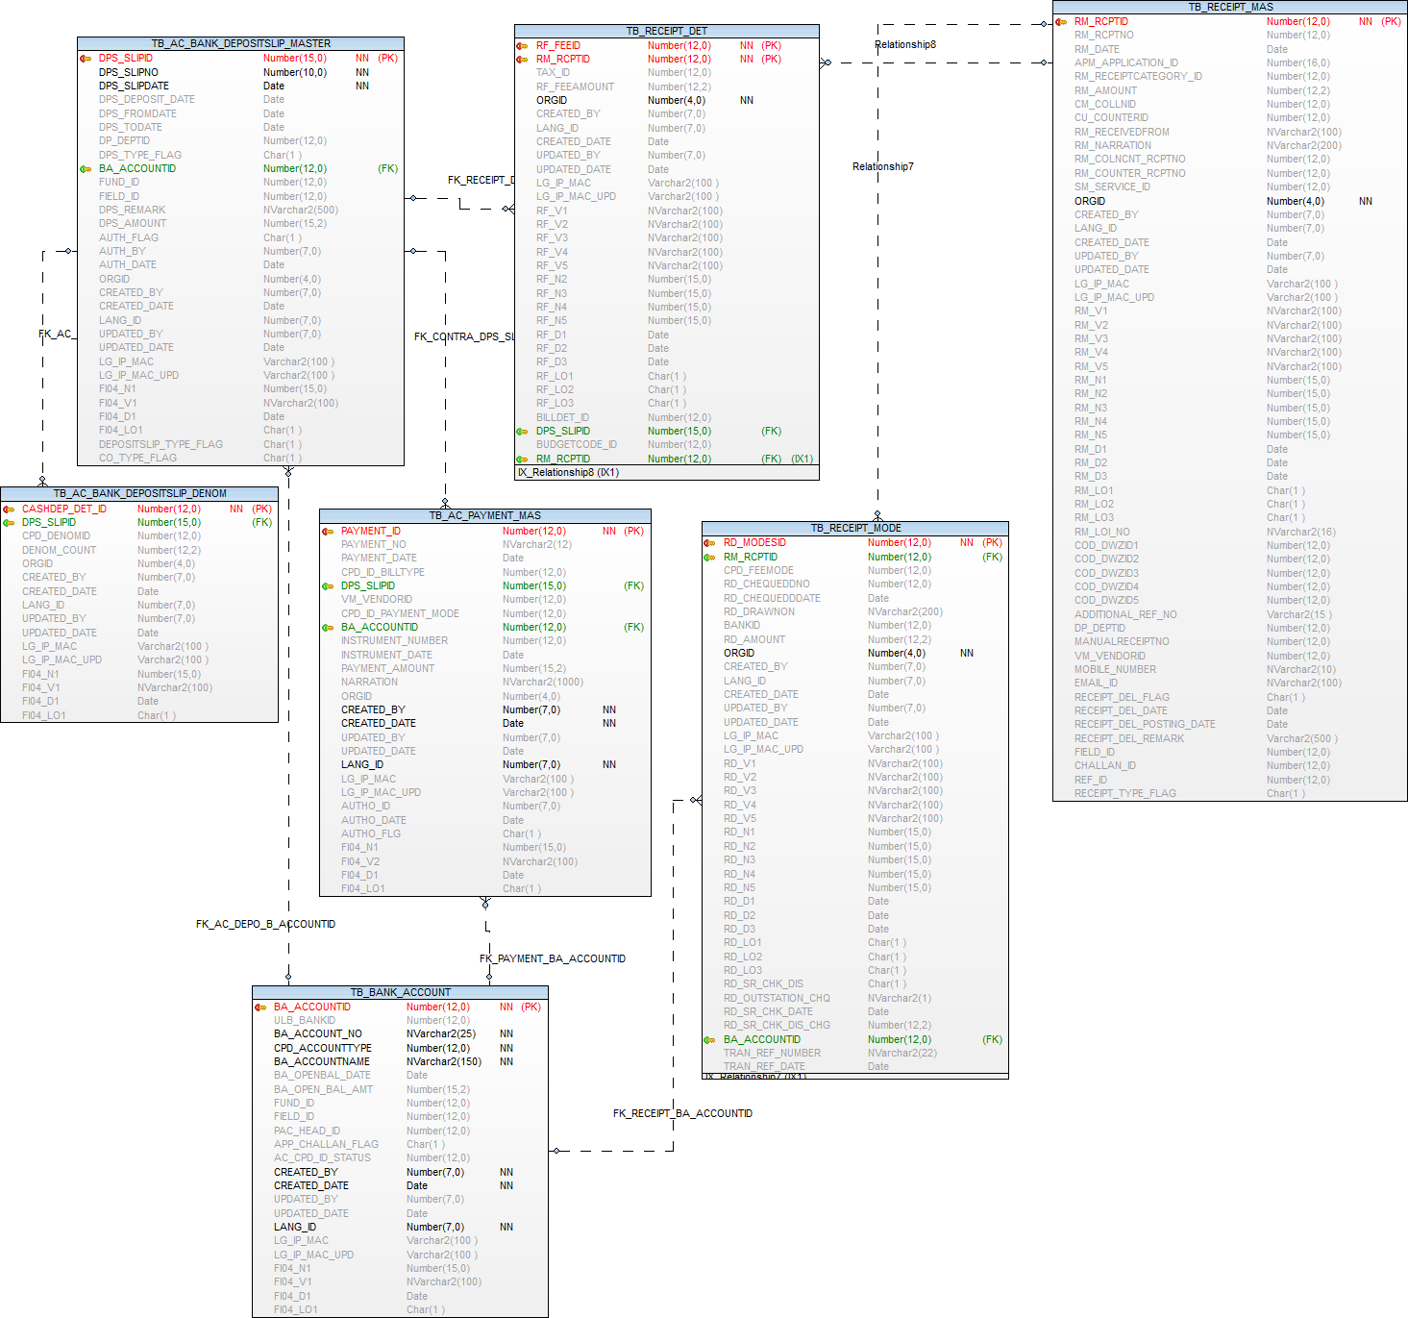

Voucher Entry

Operations-→  Tables | Select | Insert | Edit | Delete
TB_AC_VOUCHER | Y | Y | Y | N
TB_AC_VOUCHER_DET | Y | Y | Y | N
EMPLOYEE | Y | N | N | N
TB_DEPARTMENT | Y | N | N | N
TB_COMPARAM_DET | Y | N | N | N
TB_ORGANISATION | Y | N | N | N
TB_AC_FIELD_MASTER | Y | N | N | N
TB_AC_BUDGETCODE_MAS | Y | N | N | N

Prefixes used:
Prefix | Description | Remarks/use
VOT | Voucher Type | Voucher type
JV | Journal Voucher | (only for JV entry) Voucher Sub type
DCR | Debit / Credit Type | Dr. / Cr. Type

TB_AC_VOUCHER

Purpose: - This table stores the details of Accounting voucher entry (RV, PV,CV,JV)

Name | Type | Nullable | Default | Comments
VOU_ID | NUMBER(12) |  |  | Primary Key
VOU_NO | NVARCHAR2(12) | Y |  | Voucher number system generated
VOU_DATE | DATE | Y |  | Voucher entry Date
VOU_POSTING_DATE | DATE | Y |  | Voucher posting entry Date
VOU_TYPE_CPD_ID | NUMBER(12) | Y |  | Voucher type jv/rv/pv/cv - ref tb_comparam_det
VOU_SUBTYPE_CPD_ID | NUMBER(12) | Y |  | Voucher sub type- ref tb_comparam_det
DP_DEPTID | NUMBER(12) | Y |  | Voucher Department ref tb_department
VOU_REFERENCE_NO | NVARCHAR2(20) | Y |  | Voucher ref number receipt/bill/contra etc number
VOU_REFERENCE_NO_DATE | DATE | Y |  | Voucher ref number receipt/bill/contra etc number
NARRATION | NVARCHAR2(1000) | Y |  | Voucher NARRATION
CHEQUENO | NUMBER(10) | Y |  | Cheque no
CHEQUEDATE | DATE | Y |  | Cheque Date
DRAWNON | NVARCHAR2(100) | Y |  | Drawnon
PAYER_PAYEE | NVARCHAR2(1000) | Y |  | Payer and Payee from receipt master and payment voucher
FIELD_ID | NUMBER(12) | Y |  | Field Master Reference key --TB_AC_FIELD_MASTER
ORGID | NUMBER(4) | Y |  | Organisation Id
CREATED_BY | NUMBER(7) |  |  | Created User Identity
CREATED_DATE | DATE |  |  | Created Date
UPDATED_BY | NUMBER(7) | Y |  | User id who update the data
UPDATED_DATE | DATE | Y |  | Date on which data is going to update
LANG_ID | NUMBER(7) |  |  | Language Identity
LG_IP_MAC | VARCHAR2(100) | Y |  | Client Machine?s Login Name | IP Address | Physical Address
LG_IP_MAC_UPD | VARCHAR2(100) | Y |  | Updated Client Machine?s Login Name | IP Address | Physical Address
AUTHO_ID | NUMBER(7) | Y |  | Authoer Id
AUTHO_DATE | DATE | Y |  | Sysdate
AUTHO_FLG | CHAR(1) | Y |  | Flag
ENTRY_TYPE | NUMBER(2) | Y | 1 | Voucher entry type: System :- 1,Manual :- 2
FI04_N1 | NUMBER(15) | Y |  | Additional number FI04_N1 to be used in future
FI04_V2 | NVARCHAR2(100) | Y |  | Additional nvarchar2 FI04_V2 to be used in future
FI04_D1 | DATE | Y |  | Additional Date FI04_D1 to be used in future
FI04_LO1 | CHAR(1) | Y |  | Additional Logical field FI04_LO1 to be used in future

Index (es):-

Index Name | Table Name | Field Name | Index Type
PK_TB_AC_VOUCHER_HD_VOU_ID | TB_AC_VOUCHER | VOU_ID | Unique

Other Information:-

Key | Name | Field Name | Reference Table | Reference Field
Primary | PK_TB_AC_VOUCHER_HD_VOU_ID | VOU_ID
Foreign | FK_DP_DEPTID_VOUCHER | DP_DEPTID | TB_DEPARTMENT | DP_DEPTID
Foreign | FK_VOUCHERHD_FIELD_ID | FIELD_ID | TB_AC_FIELD_MASTER | FIELD_ID
Foreign | FK_VOU_SUBTYPE_CPDID_VOUCSUBID | VOU_SUBTYPE_CPD_ID | TB_COMPARAM_DET | CPD_ID

TB_AC_VOUCHER_DET

Purpose: - This table stores the details of Accounting voucher entry details (RV, PV, CV, JV – Debit and Credit transation)

Name | Type | Nullable | Default | Comments
VOUDET_ID | NUMBER(12) |  |  | Primary Key
VOU_ID | NUMBER(12) | Y |  | Fund Master Reference key --tb_ac_voucher
BUDGETCODE_ID | NUMBER(12) | Y |  | FK - tb_ac_budgetcode_mas
VOUDET_AMT | NUMBER(15,2) | Y |  | Voucher Amount
DRCR_CPD_ID | NUMBER(15) | Y |  | Voucher Dr/ Cr. Prefix -DCR
ORGID | NUMBER(4) | Y |  | Organisation Id
CREATED_BY | NUMBER(7) |  |  | Created User Identity
LANG_ID | NUMBER(7) |  |  | Language Identity
CREATED_DATE | DATE |  |  | Created Date
UPDATED_BY | NUMBER(7) | Y |  | User id who update the data
UPDATED_DATE | DATE | Y |  | Date on which data is going to update
LG_IP_MAC | VARCHAR2(100) | Y |  | Client Machine?s Login Name | IP Address | Physical Address
LG_IP_MAC_UPD | VARCHAR2(100) | Y |  | Updated Client Machine?s Login Name | IP Address | Physical Address
FI04_N1 | NUMBER(15) | Y |  | Additional number FI04_N1 to be used in future
FI04_V2 | NVARCHAR2(100) | Y |  | Additional nvarchar2 FI04_V2 to be used in future
FI04_D1 | DATE | Y |  | Additional Date FI04_D1 to be used in future
FI04_LO1 | CHAR(1) | Y |  | Additional Logical field FI04_LO1 to be used in future

Index (es):-

Index Name | Table Name | Field Name | Index Type
PK_VOUDET_ID | TB_AC_VOUCHER_DET | VOUDET_ID | Unique

Other Information:-

Key | Name | Field Name | Reference Table | Reference Field
Primary | PK_VOUDET_ID | VOUDET_ID
Foreign | FK_DRCR_CPD_ID | DRCR_CPD_ID | TB_COMPARAM_DET | CPD_ID
Foreign | FK_VOU_BUDGETCODE_ID | BUDGETCODE_ID | TB_AC_BUDGETCODE_MAS | BUDGETCODE_ID
Foreign | FK_VOU_ID | VOU_ID | TB_AC_VOUCHER | VOU_ID

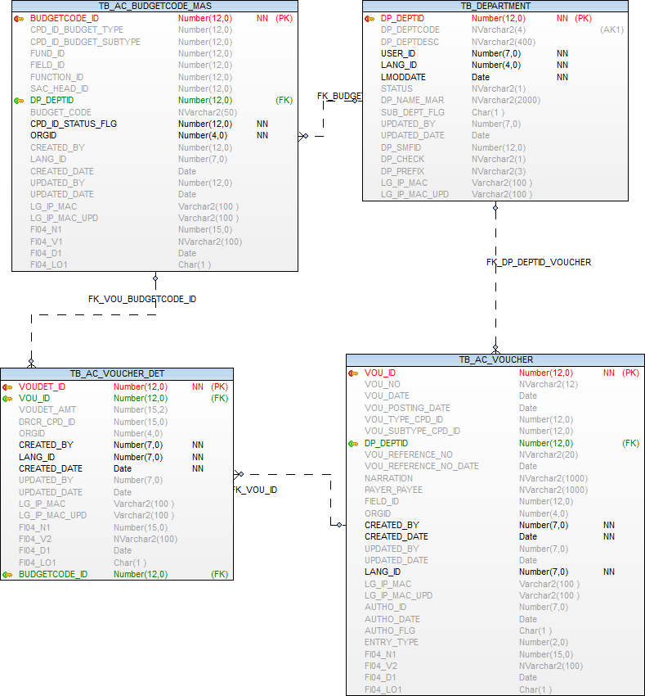

Tender Entry

Operations-→  Tables | Select | Insert | Edit | Delete
TB_AC_TENDER_MASTER | Y | Y | Y | N
TB_AC_TENDER_DET | Y | Y | Y | N
EMPLOYEE | Y | N | N | N
TB_DEPARTMENT | Y | N | N | N
TB_COMPARAM_DET | Y | N | N | N
TB_ORGANISATION | Y | N | N | N
TB_VENDORMASTER | Y | N | N | N
TB_AC_BUDGETCODE_MAS | Y | N | N | N

Prefixes used:
Prefix | Description | Remarks/use
LTY | Liability Type | Miscellaneous M  Works W  Supply S

TB_AC_TENDER_MASTER

Purpose: - This table stores the tender details

Name | Type | Nullable | Default | Comments
TR_TENDER_ID | NUMBER(12) |  |  | Primary Key
TR_ENTRY_DATE | DATE |  |  | Entry Date
TR_TENDER_NO | NVARCHAR2(20) |  |  | Tender Number
TR_TENDER_DATE | DATE |  |  | Tender Date
TR_TYPE_CPD_ID | NUMBER(12) |  |  | User has to select one from : Works / Supply
TR_NAMEOFWORK | NVARCHAR2(500) | Y |  | Nature or Purpose of Proposal
TR_EMD_AMT | NUMBER(15,2) | Y |  | Amount -Earnest Money Deposit
DP_DEPTID | NUMBER(12) |  |  | Department ID
VM_VENDORID | NUMBER(12) |  |  | Vendor ID
SPECIALCONDITIONS | NVARCHAR2(500) | Y |  | Special Conditions
TR_TENDER_AMOUNT | NUMBER(15,2) |  |  | Tender Amount
TR_PROPOSAL_NO | NVARCHAR2(20) |  |  | Proposal Number
TR_PROPOSAL_DATE | DATE |  |  | Proposal Date
ORGID | NUMBER(4) |  |  | Organisation id
CREATED_BY | NUMBER(7) |  |  | Created User Identity
CREATED_DATE | DATE |  |  | Created Date
UPDATED_BY | NUMBER(7) | Y |  | User id who update the data
UPDATED_DATE | DATE | Y |  | Date on which data is going to update
LANG_ID | NUMBER(7) |  |  | Language Identity
LG_IP_MAC | VARCHAR2(100) | Y |  | Client Machine is Login Name | IP Address | Physical Address
LG_IP_MAC_UPD | VARCHAR2(100) | Y |  | Updated Client Machine is Login Name | IP Address | Physical Address
FI04_N1 | NUMBER(15) | Y |  | Additional number FI04_N1 to be used in future
FI04_V1 | NVARCHAR2(100) | Y |  | Additional nvarchar2 FI04_V1 to be used in future
FI04_D1 | DATE | Y |  | Additional Date FI04_D1 to be used in future
FI04_LO1 | CHAR(1) | Y |  | Additional Logical field FI04_LO1 to be used in future

Index (es):-

Index Name | Table Name | Field Name | Index Type
PK_TR_TENDERID | TB_AC_TENDER_MASTER | TR_TENDER_ID | Unique

Other Information:-

Key | Name | Field Name | Reference Table | Reference Field
Primary | PK_TR_TENDERID | TR_TENDER_ID
Foreign | FK_TR_DEPTID | DP_DEPTID | TB_DEPARTMENT | DP_DEPTID
Foreign | FK_TR_TYPE_CPD_ID | TR_TYPE_CPD_ID | TB_COMPARAM_DET | CPD_ID
Foreign | FK_TR_VENDORID | VM_VENDORID | TB_VENDORMASTER | VM_VENDORID

TB_AC_TENDER_DET

Purpose: - This table stores the tender details head code (fund, function, field, Primary and accounts head code wise)

Name | Type | Nullable | Default | Comments
TR_TENDERID_DET | NUMBER(12) |  |  | Primary Key
TR_TENDER_ID | NUMBER(12) | Y |  | Reference key -- TB_AC_TENDER_MASTER
BUDGETCODE_ID | NUMBER(12) | Y |  | FK - tb_ac_budgetcode_mas
BUDGETARY_PROV | NUMBER(15,2) | Y |  | Budgetary Provision
BALANCE_PROV | NUMBER(15,2) | Y |  | Balance Provision
ORGID | NUMBER(4) |  |  | Organisation id
CREATED_BY | NUMBER(7) |  |  | Created User Identity
CREATED_DATE | DATE |  |  | Created Date
UPDATED_BY | NUMBER(7) | Y |  | User id who update the data
UPDATED_DATE | DATE | Y |  | Date on which data is going to update
LANG_ID | NUMBER(7) |  |  | Language Identity
LG_IP_MAC | VARCHAR2(100) | Y |  | Client Machine is Login Name | IP Address | Physical Address
LG_IP_MAC_UPD | VARCHAR2(100) | Y |  | Updated Client Machine is Login Name | IP Address | Physical Address
FI04_N1 | NUMBER(15) | Y |  | Additional number FI04_N1 to be used in future
FI04_V1 | NVARCHAR2(100) | Y |  | Additional nvarchar2 FI04_V1 to be used in future
FI04_D1 | DATE | Y |  | Additional Date FI04_D1 to be used in future
FI04_LO1 | CHAR(1) | Y |  | Additional Logical field FI04_LO1 to be used in future

Index (es):-

Index Name | Table Name | Field Name | Index Type
PK_TR_TENDERID_DET | TB_AC_TENDER_DET | TR_TENDERID_DET | Unique

Other Information:-

Key | Name | Field Name | Reference Table | Reference Field
Primary | PK_TR_TENDERID_DET | TR_TENDERID_DET
Foreign | FK_TR_BUDGETCODE_ID | BUDGETCODE_ID | TB_AC_BUDGETCODE_MAS | BUDGETCODE_ID
Foreign | FK_TR_TENDER_IDD | TR_TENDER_ID | TB_AC_TENDER_MASTER | TR_TENDER_ID

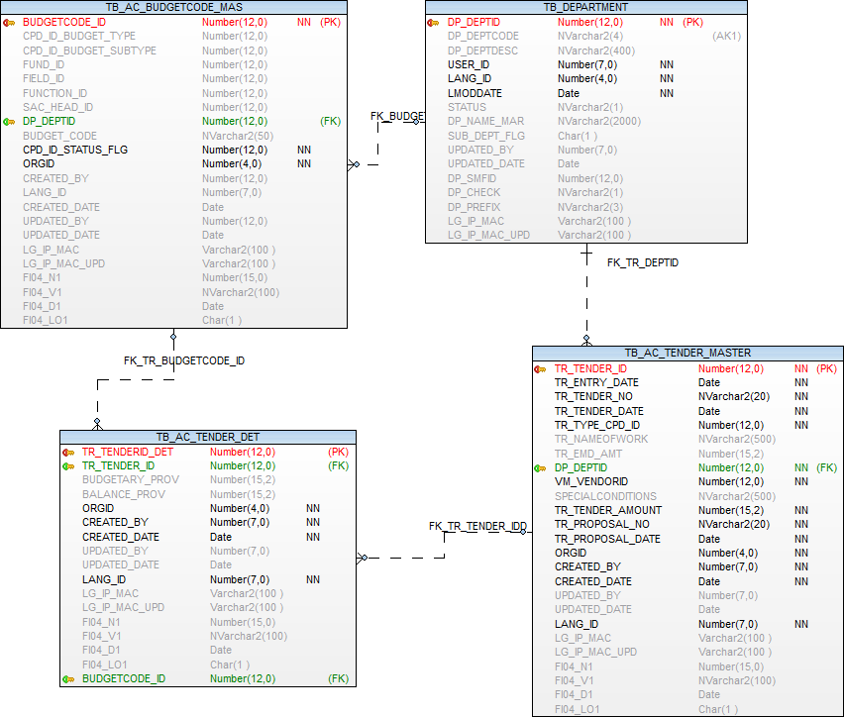

Liability Book Entry

Operations-→  Tables | Select | Insert | Edit | Delete
TB_AC_LIABILITY_BOOKING | Y | Y | Y | N
TB_AC_LIABILITY_BOOKING_DET | Y | Y | Y | N
TB_AC_TENDER_MASTER | Y | N | N | N
TB_AC_BUDGETCODE_MAS | Y | N | N | N
EMPLOYEE | Y | N | N | N
TB_DEPARTMENT | Y | N | N | N
TB_ORGANISATION | Y | N | N | N

Prefixes used:
Prefix | Description | Remarks/use

TB_AC_LIABILITY_BOOKING

Purpose: - This table stores Liability entry details,

Name | Type | Nullable | Default | Comments
LB_LIABILITY_ID | NUMBER(12) |  |  | Primary Key
LB_LIABILITY_NO | NUMBER(12) | Y
LB_ENTRY_DATE | DATE | Y |  | Entry Date
TR_TENDER_ID | NUMBER(12) | Y
ORGID | NUMBER(4) |  |  | Organisation id
CREATED_BY | NUMBER(7) |  |  | Created User Identity
CREATED_DATE | DATE |  |  | Created Date
UPDATED_BY | NUMBER(7) | Y |  | User id who update the data
UPDATED_DATE | DATE | Y |  | Date on which data is going to update
LANG_ID | NUMBER(7) |  |  | Language Identity
LG_IP_MAC | VARCHAR2(100) | Y |  | Client Machine is Login Name | IP Address | Physical Address
LG_IP_MAC_UPD | VARCHAR2(100) | Y |  | Updated Client Machine is Login Name | IP Address | Physical Address
FI04_N1 | NUMBER(15) | Y |  | Additional number FI04_N1 to be used in future
FI04_V1 | NVARCHAR2(100) | Y |  | Additional nvarchar2 FI04_V1 to be used in future
FI04_D1 | DATE | Y |  | Additional Date FI04_D1 to be used in future
FI04_LO1 | CHAR(1) | Y |  | Additional Logical field FI04_LO1 to be used in future

Index (es):-

Index Name | Table Name | Field Name | Index Type
PK_LB_LIABILITY_ID | TB_AC_LIABILITY_BOOKING | LB_LIABILITY_ID | Unique

Other Information:-

Key | Name | Field Name | Reference Table | Reference Field
Primary | PK_LB_LIABILITY_ID | LB_LIABILITY_ID
Foreign | FK_TR_TENDER_ID | TR_TENDER_ID | TB_AC_TENDER_MASTER | TR_TENDER_ID

TB_AC_LIABILITY_BOOKING_DET

Purpose: - This table contains Liability Heads Details.

Name | Type | Nullable | Default | Comments
LB_LIABILITY_DET_ID | NUMBER(12) |  |  | Primary Key
LB_LIABILITY_ID | NUMBER(12) | Y |  | Reference key -- TB_AC_LIABILITY_BOOKING
BUDGETCODE_ID | NUMBER(12) | Y |  | FK - tb_ac_budgetcode_mas
LIABILITY_AMOUNT | NUMBER(15,2) | Y |  | Liability Amount
FA_YEARID | NUMBER(12) | Y |  | Financial year ID
ORGID | NUMBER(4) |  |  | Organisation id
CREATED_BY | NUMBER(7) |  |  | Created User Identity
CREATED_DATE | DATE |  |  | Created Date
UPDATED_BY | NUMBER(7) | Y |  | User id who update the data
UPDATED_DATE | DATE | Y |  | Date on which data is going to update
LANG_ID | NUMBER(7) |  |  | Language Identity
LG_IP_MAC | VARCHAR2(100) | Y |  | Client Machine is Login Name | IP Address | Physical Address
LG_IP_MAC_UPD | VARCHAR2(100) | Y |  | Updated Client Machine is Login Name | IP Address | Physical Address
FI04_N1 | NUMBER(15) | Y |  | Additional number FI04_N1 to be used in future
FI04_V1 | NVARCHAR2(100) | Y |  | Additional nvarchar2 FI04_V1 to be used in future
FI04_D1 | DATE | Y |  | Additional Date FI04_D1 to be used in future
FI04_LO1 | CHAR(1) | Y |  | Additional Logical field FI04_LO1 to be used in future

Index (es):-

Index Name | Table Name | Field Name | Index Type
PK_LB_LIABILITY_DET_ID | TB_AC_LIABILITY_BOOKING_DET | LB_LIABILITY_DET_ID | Unique

Other Information:-

Key | Name | Field Name | Reference Table | Reference Field
Primary | PK_LB_LIABILITY_DET_ID | LB_LIABILITY_DET_ID
Foreign | FK_LB_LIABILITY_ID | LB_LIABILITY_ID | TB_AC_LIABILITY_BOOKING | LB_LIABILITY_ID
Foreign | FK_LB_BUDGETCODE_ID | BUDGETCODE_ID | TB_AC_BUDGETCODE_MAS | BUDGETCODE_ID

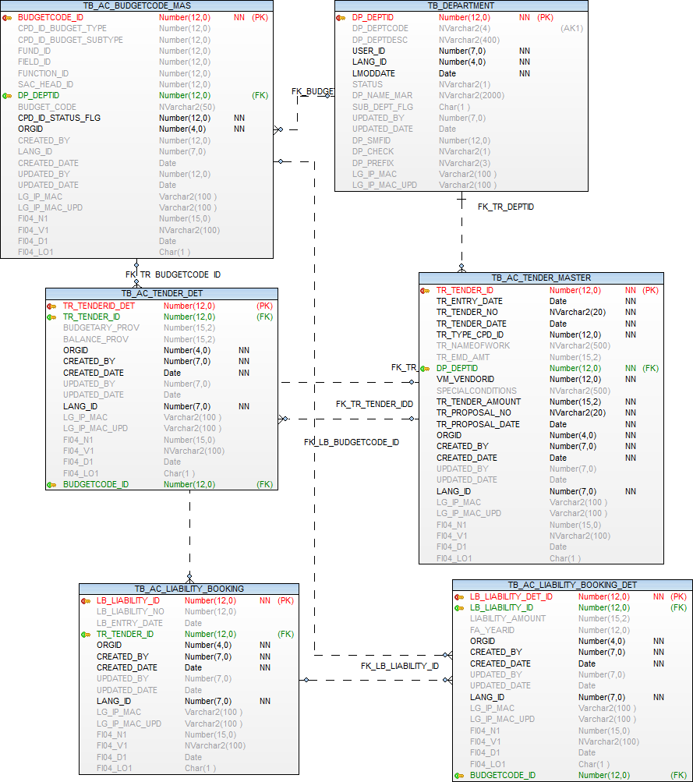

Pay In Slip – Cash / Cheque / Dd Deposit

Operations-→  Tables | Select | Insert | Edit | Delete
TB_AC_BANK_DEPOSITSLIP_MASTER | Y | Y | Y | N
TB_AC_BANK_DEPOSITSLIP_DENOM | Y | Y | Y | N
TB_RECEIPT_DET | Y | N | Y | N
EMPLOYEE | Y | N | N | N
TB_ORGANISATION | Y | N | N | N
TB_AC_FIELD_MASTER | Y | N | N | N
TB_AC_FUND_MASTER | Y | N | N | N
TB_DEPARTMENT | Y | N | N | N
TB_BANK_ACCOUNT | Y | N | N | N
TB_COMPARAM_DET | Y | N | N | N

Prefixes used:
Prefix | Description | Remarks/use
DEN | List of Cash Deposite Denomination | Ten 10  Hundred 100  Fifty 50  Twenty 20  Five 5  Two 2  One Thousand 1000  Five Hundred 500  One 1

TB_AC_BANK_DEPOSITSLIP_MASTER

Purpose: - This table stores the details of cheque, Cash, DD etc. deposit.

Name | Type | Nullable | Default | Comments
DPS_SLIPID | NUMBER(15) |  |  | Primary key
DPS_SLIPNO | NUMBER(10) |  |  | Deposit Number
DPS_SLIPDATE | DATE |  |  | Deposit Slip Date
DPS_DEPOSIT_DATE | DATE | Y |  | Deposit Date
DPS_FROMDATE | DATE | Y |  | From Date
DPS_TODATE | DATE | Y |  | To Date
DP_DEPTID | NUMBER(12) | Y |  | Department id - Fk Ref.-tb_department
DPS_TYPE_FLAG | CHAR(1) | Y |  | Deposit flag C- Cash and Q-Deposit cheque/DD
BA_ACCOUNTID | NUMBER(12) | Y |  | Receipt Bank Account ID
FUND_ID | NUMBER(12) | Y |  | Fund Master Reference key --TB_AC_FUND_MASTER
FIELD_ID | NUMBER(12) | Y |  | Field Master Reference key --TB_AC_FIELD_MASTER
DPS_REMARK | NVARCHAR2(500) | Y |  | Remark
DPS_AMOUNT | NUMBER(15,2) | Y |  | Total Deposit Amount
AUTH_FLAG | CHAR(1) | Y |  | Authorization Flag 'Y' for authorised
AUTH_BY | NUMBER(7) | Y |  | Authorised User Identity
AUTH_DATE | DATE | Y |  | Authorised Date
ORGID | NUMBER(4) | Y |  | Organization Id
CREATED_BY | NUMBER(7) | Y |  | User Identity
CREATED_DATE | DATE | Y |  | Created Date
LANG_ID | NUMBER(7) | Y |  | Language Identity
UPDATED_BY | NUMBER(7) | Y |  | updated by
UPDATED_DATE | DATE | Y |  | updated Date
LG_IP_MAC | VARCHAR2(100) | Y |  | Client Machine?s Login Name | IP Address | Physical Address
LG_IP_MAC_UPD | VARCHAR2(100) | Y |  | Updated Client Machine?s Login Name | IP Address | Physical Address
FI04_N1 | NUMBER(15) | Y |  | Additional number FI04_N1 to be used in future
FI04_V1 | NVARCHAR2(100) | Y |  | Additional nvarchar2 FI04_V1 to be used in future
FI04_D1 | DATE | Y |  | Additional Date FI04_D1 to be used in future
FI04_LO1 | CHAR(1) | Y |  | Additional Logical field FI04_LO1 to be used in future
DEPOSITSLIP_TYPE_FLAG | CHAR(1) | Y |  | flag "D"-Deposit Slip  "C"- Contra
CO_TYPE_FLAG | CHAR(1) | Y |  | CONTRA TYPE flag –  T -TRANSFER ENTRY ,  C-CASH WITHDRAWAL ENTRY,  D-CASH DEPOSIT ENTRY

Index (es):-

Index Name | Table Name | Field Name | Index Type
PK_DPS_SLIPID | TB_AC_BANK_DEPOSITSLIP_MASTER | DPS_SLIPID | Unique

Other Information:-

Key | Name | Field Name | Reference Table | Reference Field
Primary | PK_DPS_SLIPID | DPS_SLIPID
Foreign | FK_AC_DEPOSLIP_FIELD_ID | FIELD_ID | TB_AC_FIELD_MASTER | FIELD_ID
Foreign | FK_AC_DEPOSLIP_FUND_ID_PAY | FUND_ID | TB_AC_FUND_MASTER | FUND_ID
Foreign | FK_AC_DEPO_DEPARTMENT | DP_DEPTID | TB_DEPARTMENT | DP_DEPTID
Foreign | KF_AC_DEPO_BA_ACCOUNTID | BA_ACCOUNTID | TB_BANK_ACCOUNT | BA_ACCOUNTID

TB_AC_BANK_DEPOSITSLIP_DENOM
Purpose: - This table stores the deposit details with cash Denomination.

Name | Type | Nullable | Default | Comments
CASHDEP_DET_ID | NUMBER(12) |  |  | Cash Deposit Detail Id
DPS_SLIPID | NUMBER(15) | Y |  | Fk. Ref. id TB_AC_BANK_DEPOSITSLIP_MASTER
CPD_DENOMID | NUMBER(12) | Y |  | Deposit Denomination Id cpd id "DEN" Prefix
DENOM_COUNT | NUMBER(12,2) | Y |  | Denomination Count
ORGID | NUMBER(4) | Y |  | Organization Id
CREATED_BY | NUMBER(7) | Y |  | User Identity
CREATED_DATE | DATE | Y |  | Created Date
LANG_ID | NUMBER(7) | Y |  | Language Identity
UPDATED_BY | NUMBER(7) | Y |  | updated by
UPDATED_DATE | DATE | Y |  | updated Date
LG_IP_MAC | VARCHAR2(100) | Y |  | Client Machine?s Login Name | IP Address | Physical Address
LG_IP_MAC_UPD | VARCHAR2(100) | Y |  | Updated Client Machine?s Login Name | IP Address | Physical Address
FI04_N1 | NUMBER(15) | Y |  | Additional number FI04_N1 to be used in future
FI04_V1 | NVARCHAR2(100) | Y |  | Additional nvarchar2 FI04_V1 to be used in future
FI04_D1 | DATE | Y |  | Additional Date FI04_D1 to be used in future
FI04_LO1 | CHAR(1) | Y |  | Additional Logical field FI04_LO1 to be used in future

Index (es):-

Index Name | Table Name | Field Name | Index Type
PK_CASHDEP_DET_ID | TB_AC_BANK_DEPOSITSLIP_DENOM | CH_SLIPHEADID | Unique

Other Information:-

Key | Name | Field Name | Reference Table | Reference Field
Primary | PK_CASHDEP_DET_ID | CASHDEP_DET_ID
Foreign | FK_AC_DEPOSLIP_DENO_DPS_SLIPID | DPS_SLIPID | TB_AC_BANK_DEPOSITSLIP_MASTER | DPS_SLIPID
Foreign | FK_BANKDEPOCPD_DENOMID | CPD_DENOMID | TB_COMPARAM_DET | CPD_ID

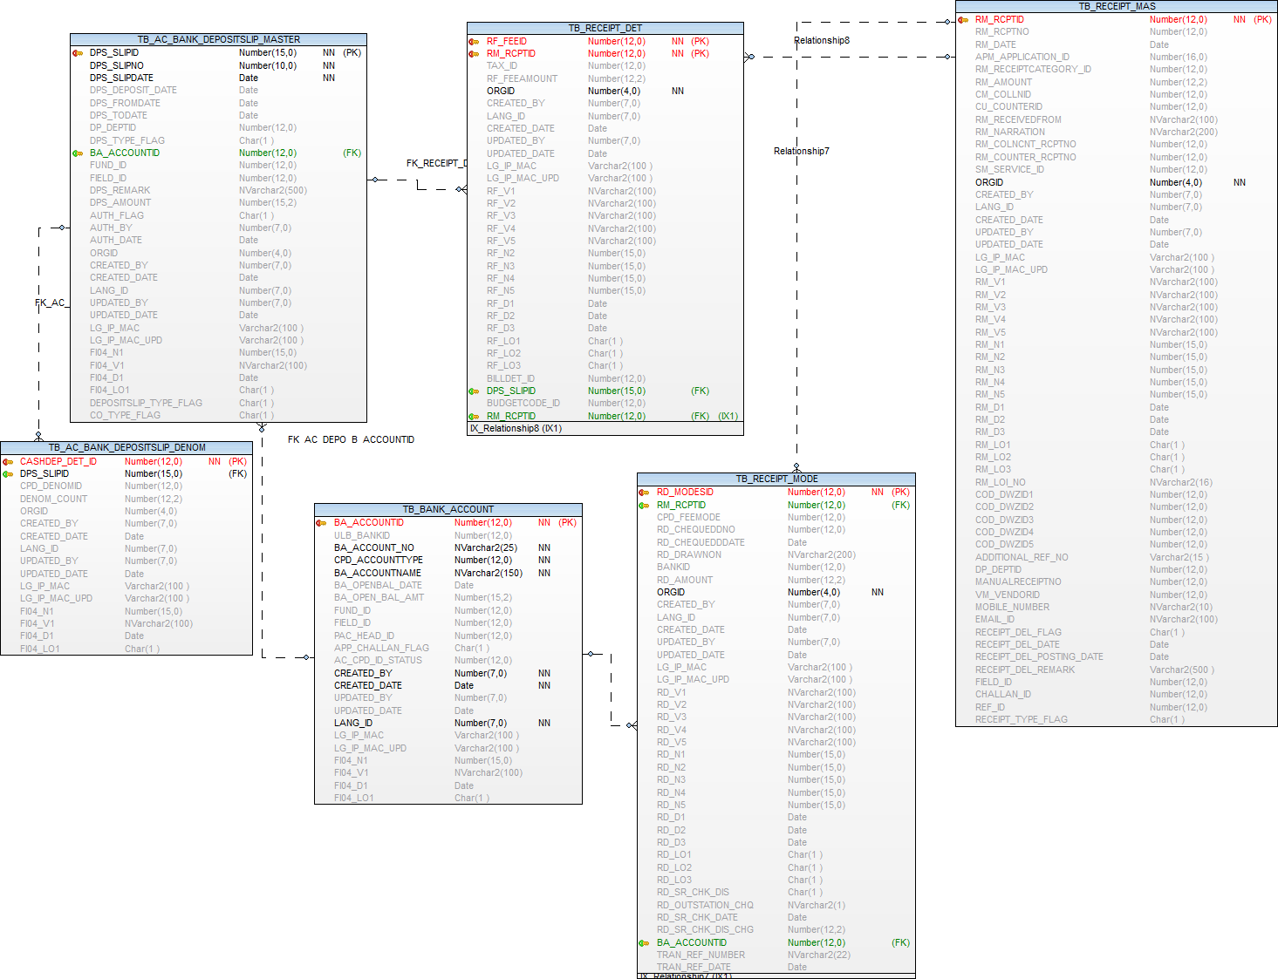

Voucher entry posting

Operations-→  Tables | Select | Insert | Edit | Delete
TB_AC_VOUCHER_POST_MASTER | Y | Y | Y | N
TB_AC_VOUCHER_POST_DETAIL | Y | Y | Y | N
EMPLOYEE | Y | N | N | N
TB_ORGANISATION | Y | N | N | N
TB_DEPARTMENT | Y | N | N | N
TB_AC_FIELD_MASTER | Y | N | N | N

Prefixes used:
Prefix | Description | Remarks/use
SDA | Accounting system
  SINGLE ENTRY / DOUBLE ENTRY | B
  DOUBLE ENTRY | N
  SINGLE ENTRY | Y
PTY | Posting Type
  Individual | I
  Group | G
VOT | Voucher Type | Journal Voucher JV  Receipt Voucher RV  Contra Voucher CV  Payment Voucher PVA
RV | Receipt Voucher | Receipt REV  Payment Voucher Deletion PVD

TB_AC_VOUCHER_POST_MASTER

Purpose: - This table stores the group accounting entry posting.

Name | Type | Nullable | Default | Comments
VP_ID | NUMBER(12) |  |  | Primary Key
TRAN_TOKENNO | NVARCHAR2(20) | Y |  | Transaction Token Number
TRAN_DATE | DATE | Y |  | Transaction Entry Date
TRANTYPE_CPD_ID | NUMBER(12) | Y |  | Transaction type Receipt Voucher / Contra Voucher/ Journal Voucher/Payment Voucher
DP_DEPTID | NUMBER(12) | Y |  | Reference key -- tb_department
FIELD_ID | NUMBER(12) | Y |  | Field Master Reference key --TB_AC_FIELD_MASTER
EMP_ID | NUMBER(12) | Y
VOUCHERSUBTYPE_CPD_ID | NUMBER(12) | Y |  | Voucher Sub Type
MODE_CPD_ID | NUMBER(12) | Y |  | Receipt / Payment Mode Prefix PAY
ACCOUNTENTRYTYPE_CPD_ID | NUMBER(12) | Y |  | Cpd_id 1.Single Entry 2.Double Entry 3.Both
POSTINGTYPE_CPD_ID | NUMBER(12) | Y |  | Cpd ID -1.Individual 2.Group
POSTING_DATE | DATE | Y |  | User to enter posting date.
POSTING_REMARK | NVARCHAR2(1000) | Y |  | Remark
ORGID | NUMBER(4) |  |  | Organisation id
CREATED_BY | NUMBER(7) |  |  | Created User Identity
CREATED_DATE | DATE |  |  | Created Date
UPDATED_BY | NUMBER(7) | Y |  | User id who update the data
UPDATED_DATE | DATE | Y |  | Date on which data is going to update
LANG_ID | NUMBER(7) |  |  | Language Identity
LG_IP_MAC | VARCHAR2(100) | Y |  | Client Machine is Login Name | IP Address | Physical Address
LG_IP_MAC_UPD | VARCHAR2(100) | Y |  | Updated Client Machine is Login Name | IP Address | Physical Address
FI04_N1 | NUMBER(15) | Y |  | Additional number FI04_N1 to be used in future
FI04_V1 | NVARCHAR2(100) | Y |  | Additional nvarchar2 FI04_V1 to be used in future
FI04_D1 | DATE | Y |  | Additional Date FI04_D1 to be used in future
FI04_LO1 | CHAR(1) | Y |  | Additional Logical field FI04_LO1 to be used in future

Index (es):-

Index Name | Table Name | Field Name | Index Type
PK_VOUCHER_POST_MAS | TB_AC_VOUCHER_POST_MASTER | VP_ID | Unique

Other Information:-

Key | Name | Field Name | Reference Table | Reference Field
Primary | PK_VOUCHER_POST_MAS | VP_ID
Foreign | FK_VOUCHER_POST_MAS_DP_DEPTID | DP_DEPTID | TB_DEPARTMENT | DP_DEPTID
Foreign | FK_VOUCHER_POST_MAS_FIELD_ID | FIELD_ID | TB_AC_FIELD_MASTER | FIELD_ID

TB_AC_VOUCHER_POST_DETAIL

Purpose: - This table stores the group accounting entry details.

Name | Type | Nullable | Default | Comments
VP_DET_ID | NUMBER(12) |  |  | Primary Key
VP_ID | NUMBER(12) | Y |  | Reference key -- TB_AC_VOUCHER_POST_master
REF_ID | NUMBER(12) | Y |  | Receipt ,Payment ,Bill,Contra , water bill, etc id
ORGID | NUMBER(4) |  |  | Organisation id
CREATED_BY | NUMBER(7) |  |  | Created User Identity
CREATED_DATE | DATE |  |  | Created Date
UPDATED_BY | NUMBER(7) | Y |  | User id who update the data
UPDATED_DATE | DATE | Y |  | Date on which data is going to update
LANG_ID | NUMBER(7) |  |  | Language Identity
LG_IP_MAC | VARCHAR2(100) | Y |  | Client Machine is Login Name | IP Address | Physical Address
LG_IP_MAC_UPD | VARCHAR2(100) | Y |  | Updated Client Machine is Login Name | IP Address | Physical Address
FI04_N1 | NUMBER(15) | Y |  | Additional number FI04_N1 to be used in future
FI04_V1 | NVARCHAR2(100) | Y |  | Additional nvarchar2 FI04_V1 to be used in future
FI04_D1 | DATE | Y |  | Additional Date FI04_D1 to be used in future
FI04_LO1 | CHAR(1) | Y |  | Additional Logical field FI04_LO1 to be used in future

Index (es):-

Index Name | Table Name | Field Name | Index Type
PK_VOUCHER_POST_DETAIL | TB_AC_VOUCHER_POST_DETAIL | VP_DET_ID | Unique

Other Information:-

Key | Name | Field Name | Reference Table | Reference Field
Primary | PK_VOUCHER_POST_DETAIL | VP_DET_ID
Foreign | FK_VOUCHER_POST_DET_VP_ID | VP_ID | TB_AC_VOUCHER_POST_MASTER | VP_ID

Validation

Column Name | Validation
Transaction Number :
Transaction Date :
Department : | After discuss with samadhan remove this column
Field : | After discuss with samadhan remove this column
Collection Center : | After discuss with samadhan remove this column
Employee :
Mode : | PAY perfix
Sub Type : | After discuss with samadhan This column not required for receipt
Account Entry Type : | Prefix SDA
Posting Type : | Prefix PTY
Posting Date :
Remark :

Posting

- Receipt Voucher
  - Receipt entry
    - Water service receipt
    - Water bill collection entry
    - Accounts receipt entry

Cash/ Cheque/ FDR/WEB/NEFT Dr. ...........
To (fund/function/field/primary a/c code/ Secondary s/c Code)Cr. ..........

Cash/ Cheque/ FDR/WEB/NEFT etc. :- Account head code get from voucher posting mapping entry from (fund/function/field/primary Account code/ Secondary Account Code)

To:- Account code get from Tax mater from (in case account deparment select get from head details table)

  - Payment voucher Deletion

(fund/function/field/primary a/c code/ Secondary s/c Code) Dr. ..........
To, Cash/ Cheque/ FDR/WEB/NEFT Cr. ...........

Cash/ Cheque/ FDR/WEB/NEFT etc :- Account head code get from voucher posting mapping entry from (fund/function/field/primary Account code/ Secondary Account Code)

Data get from payment voucher entry form, only deleted record and not posted record

- Payment Voucher
  - Payment voucher entry

  - Receipt deletion

- Contra Voucher
  - Contra entry
  - Contra entry deletion
  - Deposit entry
  - Deposit deletion

- Journal Voucher
  - Water bill generate entry
  - Water bill delete entry
  - Water interest
  - Water interest deletion
  - Water rebate
  - Water rebate deletion
  - Water bill positive adjustment entry
  - Water bill positive adjustment deletion
  - Water bill negative adjustment entry
  - Water bill negative adjustment deletion
  - Account bill entry
  - Account bill deletion

Bills / Invoices / Payment Orders
Prefixes used:
Prefix | Description | Remarks/use
ABT | Account Bill Type | Miscellaneous MI  Liability LI  Deposits DE  Advance AD  Loan LN  Adjustment AJ

Operations-→  Tables | Select | Insert | Edit | Delete
TB_AC_BILL_MAS | Y | Y | Y | N
TB_AC_BILL_EXP_DETAIL | Y | Y | Y | N
TB_AC_BILL_DEDUCTION_DETAIL | Y | Y | Y | N
EMPLOYEE | Y | N | N | N
TB_ORGANISATION | Y | N | N | N
TB_DEPARTMENT | Y | N | N | N
TB_VENDORMASTER | Y | N | N | N
TB_COMPARAM_DET | Y | N | N | N
TB_AC_BUDGETCODE_MAS | Y | N | N | N

TB_AC_BILL_MAS

Purpose: - This table stores the account bill transaction.

Name | Type | Nullable | Default | Comments
BM_ID | NUMBER(12) |  |  | Primary Key
BM_BILLTYPE_CPD_ID | NUMBER(12) | Y |  | Prefix - ABT
BM_BILLNO | NVARCHAR2(20) |  |  | Financial year wise unique bill number
BM_ENTRYDATE | DATE | Y |  | Transaction entry date
DP_DEPTID | NUMBER(12) | Y |  | Department name
VM_VENDORID | NUMBER(12) | Y |  | Vendor ID
VM_VENDORNAME | NVARCHAR2(200) | Y |  | Vendor name
BM_INVOICENUMBER | NVARCHAR2(20) | Y |  | Vendor bill number
BM_INVOICEDATE | DATE | Y |  | Vendor invoice/bill date
BM_INVOICEVALUE | NUMBER(15,2) | Y |  | Vendro invoice/bill value
BM_W_P_ORDER_NUMBER | NVARCHAR2(20) | Y |  | Work order/Purchase order number
BM_W_P_ORDER_DATE | DATE | Y |  | Work order/purchase order date
BM_RESOLUTION_NUMBER | NVARCHAR2(20) | Y |  | Resolution / administrative order number.
BM_RESOLUTION_DATE | DATE | Y |  | Resolution / administrative order date.
BM_NARRATION | NVARCHAR2(700) |  |  | Bill Particulars / Narration
BM_TOT_AMT | NUMBER(15,2) | Y |  | Total bill amount
BM_BAL_AMT | NUMBER(15,2) | Y |  | Balance amount
LB_LIABILITY_ID | NUMBER(12) | Y |  | Liability ID
DEP_ID | NUMBER(12) | Y |  | Deposit ID
LPS_LOANID | NUMBER(12) | Y |  | Loan ID
ADVTYPE_CPD_ID | NUMBER(12) | Y |  | Advance type
CHECKER_AUTHO | CHAR(1) | Y |  | Authorization flag (Y for authorized)
CHECKER_REMARKS | NVARCHAR2(500) | Y |  | Authorization remarks
CHECKER_USER | NVARCHAR2(100) | Y |  | Authorized by
CHECKER_DATE | DATE | Y |  | Authorization date
ORGID | NUMBER(4) |  |  | Organisation id
CREATED_BY | NUMBER(7) |  |  | Created User Identity
CREATED_DATE | DATE |  |  | Created Date
UPDATED_BY | NUMBER(7) | Y |  | User id who update the data
UPDATED_DATE | DATE | Y |  | Date on which data is going to update
LANG_ID | NUMBER(7) |  |  | Language Identity
LG_IP_MAC | VARCHAR2(100) | Y |  | Client Machine is Login Name | IP Address | Physical Address
LG_IP_MAC_UPD | VARCHAR2(100) | Y |  | Updated Client Machine is Login Name | IP Address | Physical Address
FI04_N1 | NUMBER(15) | Y |  | Additional number FI04_N1 to be used in future
FI04_V1 | NVARCHAR2(100) | Y |  | Additional nvarchar2 FI04_V1 to be used in future
FI04_D1 | DATE | Y |  | Additional Date FI04_D1 to be used in future
FI04_LO1 | CHAR(1) | Y |  | Additional Logical field FI04_LO1 to be used in future
FIELD_ID | NUMBER(12) | Y |  | Field Master Reference key --TB_AC_FIELD_MASTER

Index (es):-

Index Name | Table Name | Field Name | Index Type
PK_BM_ID | TB_AC_BILL_MAS | BM_ID | Unique

Other Information:-

Key | Name | Field Name | Reference Table | Reference Field
Primary | PK_BM_ID | BM_ID
Foreign | FKBILL_MAS_FIELD_ID | FIELD_ID | TB_AC_FIELD_MASTER | FIELD_ID
Foreign | FK_BILL_DP_DEPTID | DP_DEPTID | TB_DEPARTMENT | DP_DEPTID
Foreign | FK_BILL_LB_LIABILITY_ID | LB_LIABILITY_ID | TB_AC_LIABILITY_BOOKING | LB_LIABILITY_ID
Foreign | FK_BILL_VM_VENDORID | VM_VENDORID | TB_VENDORMASTER | VM_VENDORID
Foreign | FK_BM_BILLTYPE_CPD_ID | BM_BILLTYPE_CPD_ID | TB_COMPARAM_DET | CPD_ID

TB_AC_BILL_EXP_DETAIL

Purpose: - This table stores the account heads for Charges against Bill.

Name | Type | Nullable | Default | Comments
BCH_ID | NUMBER(12) |  |  | Primary Key
BM_ID | NUMBER(12) |  |  | Reference key TB_AC_BILL_MAS
BUDGETCODE_ID | NUMBER(12) | Y |  | FK - tb_ac_budgetcode_mas
BCH_CHARGES_AMT | NUMBER(15,2) |  |  | Amount of Bill Charges
DISALLOWED_AMT | NUMBER(15,2) | Y |  | Disallowed Amount
DISALLOWED_REMARK | NVARCHAR2(1000) | Y
ACT_AMT | NUMBER(15,2) | Y |  | Actual Amount - Before Sanction
ORGID | NUMBER(4) |  |  | Organisation id
CREATED_BY | NUMBER(7) |  |  | Created User Identity
CREATED_DATE | DATE |  |  | Created Date
UPDATED_BY | NUMBER(7) | Y |  | User id who update the data
UPDATED_DATE | DATE | Y |  | Date on which data is going to update
LANG_ID | NUMBER(7) |  |  | Language Identity
LG_IP_MAC | VARCHAR2(100) | Y |  | Client Machine is Login Name | IP Address | Physical Address
LG_IP_MAC_UPD | VARCHAR2(100) | Y |  | Updated Client Machine is Login Name | IP Address | Physical Address
FI04_N1 | NUMBER(15) | Y |  | Additional number FI04_N1 to be used in future
FI04_V1 | NVARCHAR2(100) | Y |  | Additional nvarchar2 FI04_V1 to be used in future
FI04_D1 | DATE | Y |  | Additional Date FI04_D1 to be used in future
FI04_LO1 | CHAR(1) | Y |  | Additional Logical field FI04_LO1 to be used in future

Index (es):-

Index Name | Table Name | Field Name | Index Type
PK_BCH_ID | TB_AC_BILL_EXP_DETAIL | BCH_ID | Unique

Other Information:-

Key | Name | Field Name | Reference Table | Reference Field
Primary | PK_BCH_ID | BCH_ID
Foreign | FK_BM_BUDGETCODE_ID | BUDGETCODE_ID | TB_AC_BUDGETCODE_MAS | BUDGETCODE_ID
Foreign | FK_BM_ID_BILLMAS | BM_ID | TB_AC_BILL_MAS | BM_ID

TB_AC_BILL_DEDUCTION_DETAIL

Purpose: - This table stores the account heads for deduction against Bill.

Name | Type | Nullable | Default | Comments
BDH_ID | NUMBER(12) |  |  | Primary Key
BM_ID | NUMBER(12) |  |  | Reference key TB_AC_BILL_MAS
BUDGETCODE_ID | NUMBER(12) | Y |  | FK - tb_ac_budgetcode_mas
DEDUCTION_RATE | NUMBER(15,2) | Y |  | Deduction Rate
DEDUCTION_AMT | NUMBER(15,2) | Y |  | Amount of Deduction
ORGID | NUMBER(4) |  |  | Organisation id
CREATED_BY | NUMBER(7) |  |  | Created User Identity
CREATED_DATE | DATE |  |  | Created Date
UPDATED_BY | NUMBER(7) | Y |  | User id who update the data
UPDATED_DATE | DATE | Y |  | Date on which data is going to update
LANG_ID | NUMBER(7) |  |  | Language Identity
LG_IP_MAC | VARCHAR2(100) | Y |  | Client Machine is Login Name | IP Address | Physical Address
LG_IP_MAC_UPD | VARCHAR2(100) | Y |  | Updated Client Machine is Login Name | IP Address | Physical Address
FI04_N1 | NUMBER(15) | Y |  | Additional number FI04_N1 to be used in future
FI04_V1 | NVARCHAR2(100) | Y |  | Additional nvarchar2 FI04_V1 to be used in future
FI04_D1 | DATE | Y |  | Additional Date FI04_D1 to be used in future
FI04_LO1 | CHAR(1) | Y |  | Additional Logical field FI04_LO1 to be used in future

Index (es):-

Index Name | Table Name | Field Name | Index Type
PK_BCH_ID_DED | TB_AC_BILL_DEDUCTION_DETAIL | BCH_ID | Unique

Other Information:-

Key | Name | Field Name | Reference Table | Reference Field
Primary | PK_BCH_ID_DED | BDH_ID
Foreign | FK_DEDU_BUDGETCODE_ID | BUDGETCODE_ID | TB_AC_BUDGETCODE_MAS | BUDGETCODE_ID
Foreign | FK_DEDUCTION_DETAIL_BILLMAS | BM_ID | TB_AC_BILL_MAS | BM_ID

Column Name | Validation
Bill Type* | The system shall allow user to select pre-defined bill types as bellows : Miscellaneous , Liability , deposits , Advance , Loan and Adjustment
Bill Number | The system shall able to generate financial year wise unique bill number.
Bill Date* | The system shall allow user to enter bill transaction date. The system shall validate bill date not greater than current date.
Entry Date* | The system shall display transaction entry date. The system shall validate entry date not greater than current date.
Department Name* | The system shall allow user to select department name from drop down list. The system shall display active departments.
Vendor Code* | The system shall allow user to select vendor code from drop list. The system shall display active and not black listed vendor code and name.
Name of Vendor* | The system shall display vendor name. The system shall display active and not black listed vendor code and name.
Invoice Number | The system shall allow user to enter vendor bill number. The system allow duplicate invoice number.
Invoice Date | The system shall allow user to enter vendor invoice / Bill date. The system shall validate invoice date not greater than current date.
Invoice Value | The system shall allow user to enter vendor invoice / Bill value.
Work Order / Purchase Order Number | The system shall allow user to enter work order / purchase order number.
Work Order / Purchase Order Date | The system shall allow user to enter work order / purchase order date. The system shall validate this date not greater than current date.
Resolution Number / Office Order Number | The system shall allow user to enter resolution / administrative order number.
Resolution Number / Office Order Date | The system shall allow user to enter resolution / administrative order date. The system shall validate this date not greater than current date.
Bill Particulars / Narration* | The system shall allow user to enter Bill Particulars / Narration
Field | List populate from field master
Expenditure Head* | The system shall allow user to select expenditure heads. The system does not allow selection of income heads , vendor heads and bank account heads while bill entry.
Bill Amount* | The system shall allow user to enter expenditure head wise bill amount.
Sanctioned Amount | The system shall display sanctioned bill amount.
Disallowed amount | The system shall allow user to enter disallowed amount.
Disallowance Reason | The system shall allow user to enter reason of disallowances. The system validate this only for if there are any disallowances
Deduction Head Description | The system shall allow user to select deduction heads. The system shall allow selection from statutory deduction master.
Rate of Deduction | The system shall allow user to enter deduction rate.
Deduction Amount | The system shall allow user to enter deduction amount.
Total Deduction Amount | The system shall display total deduction amount.
Net Payable amount* | The system shall display total net payable amount.
Budget Provision | The system shall display amount of selected or entered expenditure head. The system shall display real time figures against it.
Utilized Budget Provision | The system shall display Budget Provision amount of selected or entered expenditure head. The system  shall display real time figures against it.
Bills Paid | The system shall display bills paid amount of selected or entered expenditure head. The system shall display real time figures against it.
Bills Unpaid | The system shall display bills unpaid amount of selected or entered expenditure head. The system shall display real time figures against it.
Expenses of running bill | The system shall display running expense amount of selected or entered expenditure head. The system shall display real time figures against it.
Total Expenditure | The system shall display total expense amount of selected or entered expenditure head. The system shall display real time figures against it.
Balance Budget Provision | The system shall display Balance Budget Provision amount of selected or entered expenditure head. The system shall display real time figures against it.

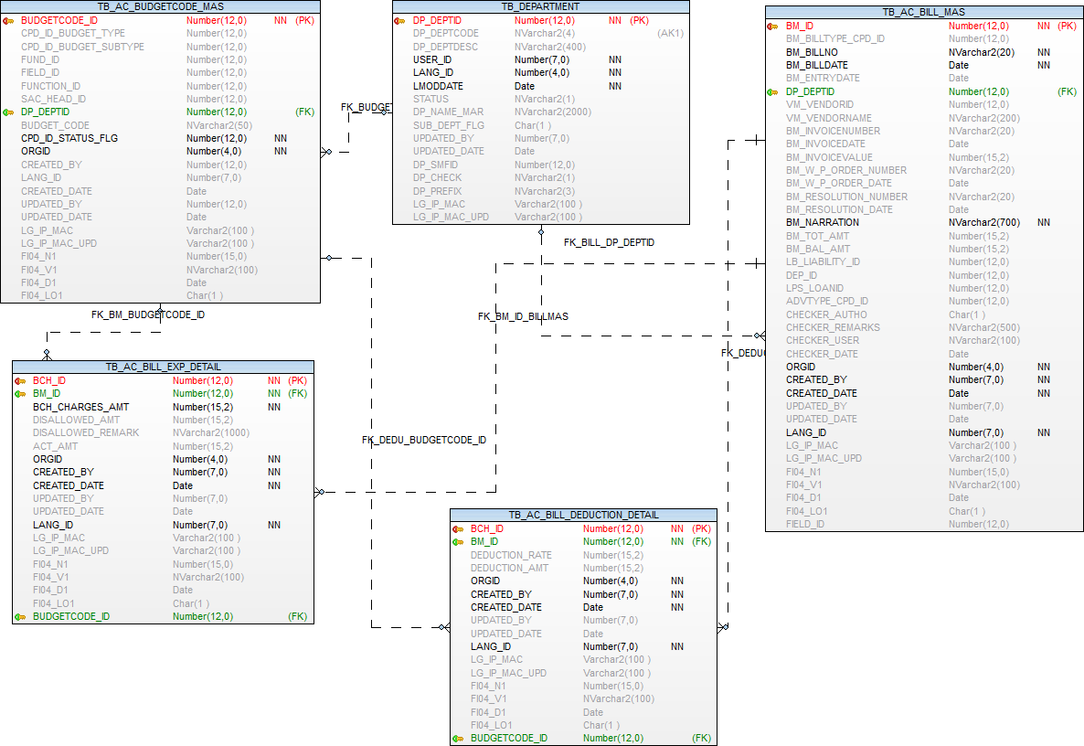

Deposit Master

Operations-→  Tables | Select | Insert | Edit | Delete
TB_AC_DEPOSITS | Y | Y | Y | N
EMPLOYEE | Y | N | N | N
TB_ORGANISATION | Y | N | N | N
TB_DEPARTMENT | Y | N | N | N
TB_COMPARAM_DET | Y | N | N | N
TB_VENDORMASTER | Y | N | N | N

Prefixes used:
Prefix | Description | Remarks/use
DTY | Type of Deposits | EMD EM  Security Deposit SD  Water Deposit WD  Rental Deposit RD  Staff Deposit ST  Building Permission Deposit BP  Illegal Construction Deposit IC
TOS | Type of Source | Receipt RP  Bill/Payment Dedcuation BP
RDC | Deposit Status | Deposit Refunded DR  Receipt Deleted RD  Cheque Dishonoured CD  Full Forfeited FF  Deposit Open DO

TB_AC_DEPOSITS

Purpose: - This table contains list of deposits made through receipts. Here Back-dated transaction details also are captured.

Name | Type | Nullable | Default | Comments
DEP_ID | NUMBER(12) |  |  | Primary Key
DEP_ENTRY_DATE | DATE |  |  | Date on which Deposit entry is made
DEP_RECEIPTDT | DATE | Y |  | Amount Deposited, its Receipt Date also backdated receipts can be entered
DEP_NO | NUMBER(12) |  |  | Deposit number. which will be one-up generated
CPD_DEPOSIT_TYPE | NUMBER(12) |  |  | Deposit Type stored in common parameter DTY
DP_DEPTID | NUMBER(12) |  |  | department wherein its deposited
DEP_RECEIPTNO | NUMBER(12) | Y |  | Amount Deposited, its Receipt No also backdated receipt numbers can be entered
CPD_SOURCE_TYPE | NUMBER(12) |  |  | Deposit Type stored in common parameter
CPD_STATUS | NUMBER(12) |  |  | Deposit Type stored in common parameter
DEP_AMOUNT | NUMBER(12,2) |  |  | Amount Deposited
DEP_REFUND_BAL | NUMBER(12,2) | Y |  | Balance Amount yet to be refunded through payment voucher
VM_VENDORID | NUMBER(12) | Y |  | Vendor Id From Vendor Master
DEP_RECEIVEDFROM | NVARCHAR2(500) | Y |  | Deposit Received from whom
DEP_NARRATION | NVARCHAR2(1000) |  |  | Narration of Deposit
SAC_HEAD_ID | NUMBER(12) | Y |  | Secondary Master Reference key -- tb_ac_secondaryhead_master
DM_FLAG | CHAR(1) | Y |  | Deposits entry Menutree - M /Data Entry Site - D
ORGID | NUMBER(4) |  |  | Organisation id
CREATED_BY | NUMBER(7) |  |  | User Identity
CREATED_DATE | DATE |  |  | created Date
UPDATED_BY | NUMBER(7) | Y |  | User id who update the data
UPDATED_DATE | DATE | Y |  | Date on which data is going to update
LANG_ID | NUMBER(7) |  |  | Language Identity
LG_IP_MAC | VARCHAR2(100) | Y |  | Client Machine’s Login Name | IP Address | Physical Address
LG_IP_MAC_UPD | VARCHAR2(100) | Y |  | Updated Client Machine’s Login Name | IP Address | Physical Address
FI04_N1 | NUMBER(15) | Y |  | Additional number FI04_N1 to be used in future
FI04_V1 | NVARCHAR2(100) | Y |  | Additional nvarchar2 FI04_V1 to be used in future
FI04_D1 | DATE | Y |  | Additional Date FI04_D1 to be used in future
FI04_LO1 | CHAR(1) | Y |  | Additional Logical field FI04_LO1 to be used in future

Index (es):-

Index Name | Table Name | Field Name | Index Type
PK_AC_DEP_ID | TB_AC_DEPOSITS | DEP_ID | Unique

Other Information:-

Key | Name | Field Name | Reference Table | Reference Field
Primary | PK_AC_DEP_ID | DEP_ID
Foreign | FK_AC_DEP_DEPTID | DP_DEPTID | TB_DEPARTMENT | DP_DEPTID
Foreign | FK_CPD_DEPOSIT_TYPE | CPD_DEPOSIT_TYPE | TB_COMPARAM_DET | CPD_ID
Foreign | FK_CPD_SOURCE_TYPE | CPD_SOURCE_TYPE | TB_COMPARAM_DET | CPD_ID
Foreign | FK_CPD_STATUS | CPD_STATUS | TB_COMPARAM_DET | CPD_ID
Foreign | FK_TR_VENDOR_ID_DPST | VM_VENDORID | TB_VENDORMASTER | VM_VENDORID

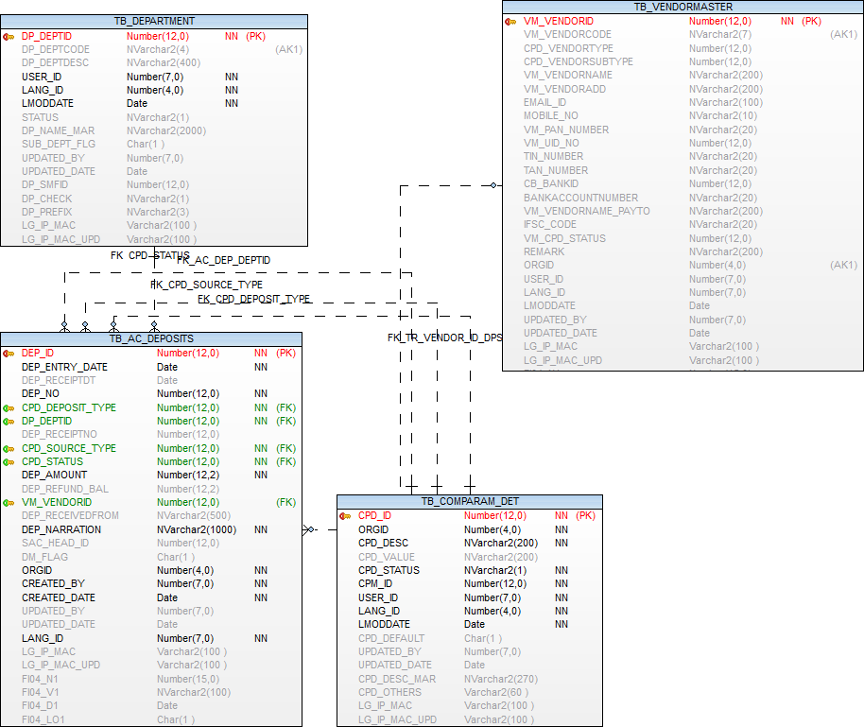

Payments Entry

Operations-→  Tables | Select | Insert | Edit | Delete
TB_AC_PAYMENT_MAS | Y | Y | Y | N
TB_AC_PAYMENT_DET | Y | Y | Y | N
TB_AC_BILL_MAS | Y | N | N | N
TB_AC_BILL_DEDUCTION_DETAIL | Y | N | N | N
TB_AC_BILL_EXP_DETAIL | Y | N | N | N
TB_AC_BUDGETCODE_MAS | Y | N | N | N
TB_AC_CHEQUEBOOKLEAF_DET | Y | N | Y | N
TB_AC_CHEQUEBOOKLEAF_MAS | Y | N | N | N
EMPLOYEE | Y | N | N | N
TB_ORGANISATION | Y | N | N | N
TB_DEPARTMENT | Y | N | N | N
TB_COMPARAM_DET | Y | N | N | N
TB_VENDORMASTER | Y | N | N | N
TB_BANK_ACCOUNT | Y | N | N | N

Prefixes used:
Prefix | Description | Remarks/use

TB_AC_PAYMENT_MAS

Purpose: - This table contains list of payment master details

Name | Type | Nullable | Default | Comments
PAYMENT_ID | NUMBER(12) |  |  | Primary Key
PAYMENT_NO | NVARCHAR2(12) | Y |  | Payment number system generated
PAYMENT_DATE | DATE | Y |  | payment Date
CPD_ID_BILLTYPE | NUMBER(12) | Y |  | Bill type prefix BBT - ref tb_comparam_det
DPS_SLIPID | NUMBER(12) | Y
VM_VENDORID | NUMBER(12) | Y |  | Vendor id- ref tb_vendormaster
CPD_ID_PAYMENT_MODE | NUMBER(12) | Y |  | Payment Mode from PAY prefix
BA_ACCOUNTID | NUMBER(12) | Y |  | Ref. Key -TB_BANK_ACCOUNT
INSTRUMENT_NUMBER | NUMBER(12) | Y |  | Cheque Number/ RTGS ref. Number/ NFT ref. Number etc.
INSTRUMENT_DATE | DATE | Y |  | Cheque Date/ RTGS Date/ NFT Date etc.
PAYMENT_AMOUNT | NUMBER(15,2) | Y |  | Payment Amount
NARRATION | NVARCHAR2(1000) | Y |  | Narration / Remark
ORGID | NUMBER(4) | Y |  | Organisation Id
CREATED_BY | NUMBER(7) | Y |  | Created User Identity
CREATED_DATE | DATE | Y |  | Created Date
UPDATED_BY | NUMBER(7) | Y |  | User id who update the data
UPDATED_DATE | DATE | Y |  | Date on which data is going to update
LANG_ID | NUMBER(7) |  |  | Language Identity
LG_IP_MAC | VARCHAR2(100) | Y |  | Client Machine?s Login Name | IP Address | Physical Address
LG_IP_MAC_UPD | VARCHAR2(100) | Y |  | Updated Client Machine?s Login Name | IP Address | Physical Address
AUTHO_ID | NUMBER(7) | Y |  | Authoer Id
AUTHO_DATE | DATE | Y |  | Sysdate
AUTHO_FLG | CHAR(1) | Y |  | Flag
FI04_N1 | NUMBER(15) | Y |  | Additional number FI04_N1 to be used in future
FI04_V2 | NVARCHAR2(100) | Y |  | Additional nvarchar2 FI04_V2 to be used in future
FI04_D1 | DATE | Y |  | Additional Date FI04_D1 to be used in future
FI04_LO1 | CHAR(1) | Y |  | Additional Logical field FI04_LO1 to be used in future
DISCREPANCY_FLAG | CHAR(1) | Y | 'N' | Update from Reconciliation form - if discrepancy is found update "Y" else default "N"
DISCREPANCYDETAILS | NVARCHAR2(500) | Y |  | Update from Reconciliation form - if discrepancy is found then enter discrepancy details.

Index (es):-

Index Name | Table Name | Field Name | Index Type
PK_PAYMENT_ID | TB_AC_PAYMENT_MAS | PAYMENT_ID | Unique

Other Information:-

Key | Name | Field Name | Reference Table | Reference Field
Primary | PK_PAYMENT_ID | PAYMENT_ID
Foreign | FK_CONTRA_DPS_SLIPID | DPS_SLIPID | TB_AC_BANK_DEPOSITSLIP_MASTER | DPS_SLIPID
Foreign | FK_CPD_ID_BILLTYPE | CPD_ID_BILLTYPE | TB_COMPARAM_DET | CPD_ID
Foreign | FK_CPD_ID_PAYMENT_MODE | CPD_ID_PAYMENT_MODE | TB_COMPARAM_DET | CPD_ID
Foreign | FK_PAYMENT_BA_ACCOUNTID | BA_ACCOUNTID | TB_BANK_ACCOUNT | BA_ACCOUNTID
Foreign | FK_PAYMENT_VM_VENDORID | VM_VENDORID | TB_VENDORMASTER | VM_VENDORID

TB_AC_PAYMENT_DET

Purpose: - This table contains list of payment details

Name | Type | Nullable | Default | Comments
PAYMENTDET_ID | NUMBER(12) |  |  | Primary Key
PAYMENT_ID | NUMBER(12) |  |  | Reference key TB_AC_PAYMENT_MAS
BCH_ID | NUMBER(12) | Y |  | Reference key TB_AC_BILL_EXP_DETAIL
BUDGETCODE_ID | NUMBER(12) | Y |  | Reference key TB_AC_BUDGETCODE_MAS
PAYMENT_AMT | NUMBER(15,2) | Y |  | Payment Amount
PAYMENT_DEDUCTION_AMT | NUMBER(15,2) | Y |  | Deduction Amount
ORGID | NUMBER(4) | Y |  | Organisation Id
CREATED_BY | NUMBER(12) |  |  | Created User Identity
CREATED_DATE | DATE |  |  | Created Date
UPDATED_BY | NUMBER(12) | Y |  | User id who update the data
UPDATED_DATE | DATE | Y |  | Date on which data is going to update
LANG_ID | NUMBER(7) |  |  | Language Identity
LG_IP_MAC | VARCHAR2(100) |  |  | Client Machine?s Login Name | IP Address | Physical Address
LG_IP_MAC_UPD | VARCHAR2(100) | Y |  | Updated Client Machine?s Login Name | IP Address | Physical Address
FI04_N1 | NUMBER(15) | Y |  | Additional number FI04_N1 to be used in future
FI04_V2 | NVARCHAR2(100) | Y |  | Additional nvarchar2 FI04_V2 to be used in future
FI04_D1 | DATE | Y |  | Additional Date FI04_D1 to be used in future
FI04_LO1 | CHAR(1) | Y |  | Additional Logical field FI04_LO1 to be used in future

Index (es):-

Index Name | Table Name | Field Name | Index Type
PK_PAYMENTDET_ID | TB_AC_PAYMENT_DET | PAYMENTDET_ID

Other Information:-

Key | Name | Field Name | Reference Table | Reference Field
Primary | PK_PAYMENTDET_ID | PAYMENTDET_ID
Foreign | FK_BILL_DET_BCH_ID | BCH_ID | TB_AC_BILL_EXP_DETAIL | BCH_ID
Foreign | FK_PAYMENT_BUDGETCODE_ID | BUDGETCODE_ID | TB_AC_BUDGETCODE_MAS | BUDGETCODE_ID
Foreign | FK_PAYMENT_ID_PAYDET | PAYMENT_ID | TB_AC_PAYMENT_MAS | PAYMENT_ID

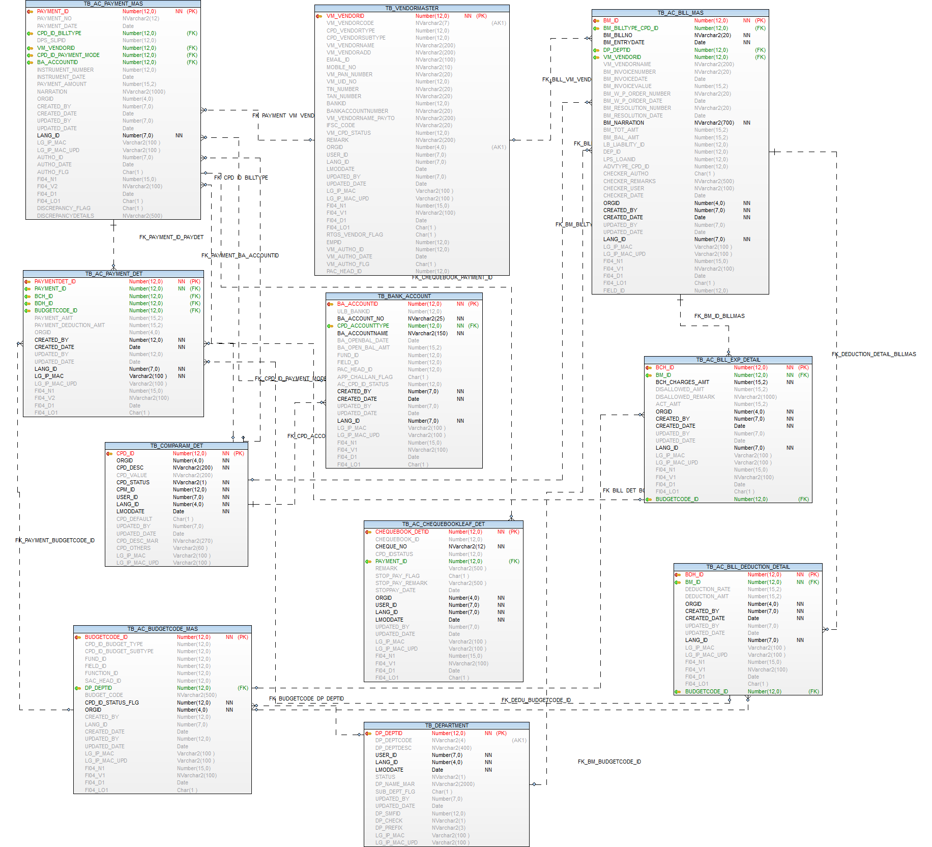

Direct Payment Entry

Operations-→  Tables | Select | Insert | Edit | Delete
TB_AC_PAYMENT_MAS | Y | Y | Y | N
TB_AC_PAYMENT_DET | Y | Y | Y | N
TB_AC_BUDGETCODE_MAS | Y | N | N | N
TB_VENDORMASTER | Y | N | N | N
TB_BANK_ACCOUNT | Y | N | N | N
TB_AC_CHEQUEBOOKLEAF_MAS | Y | N | N | N
TB_AC_CHEQUEBOOKLEAF_DET | Y | N | Y | N
EMPLOYEE | Y | N | N | N
TB_ORGANISATION | Y | N | N | N
TB_DEPARTMENT | Y | N | N | N
TB_COMPARAM_DET | Y | N | N | N

Prefixes used:
Prefix | Description | Remarks/use

TB_AC_PAYMENT_MAS

Purpose: - This table contains list of payment master details

Name | Type | Nullable | Default | Comments
PAYMENT_ID | NUMBER(12) |  |  | Primary Key
PAYMENT_NO | NVARCHAR2(12) | Y |  | Payment number system generated
PAYMENT_DATE | DATE | Y |  | payment Date
CPD_ID_BILLTYPE | NUMBER(12) | Y |  | Bill type prefix BBT - ref tb_comparam_det
DPS_SLIPID | NUMBER(12) | Y
VM_VENDORID | NUMBER(12) | Y |  | Vendor id- ref tb_vendormaster
CPD_ID_PAYMENT_MODE | NUMBER(12) | Y |  | Payment Mode from PAY prefix
BA_ACCOUNTID | NUMBER(12) | Y |  | Ref. Key -TB_BANK_ACCOUNT
INSTRUMENT_NUMBER | NUMBER(12) | Y |  | Cheque Number/ RTGS ref. Number/ NFT ref. Number etc.
INSTRUMENT_DATE | DATE | Y |  | Cheque Date/ RTGS Date/ NFT Date etc.
PAYMENT_AMOUNT | NUMBER(15,2) | Y |  | Payment Amount
NARRATION | NVARCHAR2(1000) | Y |  | Narration / Remark
ORGID | NUMBER(4) | Y |  | Organisation Id
CREATED_BY | NUMBER(7) | Y |  | Created User Identity
CREATED_DATE | DATE | Y |  | Created Date
UPDATED_BY | NUMBER(7) | Y |  | User id who update the data
UPDATED_DATE | DATE | Y |  | Date on which data is going to update
LANG_ID | NUMBER(7) |  |  | Language Identity
LG_IP_MAC | VARCHAR2(100) | Y |  | Client Machine?s Login Name | IP Address | Physical Address
LG_IP_MAC_UPD | VARCHAR2(100) | Y |  | Updated Client Machine?s Login Name | IP Address | Physical Address
AUTHO_ID | NUMBER(7) | Y |  | Authoer Id
AUTHO_DATE | DATE | Y |  | Sysdate
AUTHO_FLG | CHAR(1) | Y |  | Flag
FI04_N1 | NUMBER(15) | Y |  | Additional number FI04_N1 to be used in future
FI04_V2 | NVARCHAR2(100) | Y |  | Additional nvarchar2 FI04_V2 to be used in future
FI04_D1 | DATE | Y |  | Additional Date FI04_D1 to be used in future
FI04_LO1 | CHAR(1) | Y |  | Additional Logical field FI04_LO1 to be used in future
DISCREPANCY_FLAG | CHAR(1) | Y | 'N' | Update from Reconciliation form - if discrepancy is found update "Y" else default "N"
DISCREPANCYDETAILS | NVARCHAR2(500) | Y |  | Update from Reconciliation form - if discrepancy is found then enter discrepancy details.

Index (es):-

Index Name | Table Name | Field Name | Index Type
PK_PAYMENT_ID | TB_AC_PAYMENT_MAS | PAYMENT_ID | Unique

Other Information:-

Key | Name | Field Name | Reference Table | Reference Field
Primary | PK_PAYMENT_ID | PAYMENT_ID
Foreign | FK_CONTRA_DPS_SLIPID | DPS_SLIPID | TB_AC_BANK_DEPOSITSLIP_MASTER | DPS_SLIPID
Foreign | FK_CPD_ID_BILLTYPE | CPD_ID_BILLTYPE | TB_COMPARAM_DET | CPD_ID
Foreign | FK_CPD_ID_PAYMENT_MODE | CPD_ID_PAYMENT_MODE | TB_COMPARAM_DET | CPD_ID
Foreign | FK_PAYMENT_BA_ACCOUNTID | BA_ACCOUNTID | TB_BANK_ACCOUNT | BA_ACCOUNTID
Foreign | FK_PAYMENT_VM_VENDORID | VM_VENDORID | TB_VENDORMASTER | VM_VENDORID

TB_AC_PAYMENT_DET

Purpose: - This table contains list of payment details

Name | Type | Nullable | Default | Comments
PAYMENTDET_ID | NUMBER(12) |  |  | Primary Key
PAYMENT_ID | NUMBER(12) |  |  | Reference key TB_AC_PAYMENT_MAS
BCH_ID | NUMBER(12) | Y |  | Reference key TB_AC_BILL_EXP_DETAIL
BUDGETCODE_ID | NUMBER(12) | Y |  | Reference key TB_AC_BUDGETCODE_MAS
PAYMENT_AMT | NUMBER(15,2) | Y |  | Payment Amount
PAYMENT_DEDUCTION_AMT | NUMBER(15,2) | Y |  | Deduction Amount
ORGID | NUMBER(4) | Y |  | Organisation Id
CREATED_BY | NUMBER(12) |  |  | Created User Identity
CREATED_DATE | DATE |  |  | Created Date
UPDATED_BY | NUMBER(12) | Y |  | User id who update the data
UPDATED_DATE | DATE | Y |  | Date on which data is going to update
LANG_ID | NUMBER(7) |  |  | Language Identity
LG_IP_MAC | VARCHAR2(100) |  |  | Client Machine?s Login Name | IP Address | Physical Address
LG_IP_MAC_UPD | VARCHAR2(100) | Y |  | Updated Client Machine?s Login Name | IP Address | Physical Address
FI04_N1 | NUMBER(15) | Y |  | Additional number FI04_N1 to be used in future
FI04_V2 | NVARCHAR2(100) | Y |  | Additional nvarchar2 FI04_V2 to be used in future
FI04_D1 | DATE | Y |  | Additional Date FI04_D1 to be used in future
FI04_LO1 | CHAR(1) | Y |  | Additional Logical field FI04_LO1 to be used in future

Index (es):-

Index Name | Table Name | Field Name | Index Type
PK_PAYMENTDET_ID | TB_AC_PAYMENT_DET | PAYMENTDET_ID

Other Information:-

Key | Name | Field Name | Reference Table | Reference Field
Primary | PK_PAYMENTDET_ID | PAYMENTDET_ID
Foreign | FK_BILL_DET_BCH_ID | BCH_ID | TB_AC_BILL_EXP_DETAIL | BCH_ID
Foreign | FK_PAYMENT_BUDGETCODE_ID | BUDGETCODE_ID | TB_AC_BUDGETCODE_MAS | BUDGETCODE_ID
Foreign | FK_PAYMENT_ID_PAYDET | PAYMENT_ID | TB_AC_PAYMENT_MAS | PAYMENT_ID

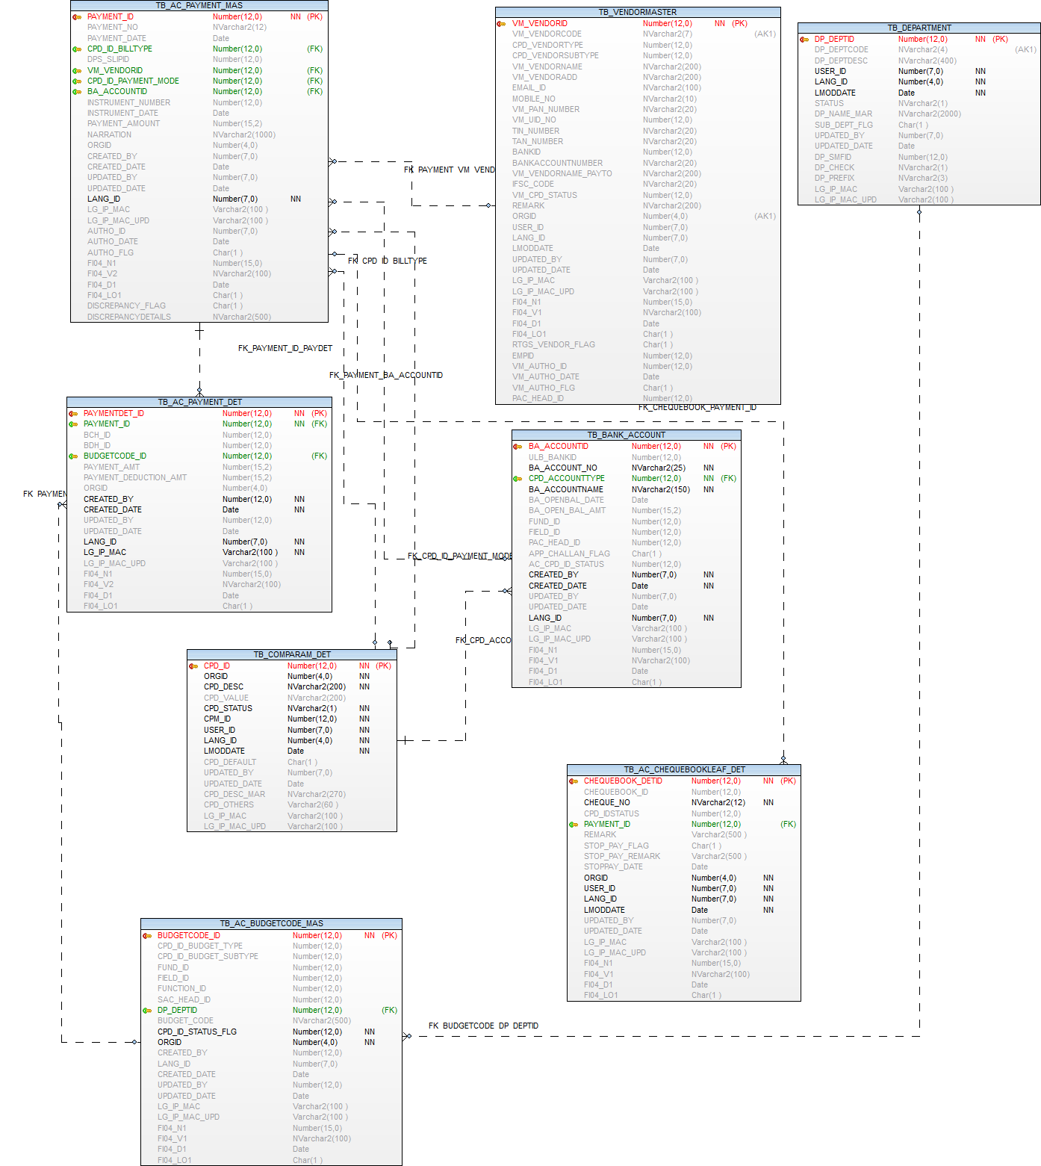

Payments Cheque Issauance Entry

Operations-→  Tables | Select | Insert | Edit | Delete
TB_AC_PAYMENT_MAS | Y | N | N | N
TB_AC_PAYMENT_DET | Y | N | N | N
TB_AC_BUDGETCODE_MAS | Y | N | N | N
TB_VENDORMASTER | Y | N | N | N
TB_BANK_ACCOUNT | Y | N | N | N
TB_AC_CHEQUEBOOKLEAF_MAS | Y | N | N | N
TB_AC_CHEQUEBOOKLEAF_DET | Y | N | Y | N
EMPLOYEE | Y | N | N | N
TB_ORGANISATION | Y | N | N | N
TB_DEPARTMENT | Y | N | N | N
TB_COMPARAM_DET | Y | N | N | N

Stop Payment Order

Operations-→  Tables | Select | Insert | Edit | Delete
TB_AC_PAYMENT_MAS | Y | N | N | N
TB_AC_PAYMENT_DET | Y | N | N | N
TB_AC_BUDGETCODE_MAS | Y | N | N | N
TB_VENDORMASTER | Y | N | N | N
TB_BANK_ACCOUNT | Y | N | N | N
TB_AC_CHEQUEBOOKLEAF_MAS | Y | N | N | N
TB_AC_CHEQUEBOOKLEAF_DET | Y | N | Y | N
EMPLOYEE | Y | N | N | N
TB_ORGANISATION | Y | N | N | N
TB_DEPARTMENT | Y | N | N | N
TB_COMPARAM_DET | Y | N | N | N

Cancellation / Re-Issue Of Cheques

Operations-→  Tables | Select | Insert | Edit | Delete
TB_AC_PAYMENT_MAS | Y | N | N | N
TB_AC_PAYMENT_DET | Y | N | N | N
TB_AC_BUDGETCODE_MAS | Y | N | N | N
TB_VENDORMASTER | Y | N | N | N
TB_BANK_ACCOUNT | Y | N | N | N
TB_AC_CHEQUEBOOKLEAF_MAS | Y | N | N | N
TB_AC_CHEQUEBOOKLEAF_DET | Y | N | Y | N
EMPLOYEE | Y | N | N | N
TB_ORGANISATION | Y | N | N | N
TB_DEPARTMENT | Y | N | N | N
TB_COMPARAM_DET | Y | N | N | N

Bank Reconciliation

Operations-→  Tables | Select | Insert | Edit | Delete
TB_AC_PAYMENT_MAS | Y | N | Y | N
TB_RECEIPT_MODE | Y | N | Y | N
TB_AC_CHEQUEBOOKLEAF_DET | Y | N | N | N
EMPLOYEE | Y | N | N | N
TB_ORGANISATION | Y | N | N | N
TB_DEPARTMENT | Y | N | N | N
TB_COMPARAM_DET | Y | N | N | N

Cheque Dishonour Entry

Operations-→  Tables | Select | Insert | Edit | Delete
TB_RECEIPT_MAS | Y | N | N | N
TB_RECEIPT_MODE | Y | N | Y | N
TB_AC_BANK_DEPOSITSLIP_MASTER | Y | N | N | N

